## 



College of Business,

Technology and   
Engineering

MSc Dissertation Report

**Understanding Traffic Patterns: A Comprehensive Analysis of Vehicle Counts in Great Britain**

A dissertation submitted in partial fulfilment of the requirements of Sheffield Hallam University for the degree of Master of Science in Big Data Analytics

|  |  |
| --- | --- |
| Student Name | Arya Shibu |
| Student ID | 33070752 |
| Supervisor | Dani Papamaximou |
| Date of Submission | 16/01/2025 |

This dissertation does NOT contain confidential material and thus   
can be made available to staff and students via the library.

# ABSTRACT

The analysis of traffic or the count of vehicles on the road is an important domain as it helps in making policies that govern the management of traffic. The different elements that affect the traffic in different regions needs to be analysed. Also forecasting the count of vehicles based on specific factors can help in understanding how the vehicle count will be in different regions and years. In the study carried out here the data associated with traffic in Great Britain is analysed and insights are gained. The study also proposes a machine learning based model that predicts the traffic(number of vehicles on the road) in Great Britain based on factors like location, year, day of week and month. The data is analysed and visual plots are generated based on patterns in the data. The machine learning models used in the study are Long Short Term Memory(LSTM), Gated Recurrent Unit(GRU), and Support Vector Machine(SVM). The machine learning models are trained for predicting the vehicle count. Prediction models are built for different kinds of vehicles. The performances of the models are evaluated and it was seen that the best performances are shown by the LSTM and GRU. The LSTM and GRU models are used for building a web app that predicted the number of vehicles. The web app was built and it was able to successfully predict the number of vehicles based on factors like location, year, day of week and month.

# ACKNOWLEDGEMENT

I would like to express my deepest gratitude to my research supervisor Dani Papamaximou, for their unwavering support, invaluable insights, and consistent guidance throughout the course of this dissertation. Their expertise, dedication, and constructive feedback have been instrumental in shaping the direction and overall quality of this research.

I am also sincerely thankful to the study participants, the staff and students of [Your University], as well as my classmates and friends, whose cooperation and contributions have greatly enriched this research. Each contribution, no matter how small, has been meaningful and appreciated.

To my dearest parents, [Parents’ Names or "my mother and father"], I am forever grateful for your boundless love, encouragement, and belief in me. Your unwavering support and sacrifices have been the foundation of my strength, providing me with the resilience to persevere even in the most challenging moments.

Lastly, I acknowledge with humility the presence of a higher power that has guided me throughout this journey. My faith in God has been a source of comfort, clarity, and inspiration, enabling me to overcome obstacles and remain focused on my goals.

From the bottom of my heart, thank you to everyone who has supported me on this journey

**Table of Contents**

1

Abstract 2

Chapter 1: Introduction 8

1.1 Background 8

1.2 Aim 10

1.3 Objectives 10

1.4 Research Questions 10

1.5 Report Structure 11

Chapter 2: Literature Review 11

2.1 Traffic Patterns and Vehicle Counts: An Overview 11

2.2 Importance of Traffic Analysis 12

2.3 Challenges in Traffic Prediction 12

2.4 Existing Models for Traffic Analysis 13

2.5 Rationale for Using LSTM, GRU, and SVM 14

2.6 Related Work 15

2.7 Research Gap 19

Chapter 3: Methodology 19

3.1 Research Design 20

3.2 Research Philosophy 20

3.3 Research Approach 21

3.4 Research Method 21

3.5 Data Collection 22

Chapter 4: Implementation 22

4.1 Tools Used 23

4.2 Dataset 23

4.3 Pre-processing 24

4.4 Exploratory Data Analysis 25

4.5 Machine Learning models 34

4.6 Performance Evaluation 40

4.7 Testing 40

Chapter 5: Results 42

5.1 Performance Metrics 42

5.2 Results of testing 43

Chapter 6: Discussion and Evaluation 49

6.1 Discussion 49

6.2 Evaluation 50

7 Conclusion and future enhancements 51

References 52

APPENDICES 60

Appendix A – Research Project plan and Project Schedule 60

INTRODUCTION 61

BACKGROUND AND RATIONALE 62

RESEARCH QUESTIONS 62

AIMS AND OBJECTIVES 62

LITERATURE REVIEW 63

Traffic Patterns and Vehicle Counts: An Overview 63

Importance of Traffic Analysis 63

Challenges in Traffic Prediction 63

Existing Models for Traffic Analysis 64

Rationale for Using LSTM, GRU, and SVM 65

Related Work 66

Research Gap 68

RESEARCH DESIGN AND METHODOLOGY 68

Methodology: 68

Tools and Frameworks: 69

Deliverables 69

Expected Outcomes 69

ETHICS, RISKS, AND ISSUES 70

Timeline and project plan 71

72

CONCLUSION 72

Reference 72

Appendix B – Ethics Form and Publication Procedure Form 74

Appendix C – Publication Procedure Form 85*.*

Appendix D – Heat map 110

**Table of figures**

Figure (1): Vehicles in Great Britain(Road Traffic Statistics - Summary Statistics, 2024) 8

Figure (2): traffic volume by direction per year 23

Figure (3): traffic count based on region and year 24

Figure (4): vehicle count over the years 25

Figure (5): yearly traffic trends by region 26

Figure (6): hourly peak in traffic in different years 27

Figure (7): impact on vehicle count based on road type 28

Figure (8): impact of type of roads on different kinds of vehicles 29

Figure (9): the count of vehicles based on different regions 30

Figure (10): the distribution of the different kinds of vehicles 31

Figure (11): Correlation plot 34

Figure (12): the input to the web app 44

Figure (13): the result of prediction 45

**List of tables**

Table (1): the columns in the dataset 18

Table (2): Parameters used for SVM Regression 31

Table (3): Parameters of MultipleOutputRgeressor 31

Table (4): Parameters of the LSTM 32

Table (5): performance metrics of the models for predicting the number of cycles 35

Table (6): performance metrics of the models for predicting the number of two wheeled motor vehicles 35

Table (7): performance metrics of the models for predicting the number of cars and taxis 35

Table (8): performance metrics of the models for predicting the number of buses and coaches 36

Table (9): performance metrics of the models for predicting the number of light good vehicles 36

Table (10): performance metrics of the models for predicting the number of heavy good vehicles 36

Table (11): results of Blackbox testing 38

Table (12): results of unit testing 40

# Chapter 1: Introduction

## Background

Traffic patterns reflect, to a large extent, the socio-economic state of any given nation, and help determine public mobility, economic productivity, and environmental sustainability (Corchado et al., 2022). An important aspect of urban planning, infrastructure development, and ecological conservation, their knowledge allows them to allocate resources effectively and reduce congestion (Hanna & Comín, 2021). With expanding populations and recent rapid urbanization as seen in many metropolitan areas, it has always been difficult to manage traffic flow on roads, hence traffic analysis and prediction require novel approaches. Moreover, regional demographics, road network design, and vehicle types interact to create heterogeneous traffic dynamics across space and time, making them complex and heterogeneous (H. Xiong et al., 2023).

It is way beyond congestion and travel time, understanding traffic patterns, affects various facets of socio-economics and environmental factors (C. Sun & Lu, 2022). Traffic density and flow are critical parameters for fuel consumption, greenhouse gas emission, public safety, and economic productivity, making this field of study important for sustainable development. This holds for the United Kingdom (UK) including Great Britain, which uniquely faces multiple challenges in this context, considering its heterogeneous road networks and spatial traffic patterns due to urbanization, industrial estates, and rural areas (Zeng et al., 2020). Data on vehicles, segregated into categories including pedal cycles, two-wheeler motor vehicles, automobile transport, bus transport, and heavy goods vehicles (HGVs) can be a more comprehensive lens into the complexities of traffic flow.

Data-derived insights developed from such analyses can play an important role in addressing key challenges. Planning for urban infrastructure can be improved by locating high-traffic areas and peak times and prioritizing infrastructure improvements. Such information helps inform targeted policies to reduce traffic congestion and its environmental consequences. Likewise, economic optimization in logistics and supply chains is made possible due to the predictions on vehicle flow trends (Alkahtani, 2022). Additionally, protecting public safety may be improved by reducing road accidents by using predictive models to inform traffic management or infrastructure design and implement proactive measures (Gatarić et al., 2023). These dynamics are essential for a more efficient, safer, and sustainable movement of people and goods.

However, Traffic flow is determined by various factors and it can be difficult to analyse and understand each factor separately so it's an important study to perform in the case of transportation planning and management. Traffic data is another example of how data heterogeneity poses one of the biggest challenges, as the data obtained come from very different mediums including sensors, cameras, GPS systems, and surveys (Cvetek et al., 2021). This leads to a heterogeneous collection of datasets that differ in structure, quality, and completeness — requiring careful pre-processing and normalization steps to ensure consistency and reliability. Moreover, regional variance also comes into play; different levels of urbanization, lower levels of population density, or heterogeneous economic activities lead to highly region-centric traffic behaviours that should be analysed on a localized basis (Nickayin et al., 2022). An additional challenge in this context is temporal dynamics since traffic flow can vary significantly across various seasons, weeks, and even hours of the day, warranting models that can model its complex temporal dependencies (Golovnin, 2019).

The implications of this study are vast. For governmental organizations, the projections can inform policymakers about where to allocate budgets to road-building efforts, guiding the improvement of specific areas (Pegin et al., 2023). Transportation planners can use detailed traffic analyses and forecasts to optimize routes, public transport schedules, and more (Levterov & Kozachok, 2022). For environmental organizations, knowledge of traffic density trends can help assess and mitigate environmental threats posed by vehicle emissions (Qaiser et al., 2023). This allows logistics and supply chain companies to improve delivery schedules and minimize delays in transit. The usage of machine learning in traffic analysis not only demonstrates the power of data-driven methodologies to solve real-world problems but also acts as a conceptual framework for similar works in different areas and sectors leading towards a smarter and more sustainable transportation system (Shahraki et al., 2022).

This study focuses on analysing vehicular counts over time and exploring traffic patterns. It also employs an advanced machine learning models, to derive the hidden features that impact traffic flow and subsequently make predictions that can have great implications on urban planners and policymakers for transportation planning and efficiently allocating resources. The study focuses on the traffic in Great Britain as it offers many variables that can be studied to understand different variables for the analysis of road traffic(Figure(1)).

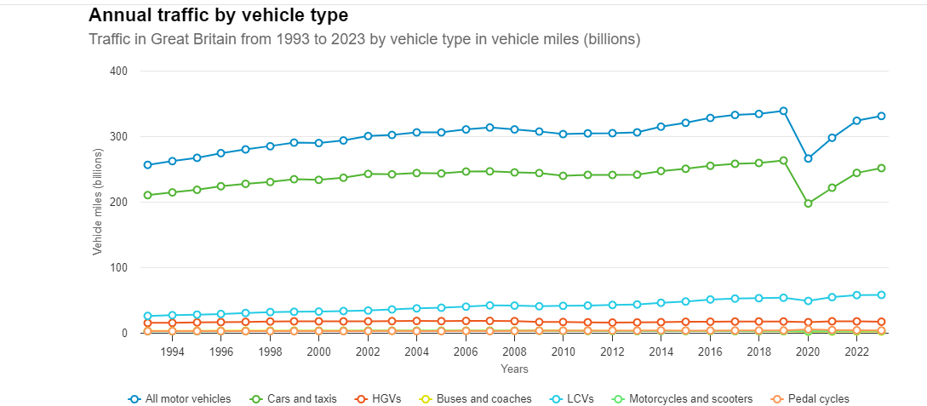

Figure (1): Vehicles in Great Britain(Road Traffic Statistics - Summary Statistics, 2024)

## Aim

The aim of the study is to analyse the different trends associated with the road traffic in Great Britain over the years, and build machine learning models that predict the number of vehicles on the road based on factors like, location, year, day of week and month.

## Objectives

* Obtain the data in pre-processed form.
* Generate visual representations of the patterns in the data.
* Obtain trained machine learning models that predict the number of different kinds of vehicles.
* Test the performance of the models.
* Obtain a web app that predicts the count of vehicles based on like, location, year, day of week and month.

## Research Questions

* How do traffic patterns differ in different regions in Great Britain over the years?
* What is the impact of the type of road (e.g., minor vs. major highways) on the counts of vehicles?
* What are the changes associated with the number of different kinds of vehicles(cars, buses etc.,) over the years?
* How do the performances of the machine learning models compare with each other in forecasting future vehicle counts in different regions based on the historical trends in the regions?
* What kind of vehicles(cars, buses etc.,) make up the traffic in different regions and how does this affect the strategies for traffic management?

## Report Structure

The report begins with an ‘Introduction’ to analysing traffic patterns, emphasizing the use of machine learning to address challenges. The ‘literature review’ section of the report consists of the existing literature that performs analysing of traffic patterns. The ‘Methodology’ outlines method used in the study. The ‘Implementation’ section the selection of models like Long Short Term Memory(LSTM), Gated Recurrent Unit(GRU), and Support Vector Machine(SVM), detailing their suitability for traffic data and the implementation of the methods. The ‘Results’ section presents the results of the study performed here. The ‘Discussion and evaluation’ section contains the details associated with the analysis of the results and the evaluation of the study carried out here. The ‘Conclusion and future enhancements’ section of the model contains the details of the main methods and results of the study performed here.

# Chapter 2: Literature Review

This section contains the details associated with the background of the methods used in the study and the existing literature associated with the study performed here.

## 2.1 Traffic Patterns and Vehicle Counts: An Overview

The count of the vehicles on roads and their traffic patterns are basic for tackling problems in urban planning, infrastructure development, traffic management, etc. Traffic has a direct correlation with economic activity, the environment and living quality in urban areas. Since Great Britain is a country where road transport makes up a huge part of daily transport, the analysis and prediction of traffic have been popular topics for optimal resource allocation and safety improvement.

## 2.2 Importance of Traffic Analysis

Analysing traffic patterns, such as the types of vehicles, roads, timing in the day and region. These analyses give valuable information about urban mobility that helps decision-makers and urban planners in managing traffic congestion. Urban planners have the ability to anticipate congestion hotspots, develop mitigation strategies for future gridlocks, and optimize the transportation infrastructure based on predicted vehicle type distributions and traffic state patterns (Švadlenka & Chrpa, 2023).

Proper analysis of traffic data is central to reducing the environmental impact of vehicle emissions as well. knowing where and at what time intervals traffic flows are dense, planners can take relatively simple steps of emission control policy, promoting public transportation and encouraging transit-oriented development. Moreover, traffic studies help to the development of smarter cities by helping government differentiate and more informed decisions based on data for the placement of electric vehicle charging stations, road designs and green zone planning.

Unfortunately, information on traffic data goes beyond that of environmental benefits, and are essential to public safety. Using predictive modelling, high-risk times and locations for accidents can be identified, allowing for focused preventive action such as increased enforcement of speed limits and improved road signage (Mallahi et al., 2023). For instance, in urban areas where traffic from pedestrians and cyclists is prevalent, creating safer crosswalks and bike lanes to aid those traveling on foot or bike can be designed.

Additionally, with real-time traffic data you can build intelligent transportation systems (ITS), which improve the efficiency of signals, reduce travel times, and result in a better commuter experience (S. Li, 2024). Applying machine learning and deep learning methods to traffic data allows authorities in contemporary smart cities to act based on real-time traffic conditions. In the end, Traffic analysis promotes efficient transportation systems, improved city planning, environmental protection and increased road safety contributing to a better urban living space.

## 2.3 Challenges in Traffic Prediction

The complexity of traffic data arises from the non-linear associations among numerous factors such as type of road, time period during the day or week, weather conditions, seasonal variations through holidays or special events with diverse types of vehicles. Traffic forecasting now becomes more challenging which is dynamic and interdependent and traditional statistical method will lose their effectiveness (Chai et al., 2024). In addition, the increasing volume and granularity of data available on vehicle numbers, geographic distributions and road properties is a complication that conventional methods are ill-equipped to efficiently address. It needed advanced computational methods to be able to analyse and interpret the data. In this sense, ML and DL models provide an important advantage, The ability to handle high-dimensional real-world data, with the capacity to learn complex interactions that cannot be detected by simpler statistical methods. Since ML algorithms like Support Vector Machine (SVM), Random Forests are really good in high-dimensional data, whereas deep learning models such as Long Short-Term Memory (LSTM) networks and Gated Recurrent Units (GRU) are suitable for modelling temporal dependencies in traffic (J. Yang et al., 2022). The improved forecasts can give further insights into traffic in Great Britain using these advanced models.

## 2.4 Existing Models for Traffic Analysis

Different models were developed to study and forecast traffic flow over the years. These include numerous traditional statistical, as well as modern ML and DL approaches, each of which comes with somewhat different pros and cons (Parishwad et al., 2023).

**Traditional Models**

For many years, the auto regressive integrated moving average (ARIMA) model was a workhorse in traffic forecasting, especially for short term forecasts. The main advantage of ARIMA is that its very simple and easy to understand model for linear relationships in time-series data, which seem ideal for predicting traffic given some past history (Wang & Zhang, 2023). Using differencing to achieve stationarity, ARIMA combines autoregressive and moving average components based on past traffic observations. So, when the traffic data is complex and non-linear in nature then ARIMA has the big limitation to implement. ARIMA is linear so even if the method has proven well for normal periods with high and low flows but it does not capture the effects of special events, or any other factors like overdemand by climate condition (hot or rainy day) and road infrastructure. In addition to this, ARIMA performance is poor for large size, very volatile datasets with many influencing factors that interact in a non-linear manner. Though ARIMA has been proved to be effective for simple forecasting under laboratory environment, as the traffic data becomes complex and heterogeneous nature, it loses its reliability and higher level techniques are needed to deal with real life traffic characteristics.

One of the most used models to find the relationship between traffic counts and some of the influencing factors like an hour, climatic condition, or road type is linear regression (Li et al., 2022). This approach is computationally light and relatively simple to implement, which makes it a popular choice for initial traffic analysis. Performing linear regression can help determine how well, or poorly, one or more independent variables determine traffic volume by fitting a linear equation to the observed data (Verbeek, 2017). Linear regression is arguably the most commonly used statistical technique, but it has some key shortcomings for traffic analysis. It takes into consideration linear relationship between predictors and traffic counts, which is rarely the case in real life. Generally, the traffic data is non-linear which results from several interplaying actions like congestion, vehicle types & regional variations. This means that linear regression models can have high bias and weak predictive performance on traffic data with nonlinear relationships. In those situations, more advanced methods out like machine learning or deep models are needed since they can elaborate on the underlying complexities and provide higher forecast precision.

**Machine Learning Models**

Support Vector Machines (SVMs) are another popular ML model that can handle high-dimensional data and perform classification problems, including vehicle type classification and traffic prediction (Prakash, 2023). They perform good when the data is complex and non-linear so they can created decision boundaries in high-dimensional space. However, their computational cost grows with the size of the datasets involved, posing difficulties for real-time applications. However, SVMs are not always ideal as they have high computational cost which may be a disadvantage in the case of real-time traffic forecasting and yet still considered precious for handling classification problems where feature space is very large and varied.

Random Forests (RFs) are ensemble method working best in forecasting traffic volumes according to weather conditions and road type. RFs build multiple decision trees to mitigate overfitting, leading them to make reliable predictions (Schonlau & Zou, 2020). RFs, on the other hand, are easy to use and show very good performance out of the box but they need lots of feature engineering for best results, also training a lot of trees may be memory and time consuming if you have large datasets. However, due to their capacity of dealing with variety of data sources and overfitting prevention, they can be very useful in the task of traffic prediction especially where high accuracy is required.

**Deep Learning Models**

Recurrent neural networks (RNN), specifically Long short-term memory LSTMs, are capable of learning dependencies over long time-series sequence data which make it ideal for traffic dataset forecasting (Fesalbon, 2024). Experience gained from past traffic patterns enable them to learn complex non-linear modelling and short-term as well as long-term variance. Compared with traditional traffic flow prediction methods such as ARIMA and linear regression, LSTMs yield superior performances because of the ability to model seasonal variations and capture abrupt changes in a sequence. LSTMs are more suited for modelling temporal dependencies as they use memory cells (Isah et al., 2023).

GRUs are a very simplified form of LSTMs, posing lower computation complexity and providing similar performance. With a reduced no of gates, GRUs are more efficient and faster to train which suits the real-time traffic forecasting applications (Rani et al., 2023). They retain prominent sequential patterns in the traffic data and are proficient at predicting both short-term and long-period trends in flows. GRUs are especially beneficial in cases where fast predictions and real-time traffic management play an important role, which means the speed and low computational effort matter.

## 2.5 Rationale for Using LSTM, GRU, and SVM

LSTM, GRU and SVM are selected in this study for their unique capabilities to handle challenges focused on the traffic analysis problem and prediction problem.

LSTM networks are very powerful in modelling the sequential and non-linear characteristics of the traffic data, therefore it is ideal for forecasting vehicle counts nationwide across Great Britain. The long short-term memory (LSTM) architecture is able to model complex dependencies with the help of a memory cell mechanism that can learn daily rush hours, weekly patterns, and seasonal variations in traffic data(Chien et al., 2022). This provides the ability to keep or forget information over time allows them to remember long-term dependencies on past experiences when making a prediction. The study dataset additionally contains multivariate attributes, such as date and time of day, region, street kind, vehicle type; sensory-driven features compounding non-linear interactions in traffic flow. This multivariate nature of the time series has been proven for an LSTM to find a relationship between features, and make an accurate, context-aware forecast. LSTM's ability to adjust for noise and heterogeneous data, therefore becomes complementary with the type of traffic data obtained in Great Britain which consist of diverse type of measurements, making it often noisy. Utilizing these capabilities, the predictions for vehicle counts will be more accurate, benefiting traffic management, urban planning and decision-making from the study. Not only does this model alleviate the limitations faced by classical models, it also opens scope for scalability and on-demand, real-time-forecasting.

This study leverages Gated Recurrent Units (GRU) because of their proved capability to model non-linear temporal data, which helps us in forecasting usage patterns and vehicle counts throughout Great Britain (Abid et al., 2023). GRUs are best suited for time-series data as they can capture short-term fluctuations and long-term dependencies, both of which are common with traffic datasets (daily rush hour or seasonal variation) (Xiong, 2024). Compared to other recurrent neural networks GRUs have a simpler architecture (fewer parameters) which helps in computational efficiency, thus making it less time consuming while still providing predictive power which was important when handling large datasets efficiently (Qi et al., 2023). The update and reset gates that are inherent in their gating mechanisms enable GRUs to conserve useful information while ignoring unimportant details, thus making them suitable for use case such as traffic data due to the noisy and inconsistent nature of those types of datasets. GRUs are also used in predictive models of real traffic, which have shown that they are superior in dynamic environments. Due to these merits, GRUs are a suitable candidate for vehicle counting and regional traffic patterns prediction in this study be they can achieve high forecasting accuracy without excessive computational cost which is crucial to build a solid web-based implementation for the application of traffic analysis.

Support Vector Machines (SVM) are also a powerful tool for forecasting traffic patterns, especially given the nature of the data as high-dimensional and non-linear, whose complex relationships should be measured in diverse input features that include vehicle types, time of day, road characteristics and regional differences. Within the framework of this paper, SVM can be an interesting candidate as it performs well on regression problems, which sound familiar to estimating continuous values (such as traffic volume) given multi-dimensional features (Wen et al., 2017). Traffic forecasting typically coordinate both sparse information and a variety of input variables, SVM avoids overfitting which is most useful in such scenarios. Moreover, SVM is able to deal with complex, non-linear relationships between the features because of the kernel trick, obviously a strong point when traffic patterns depend on non-linear interactions among variables. Although LSTM and GRU models can capture dependent patterns between time frames, SVM also proves to be advantageous where a clear decision boundary has to be made in high-dimensional space due to different traffic conditions and surroundings. In general, the SVM is a powerful approach for predicting counts of vehicle types or areas in Great Britain which are characterized by their robustness and efficiency as well as their capability to integrate heterogeneous information from different input sources such as time-series census traffic flow counts.

## 2.6 Related Work

A deep learning approach, specifically AdaBoost regression and Long Short-Term Memory (LSTM) neural networks, to enhance traffic flow predictions was proposed in this study by (Srinath, 2023). The dataset used in the research comprises real-time traffic data that is collected through cameras and sensors at different junctions, with data features such as time of the day and the count of vehicles flowing from each junction. Apart from this, feature engineering is also added in the study which provides equality-based features that it extracts based on the timestamps to help in capturing temporal patterns of traffic flow. The results prove that the proposed model consistently outperforms traditional statistical models, achieving lower mean absolute error (MAE) and higher R2 scores under various experimental conditions, with an accuracy of 91.14%. These findings demonstrate the efficacy of the proposed model for traffic flow prediction.

A deep learning model featuring a bi-directional Long Short Term Memory (LSTM) stacked autoencoder architecture was proposed for predicting urban traffic flow using multi-source Twitter, traffic and weather data in the study by (Essien et al., 2020). For the case study, we have collected all of the tweets that filtered for relevancy with road traffic conditions (totally 9,275) from the initial tweet database which was previously built upon real-world traffic data streams in Greater Manchester, UK and weather observations. The study also incorporates, apart from the main model proposed here, a comparison against both classical or statistical as well as other machine learning models to perform an evaluation of effectiveness. The results with a, Mean Absolute Error (MAE) of 5.5 veh/h, highlight that the deep learning model can significantly enhance prediction accuracy, aiding road users and helping mitigate environmental impacts by in particular for non-recurring traffic events such as lane closures.

A multi-view convolution based spatiotemporal traffic flow prediction model, leveraging high computational efficiency and robust feature extraction capability, was proposed in this study by (Xu et al., 2024).The model achieved an accuracy of 72.43%.Extracting features and constructing traffic flow prediction models often rely on large-scale spatial-temporal datasets of urban traffic data. Existing methods such as ring neural network and graph network, transformer model are cited in this study. Traffic flow prediction has been a critical task in the field of urban computing, and it highlights that better traffic operation schedule and logistics efficiency is dependent on accurate traffic flow prediction, thus they propose to outperform the state-of-the-art models for high-accuracy flow predictions across different scales.

The machine learning methods, particularly RandomForest and CatBoost models, were used for predicting traffic flow and enhancing model explainability in the study by (Zhang, 2023). The dataset is abundant and the features are less correlated with each other as such that it can do good for traffic flow prediction tasks. Also besides RandomForest and CatBoost, this study compares these models with XGBoost and LightGBM to see how well they perform. The findings showed that the RandomForest and CatBoost models gave good predictive performance of traffic flow, and their corresponding feature importance matched well with the real traffic characteristics. CatBoost has the best performance among other models (MAE of 6.163), while RandomForest predicts fewer errors compared to XGBoost and LightGBM (which have larger and more fluctuated prediction errors).

A traffic flow prediction model was developed to predict the state estimate traffic conditions on an hourly basis, forecasting up to 24 hours in advance, as used in this study by (Phapale & Shravagi, 2024). The model improves predictive power by considering different environmental and weather conditions, including rainfall and thunderstorms. The predictions are improved further using Advanced Neural Network and Support Vector Machine methods. It is successful in dealing with the models of city congestion traffic flow problems, which is a predominant element in any intelligent transportation system.

The studies by Phapale & Shravagi(2024), Zhang(2023), Xu et al.(2024), (Essien et al., 2020) and Srinath(2023). It was seen that the traffic flow can be predicted using machine learning models. However, none of these studies predicted the number of vehicles on the road based on variables like the kind of road, or region in Great Britain.

Table Related literature on Traffic Prediction

|  |  |  |  |  |  |
| --- | --- | --- | --- | --- | --- |
| **Sl.No.** | **Paper Title** | **Dataset used** | **No. of attributes/Sample size** | **ML classifier used** | **Result** |
| 1 | Vehicular Traffic Flow Prediction Model Deep learning(Srinath, 2023) | Real-time traffic data collected from junctions | Not specified | Long Short Term Memory | Accuracy: 91.14% |
| 2 | A deep-learning model for urban traffic flow prediction with traffic events mined from twitter(Essien et al., 2020) | Traffic data collected from Machester,UK, Weather data from Centre for Atmospheric Studies (CAS) at the University of Manchester, tweets from road traffic information users – Waze and TfGM | Not specified/ 109,728 | Bi-directional Long Short-Term Memory stacked autoencoder | Mean Absolute Error: 5.5 veh/h |
| 3 | Machine Learning-Based traffic flow prediction and intelligent traffic management(Xu et al., 2024) | Data collected from taxi tracks in Shenzhen City, China | Not specified | Time-Graph Convolutional Network | Accuracy : 72.43% |
| 4 | Vehicular Traffic Flow Prediction Model using Deep Learning(Sunny, 2023) | Data collected from sensors and cameras near traffic intersections | Not specified | Long Short Term Memory | Accuracy : 88.67% |
| 5 | Study Estimating hourly traffic flow using Artificial Neural Network: A M25 motorway case(Turki & Hasson, 2023) | Data from Motorway Incident Detection and Automatic Signalling (MIDAS) system focused on M25 motorway in UK | 2/ not specified | Fully-connected feedforward multi-layer Artificial Neural Network | Mean Absolute Error: 1.09  Root mean Squared Error: 1.3 |
| 6 | Traffic Prediction using Machine Learning(Tm & Cn, 2023) | Traffic forecast record dataset from Kaggle | 4/48120 | Random Forest and Long Short Term Memory | Accuracy of Random Forest : 94.96%  Root Mean Square Error of Long Short Term Memory: 4.57 |
| 7 | Traffic flow prediction for intelligent transportation system using Machine learning(Manikandan et al., 2023) | Historical traffic data collected from devices like traffic sensors | Not specified | Gated Recurrent Unit | Not specified |
| 8 | Traffic Prediction for Intelligent Transportation System using Machine Learning(Jedhe & Chopade, 2022) | Performance Measurement System (PeMS), GPS Data from Taxis, Low-Frequency Probe Vehicle Data (PVD) and Sensor Data | PeMS(not specified). GPS data(not specified/20000),PVD(not specified) and Sensor data(not specified) | Artificial Neural Network, Support Vector Machines. | Not specified |
| 9 | Traffic Flow Prediction Based on Explainable Machine Learning(X. Zhang, 2023) | Traffic flow data | 14/848,834 | XgBoost, LightGBM, Random Forest and CatBoost | Mean Absolute error of CatBoost :6.163 |

## 2.7 Research Gap

The existing literature studied here focused on the prediction of the flow of traffic and traffic trends using machine learning models. The existing studies showed that machine learning models are effective for traffic prediction. Additionally, the literature demonstrated that models like LSTM, GRU, and SVM could be employed for analysing traffic data and forecasting traffic flow. However, none of these studies considered the prediction of traffic (number of vehicles on the road) based on the geographical region (in Great Britain) and the type of road.

Furthermore, the dataset used in this study, sourced from Kaggle, has not been employed in any previous research. This dataset, which contains detailed information on traffic counts, vehicle categories, and temporal patterns, offers unique insights into traffic patterns across Great Britain. Its application in this study provides an opportunity to address the gaps in existing research by analysing previously unexplored data for uncovering trends and making predictions.

This study uses LSTM, GRU, and SVM models to predict the number of vehicles on the road based on variables such as the type of road and geographical region in Great Britain. Additionally, the traffic data is analysed, and visual representations are generated to provide new insights into the dataset.

# Chapter 3: Methodology

The main methods used in the study are defined in this section the methods used in the study like the dataset, data pre-processing and machine learning methods are defined in this section.

## 3.1 Research Design

In the study carried out here, the research approach chosen was Pragmatism. The study involved both quantitative and qualitative methods. Secondary data collection methods were used, and the dataset was obtained from Kaggle, an online platform known for hosting diverse datasets. This dataset was selected for its relevance to traffic analysis in Great Britain and its detailed features, which include timestamps, vehicle categories, and road-specific data.

The data was pre-processed to remove inconsistencies, and the important features from the dataset were identified. These features were then used to train the LSTM, GRU, and SVM regression models. The best-performing model was integrated into a web application, which was developed to predict the number of vehicles on the road. The web application utilized the trained machine learning model to forecast vehicle counts based on variables like location, year, day of the week, and month.

## 3.2 Research Philosophy

The research philosophy used in this study was Pragmatism. Pragmatism is based on the idea that the value associated with the research method is in its capability to achieve the objectives of the research in an effective manner(Foster, 2023). Whereas other philosophies like positivism( to access absolute truths through hypothesis-led quantitative methods) or interpretivism( frequently claiming subjective knowledge through qualitative analysis) uphold more rigid structures of inquiry, pragmatism is inherently fluid. It allows for both qualitative and quantitative techniques to be employed where they make sense, with a focus on outcomes and solutions rather than theoretical purism(Ranjbar, 2021).

Pragmatism is suited for the main methods of the study as it supports the study’s use of data analysis and predictive modelling in a single study for an outcome-oriented approach. The use of pragmatism enables the study to take advantage of various methods, encompassing data preprocessing, machine learning, and visualization, all of which are selected based on their effectiveness rather than a prescribed theoretical paradigm. Pragmatism puts the problem of the study as the main aspect of the research process. The goal of this study was to evaluate both past traffic patterns and try to predict future trends through Machine Learning, for achieving these goals a philosophy that could, handle a dataset with large data and incorporate both data analysis and prediction modelling, this results-oriented approach was supported by pragmatism. Pragmatism supports the selection of methods in a study based on the suitability of the methods to the particular study and such an approach was needed in the study carried out here, so Pragmatism was chosen as other philosophies like Positivism and Interpretivism which were not that flexible(Velástegui, 2016). As this study involved the use of a machine learning model, the building of the machine learning model for vehicle prediction involved multiple iterative processes and this use of iterative processes is supported by Pragmatism(Foster, 2023).

## 3.3 Research Approach

The Inductive approach was used in the study carried out here. The Inductive approach gave importance to the development of insights and conclusions based on the analysis of data rather than testing hypotheses or theories that are pre-existing(Hoiruddin & Ulfa, 2020). This approach was chosen for this study as the study needed the learning of insights based on the analysis of data.

The analysis of traffic data across Great Britain meant discovering patterns and trends without preconceptions. The inductive approach is exploratory by nature allowing, to look at road usage across the time of day, or types of vehicles, enabling the detection of seasonal or periodic patterns in traffic behaviour and identification of circumstances that are unique which could affect patterns associated with traffic. The study involves machine learning models like, SVM , GRU and LSTM. These models need enormous data compilation and feature engineering to train the best inputs into these models, for this an iterative approach that trains models by refining features of the models was needed, this is supported by the Inductive approach. The data used in the study deals with real-world issues(traffic data). A data-driven approach was needed in this study and the study should not be based on rigid theoretical frameworks, so the Inductive approach was apt.

## 3.4 Research Method

The study performed here used both quantitative and qualitative research methods. Quantitative research is a systematic approach that involves measuring data to identify patterns, relationships, or trends(Conducting Quantitative Research Study: A Step-by-Step Process, 2023). It is based on quantifiable variables, statistics, and a non-biased conclusion. This study involved applying analytical methods, which are a form of quantitative analysis, to traffic data, training machine learning models, and evaluating the performance of those models in terms of numerical metrics. However, the analysis of the data in the dataset was done using a qualitative method in the study as the analysis of the data only focused on gaining insights from the data based on patterns and trends associated with the data. Qualitative research is a methodological approach to understanding complex social phenomena by exploring non-numerical data(Lahiri, 2023). Only insights about the patterns and trends associated with the data were needed, so a qualitative analysis was also needed in the study for data analysis.

The data used in the study was from the Road Traffic Dataset. The data was made up of numerical values and contained data associated with timestamps, categories of vehicles and timestamps, the training of the machine learning models was done using this data, for achieving this a quantitative approach was needed. The machine learning models needed to be trained and then evaluated based on their performance metrics. This was an objective process, so the study needed a quantitative research method(Steurer et al., 2021). Predictive modelling was needed in this study as the number of vehicles had to be predicted based on several features and for this numerical models were needed, the studies that involve numerical models is a quantitative study.

## 3.5 Data Collection

The data collection method used in the study was Secondary as a dataset from Kaggle was used in the study. The study carried out here had the objective of analysing the patterns associated with traffic data and predicting the number of vehicles on the road. For achieving these goals data associated with traffic was needed. The collection of data associated with traffic is a difficult process as data associated with traffic blocks had to be collected from different regions of Great Britain as it was a research question of the study and for answering the research question such data was needed. The collection of data associated with traffic from different regions of Great Britain is time-consuming, difficult and highly expensive process which was not desirable for this particular study, so a dataset containing previously collected data associated with traffic was used in the study.

Kaggle is a fairly well-known website for a lot of data sets in different domains(Hayashi et al., 2021). The dataset utilized in this study was readily available, thus saving the time and costs required for primary data collection, e.g., surveys, and direct observations(Mazhar, 2021). This ease of access allowed the study to spend more time on data analysis and model building. Sources of secondary data very often provide datasets at a large scale and hence was the case for the Kaggle dataset. It featured a large amount of historical traffic data, allowing for strong training and testing of machine learning models. This gives a vast sample size, allowing the training of the models in a proper manner and generalizing the data that was unfamiliar to the model. The use of primary data would be highly time-consuming, especially in the case of large data samples as primary data collection involves the first-hand collection of data for this specific study using methods like surveys, fieldwork etc(Cabral et al., 2021). The dataset contained traffic data collected over different years and this offers insights into trends or patterns associated with the data seen over time.

# Chapter 4: Implementation

## 4.1 Tools Used

The tools used in the study are: Python methods for analysing the data and building machine learning models for traffic prediction. Python was chosen as the programming language for this particular study because Python had several libraries that supported the smooth implementation of machine learning models and associated techniques(Liu et al., 2024). Python contains a large number of libraries which contain methods for implementing machine learning models which were not seen in other programming languages(Ahmad et al., 2024). Python also supported the smooth implementation of the web app as it contained several frameworks that could be used for implementing web apps(Pazdriy, 2023). Python Django was chosen as the framework to build the web app in the study carried out here as it enabled the fast implementation of the web app(Kumar & Nandal, 2024). HTML, CSS and Javascript were used for designing the web page of the web app.

## 4.2 Dataset

The dataset used in the study contained data associated with traffic blocks. The dataset was obtained from Kaggle(Road Trafic Dataset, 2021). The dataset contained both numeric and text data. In the study, the number of vehicles was forecast. On analysing the dataset it was seen that the number of specific type of vehicles in a traffic jam were given separately. There were separate columns representing the different kinds of vehicles.

|  |  |  |
| --- | --- | --- |
| **Sl.No.** | **Column or target variables name** | **Description** |
| 1 | pedal_cycles | Represents the number of cycles in the traffic. |
| 2 | two_wheeled_motor_vehicles | Represents the number of two-wheeled motor vehicles in the traffic. |
| 3 | cars_and_taxis | Represents the number of cars and taxis. |
| 4 | buses_and_coaches | Represents the number of buses and coaches. |
| 5 | lgvs | Represents the number of light goods vehicles. |
| 6 | hgvs_2_rigid_axle | Represents the number of heavy goods vehicles with 2 rigid axles. |
| 7 | hgvs_3_rigid_axle | Represents the number of heavy goods vehicles with 3 rigid axles. |
| 8 | hgvs_4_rigid_axle | Represents the number of heavy goods vehicles with 4 or more rigid axles. |
| 9 | hgvs_3_or_4_articulated_axle | Represents the number of heavy goods vehicles with 3 or 4 articulated axles. |
| 10 | hgvs_5_articulated_axle | Represents the number of heavy goods vehicles 5 with 5 articulated axles. |
| 11 | hgvs_6_articulated_axle | Represents the number of heavy goods vehicles with 5 rigid axles. |
| 12 | all_hgvs | Represents the number of all heavy goods vehicles. |
| 13 | all_motor_vehicles | Represents the number of all kinds of vehicles. |

Table (1): the columns in the dataset

Table(1) shows the columns that represent the number of vehicles associated with each type of vehicle. However, the number of specific types of heavy goods vehicles were needed in the study. The dataset contains a column ‘all_hgvs’ which is the total number of all the heavy good vehicles for a particular record of data. As this study does not focus on the specific type of heavy goods vehicles only the data in the column ‘all_hgvs’ was needed. The column ‘all_motor_vehicles’ contains the sum of the number of vehicles. However, the total number of vehicles can be found by adding the number of vehicles of each type present in the different columns, so the data in the column ‘all_motor_vehicles’ was not needed for this study.

The data in the columns, ‘pedal_cycles’, ‘two_wheeled_motor_vehicles’, ‘cars_and_taxis’, ‘buses_and_coaches’, ‘lgvs’ and ‘all_hgvs’ was used for building six different machine learning models, with each model predicting the number of each kind of vehicle in a traffic block. The numbers predicted by each of the models can be added to get the total number of vehicles. The prediction modelling was done in such a manner as it helped in understanding the number of each specific type of vehicle in the traffic block. The total number of vehicles can easily be found from this as for obtaining the total number of vehicles the number predicted by each of the six models just needs to be added.

## 4.3 Pre-processing

The dataset was loaded. The sum of all the null values in the dataset was found and it was observed that the data contained null values, so these values were removed. This was done because the null values negatively affects the training of the machine learning models(Palanivinayagam & Damaševičius, 2023). The columns, 'count_point_id', 'region_id', 'local_authority_id', 'start_junction_road_name', 'end_junction_road_name', 'link_length_km', 'link_length_miles', 'hgvs_2_rigid_axle', 'hgvs_3_rigid_axle', 'hgvs_4_or_more_rigid_axle', 'hgvs_3_or_4_articulated_axle', 'hgvs_5_articulated_axle', 'hgvs_6_articulated_axle', 'road_name', 'easting', 'northing’, were found to be irrelevant, so these were removed from the loaded data. The rows with duplicate values and missing values were removed.

The column ‘count_date’ contained data in string form, this data was converted to the ‘datetime’ format. This was done because Python was the programming language used here and the data in the ‘datetime’ format in Python is apt for temporal analysis which can then be used for predictive modelling(Petković, 2016). The data in the column ‘direction_of_travel’ contained alphabets that represented the directions like ‘w’ for West, ‘e’ for East, however, the alphabets in lowercase was not apt for this study. So the data in the column ‘direction_of_travel’ was standardised and all the alphabets in lowercase were replaced with the same alphabets in uppercase form. This was done to make sure that there was consistency among the data. There were irrelevant alphabets in the column ‘direction_of_travel’ . The irrelevant categories were ‘C’ and ‘J’, as these alphabets do not represent and directions. These alphabets were replaced with ‘None’ and the missing values(‘None’) in the column ‘direction_of_travel’ were removed.

## 4.4 Exploratory Data Analysis

he dataset underwent a thorough analysis using various Python techniques, with visual representations such as graphs and charts being generated to help identify and understand the trends, patterns, and relationships within the data. These visualizations played a key role in uncovering meaningful insights that would have been difficult to discern from raw data alone. To ensure that the data was suitable for analysis, it was first carefully processed and transformed. The original dataset contained several elements and features that were not relevant to the specific study being conducted, which could have potentially skewed the results. Therefore, during the preprocessing phase, the data was cleaned and structured to focus solely on the necessary variables, making it ready for in-depth analysis.

The data in the column ‘direction_of_travel’ represents the different directions associated with the different records in the dataset associated with traffic blocks. The data in the column ‘direction_of_travel’ and the data in the columns ‘all_motor_vehicles’, and ‘year’ can be used to find the directions in which the number of vehicles is high in different years. The insight from this analysis can be used to understand which direction has the most number of vehicles on the road associated with it in different years.

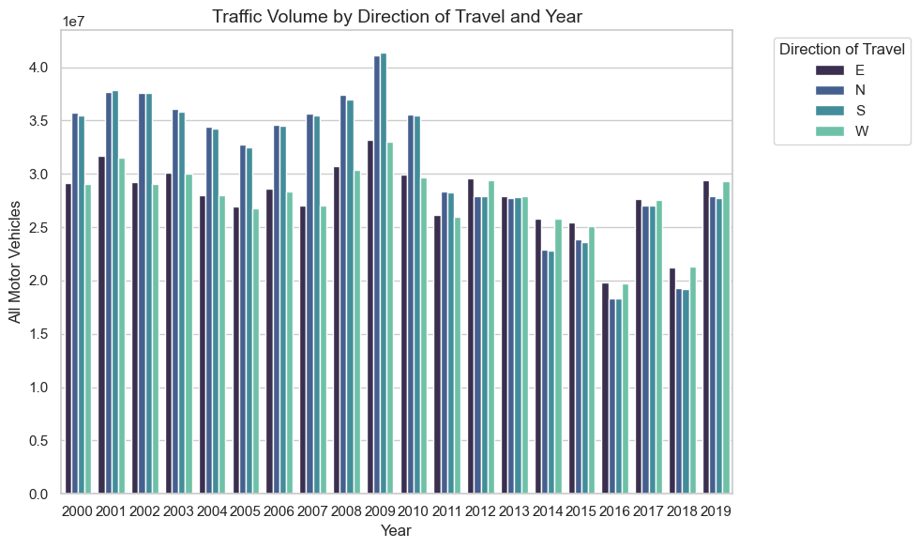

Figure (2): traffic volume by direction per year

A bar plot generate using the data in the columns ‘direction_of_travel’ , ‘all_motor_vehicles’, and ‘year’ is shown in figure(2). In figure(2) the distribution of the traffic travelled in the directions, represented by W(West), N(North),S(South) and E(East) were found. This plot helps in understanding, in which directions the vehicles travelled over the years. This insight can be used by policymakers for improving the roads in a particular direction(most travelled) so that good quality roads are found everywhere even in the direction that is most travelled. The yearly analysis was done to identify any trend that may be seen in different years.

The data in the columns ‘region_name' , ‘all_motor_vehicles’ and ‘year' were used to gain insights about the traffic counts in different regions in different years.

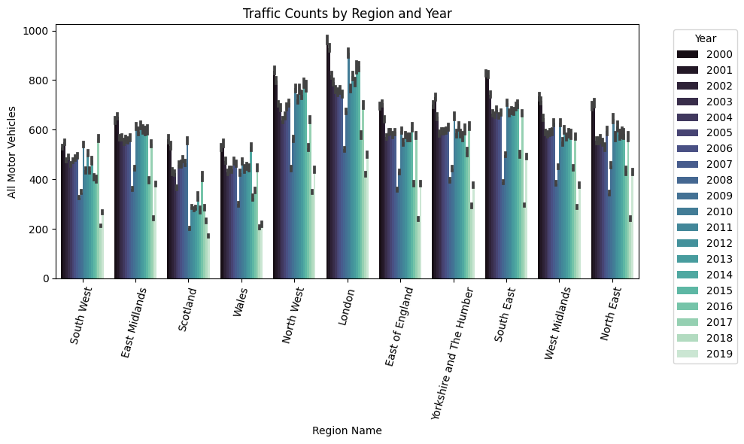

Figure (3): traffic count based on region and year

A plot created using the data in columns ‘region_name' , ‘all_motor_vehicles’ and ‘year' was shown in figure(3). In figure(3) the count for the different regions in different years were shown. From the plot, it can be seen that the highest counts of traffic was seen in London for different years, this insight from the plot was inline with the fact that London was the region with the most amount of traffic in the Great Britain(Inrix, 2024).

The analysis focused on the data from the ‘all_motor_vehicles’ and ‘year’ columns, as these variables are crucial for understanding the trends in motor vehicle usage over time. By examining these columns, insights were gained into how the number of vehicles on the road has changed across different years.

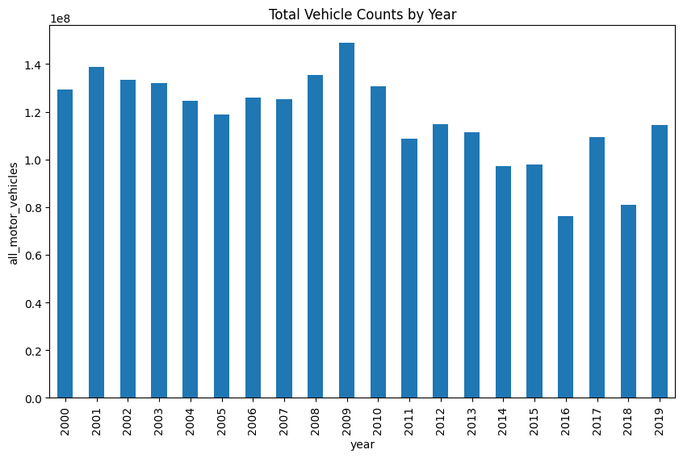

Figure (4): vehicle count over the years

Figure (4) presents a plot generated using the data from the ‘all_motor_vehicles’ and ‘year’ columns .From the figure it can be seen the least vehicle counts was seen in the year 2016 while the highest vehicle count was seen in the year 2009.

The data in the columns ‘year’, ‘region_name’ and ‘all_motor_vehicles’ were considered. The data in these columns were considered because the analysis of the data helped in understanding the yearly trends in traffic based on the different regions.

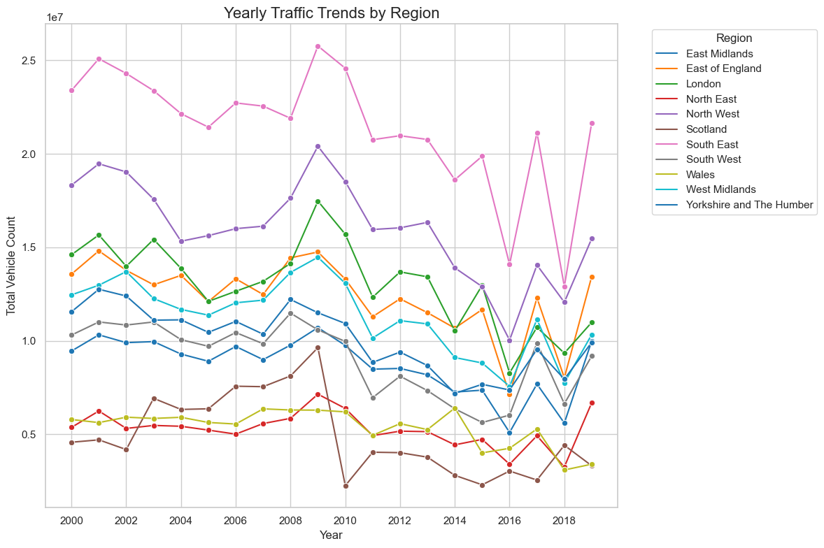

Figure (5): yearly traffic trends by region

Figure (5) displays a plot created using the data from the ‘year’, ‘region_name’, and ‘all_motor_vehicles’ columns. The plot shows that the South East and North West regions experienced the highest traffic volumes, with the greatest number of vehicles on the road. In contrast, regions such as Scotland and the North East recorded the lowest vehicle counts..

The data in the columns ‘hour’, ‘year’, and ‘all_motor_vehicles’ were considered. The data in these columns helped in understanding the hours at which the traffic peaked in different years.

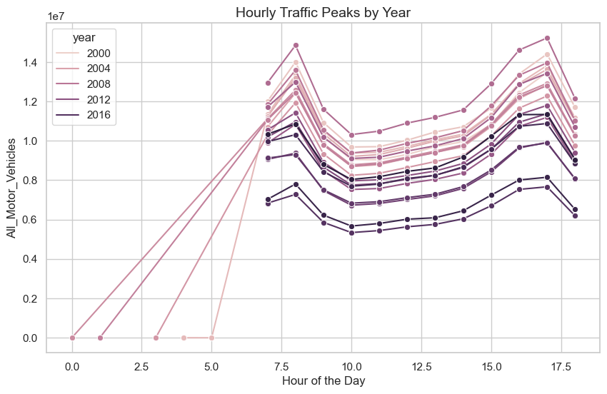

Figure (6): hourly peak in traffic in different years

A plot generated using the data in the columns ‘hour’, ‘year’, and ‘all_motor_vehicles’ is shown in figure(6). In figure(6) it can be seen that hours of the day were represented in the x-axis, with 0 representing, 12 AM and 17.5 representing , 5:30 PM. The different hours between 12 AM and 5:30 PM are shown along the x-axis. These hours were chosen because it contained the hours of the day that are likely to create a large amount of traffic. The hours included the time at which offices and schools start to the time at which people leave offices and schools. From the plot it can be seen that the number of vehicles or the traffic on the road increases greatly around and from 7.5, which represents 7:30 AM which is the time at which people start going to offices. The number of vehicles or the traffic on the road reduces after 5:30 PM because this is usually the time that people reach their homes after a day of work.

The data in the columns ‘road_type’ , ‘total_count’ and ‘average_count’ were analyzed. The data in these columns helped in understanding if the type of road impacted the traffic on the road. The average and total counts of vehicles were obtained from the columns ‘total_count’ and ‘average_count’.

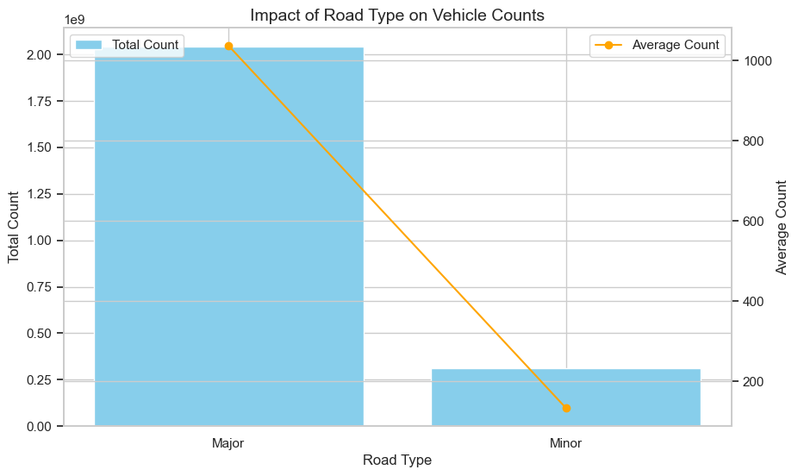

Figure (7): impact on vehicle count based on road type

Figure (7) illustrates a plot generated using the data from the columns ‘road_type’, ‘total_count’, and ‘average_count’. From the figure it can be seen that the two kinds of roads are represented along the x-axis and the count of vehicles are shown along the y-axis. From the plot it is evident that for the ‘major’(major roads) type the vehicle count was considerably higher than the vehicle counts seen for the type ‘Minor’(minor roads). This insight gained from the plot aligns with the fact that a large number of vehicles travel via the major roads while minor roads are less used by vehicles. The average counts of vehicles for the two kinds of roads were also shown in the plot and it was seen the average count of vehicles were also much greater for the major roads compared to minor roads.

The data in the columns 'total_pedal_cycles', 'total_two_wheeled_vehicles', 'total_cars_and_taxis', 'total_buses_and_coaches', 'total_lgvs', 'total_hgvs', and ‘road_type’ were analysed. The data in the columns 'total_pedal_cycles', 'total_two_wheeled_vehicles', 'total_cars_and_taxis', 'total_buses_and_coaches', 'total_lgvs', 'total_hgvs', helped in understanding the counts of the different kinds of vehicles, and ‘road_type’ gave the data about the type of road. This data helps in gaining insights about the impact on the counts of different kinds of vehicles based on the different road types.

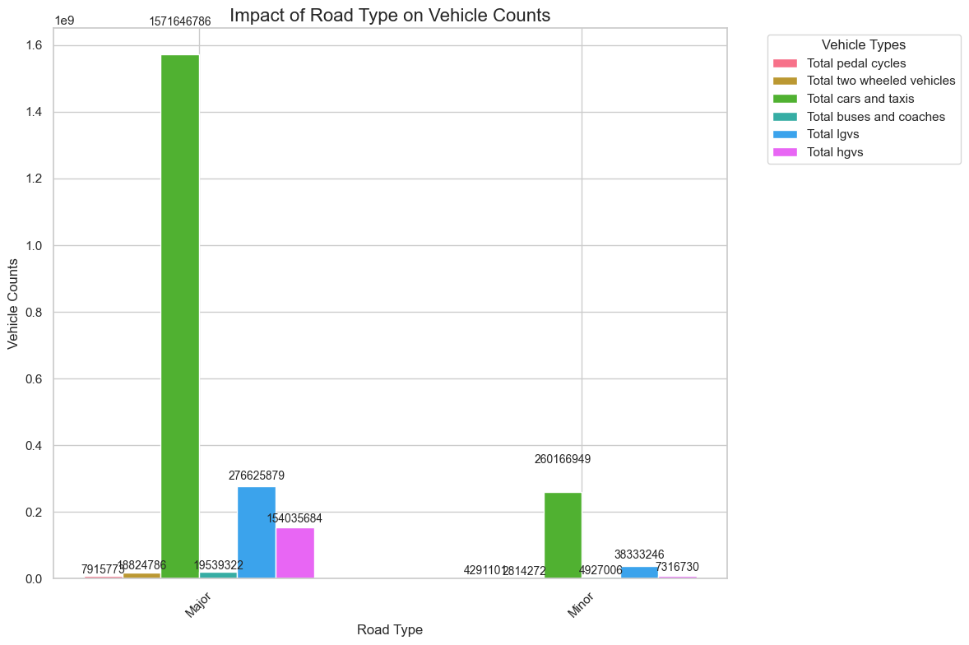

Figure (8): impact of type of roads on different kinds of vehicles

A plot generated using the data in the columns 'total_pedal_cycles', 'total_two_wheeled_vehicles', 'total_cars_and_taxis', 'total_buses_and_coaches', 'total_lgvs', 'total_hgvs', and ‘road_type’ is shown in figure(8). From figure(8) it is clear that the large vehicles like buses ,coaches and heavy goods vehicles were seen in large numbers in major roads while the heavy vehicles used minor roads sparsely. This observation aligns with the understanding that major roads are designed to accommodate a wide range of large vehicles, whereas minor roads are typically used by smaller vehicles.

The data in the column ‘all_motor_vehicles’ can be used along with the data in the column ‘region_name’ for finding the number of vehicles in a particular region in Great Britain. The insights gained from this analysis can be used to create plans that can be used to manage traffic. The plans can be made in a region-specific manner based on the insights gained from the analysis of the data.

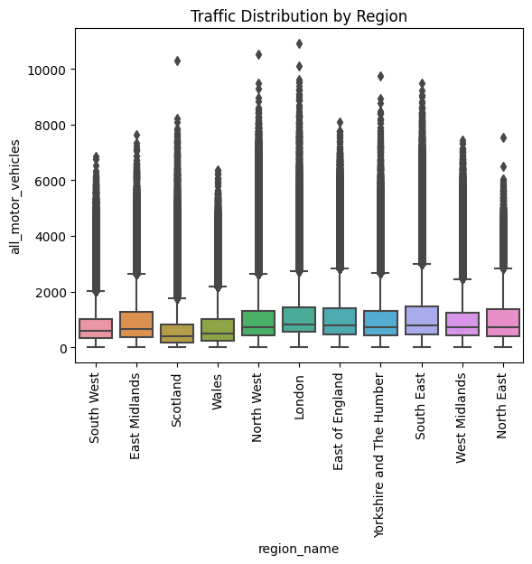

Figure (9): the count of vehicles based on different regions

In figure(9) the different region names are represented in the x-axis and the number of vehicles are represented in the y-axis. From the graph, it can be seen that regions like South East and London show the highest number of vehicle counts signifying that these regions may have frequent traffic blocks. The regions like Wales show vehicle counts that are lower. The insights gained from this analysis can be used to manage traffic based on the needs of specific regions in Great Britain.

The data in the columns that represent the count for different types of vehicles help in understanding the distribution of the different kinds of vehicles in Britain.

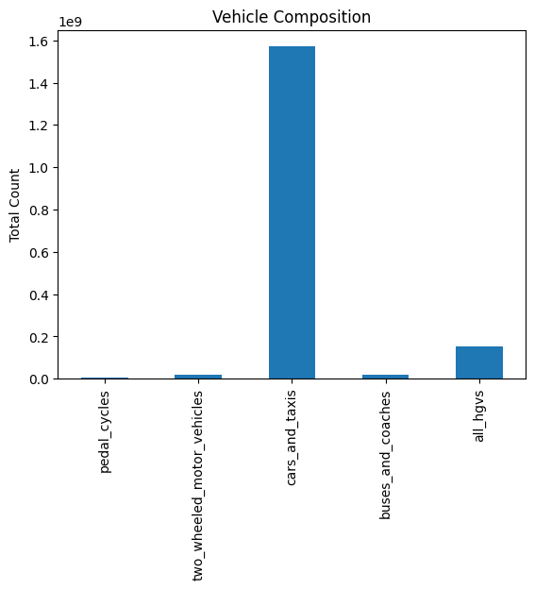

Figure (10): the distribution of the different kinds of vehicles

A heatmap showing the distribution of traffic in different regions in Great Britain was generated and it helps in getting an understanding of how the traffic was distributed in Great Britain(Appendix D).

## 4.5 Machine Learning models

In this study, three machine learning models were trained separately to predict vehicle counts for six different types of vehicles: cycles, two-wheeled motor vehicles, cars and taxis, buses and coaches, light goods vehicles, and heavy goods vehicles. For each vehicle type, three different models were developed, using Long Short-Term Memory (LSTM), Support Vector Machine (SVM), and Gated Recurrent Unit (GRU) algorithms.

The predicted vehicle count from each model was summed up to calculate the total number of vehicles. Specifically, LSTM was trained for all six vehicle categories, and the predicted counts for each category were added together to obtain the total vehicle count. The same process was followed for the GRU and SVM models, resulting in the total vehicle count for each of these two algorithms. In total, 18 models were built in this study, with three machine learning algorithms applied to the six vehicle types.

The data preprocessing step, which involved transforming the raw data into a format suitable for training machine learning and deep learning models, was performed only once. The pre-processed data was then used to train all 18 models.

**SVM Regressor(SVR)**

The SVR is an algorithm that utilises the supervised learning technique for regression and classification tasks. In regression, the prediction error is minimized within a particular margin. The difference between SVR and traditional regression models is that SVR finds a function that performs approximation on the data within the tolerance threshold, making the model robust against noise and outliers(Akhtar et al., 2024).

The SVR was chosen for this study because the traffic patterns are affected by a number of factors that are non-linear like road type, location and time of day, this means that the data had a non-linear relationship. The SVR is well-suited for capturing these non-linear relationships through its use of kernel functions(Tancara et al., 2023). Traffic data sets mix with continuous and categorical variables (e.g., traffic counts, time intervals, and vehicle types). SVM is also effective with standardized input features and can manage the high-dimensional spaces, making it a good fit for this study(Menon, 2009).

There are other machine learning models that can be trained to predict the vehicle count. However, the SVR was better than the machine learning models like Decision Trees(DT) and Random Forests(RF). Even if the DT and RF were able to capture relationships that are non-linear in the data they do not possess the flexibility of SVM while handling feature mapping that is high dimensional. The DTs are particularly prone to overfitting(Nakahara et al., 2023). The issue of overfitting is handled by the RF however the RF is computationally complex(Boulesteix et al., 2012). Another machine learning model similar to the SVR is the Linear regression(LR). LR can only capture linear relationships, and traffic data often contains complex non-linear patterns(Djaballah-Djeddour & Tazerouti, 2022). The SVR has the flexibility required to get these relationships. The LR is very sensitive to outliers, while the SVM Regressor has a margin of tolerance making it more resistant to outliers in the data(R. T. Ahmad & Ismaeel, 2023; Midi & Mohamed, 2020).

**LSTM**

Temporal patterns and dependencies are inherently shown by traffic data. For instance, the volume of traffic on the road can greatly vary by time of day, day of week, or season. LSTM’s architecture is specifically designed to learn such temporal dependencies(Mohanty, 2023). LSTMs take in sequences of observations while preserving relevant information from prior observations, which was a feature needed for the study carried out here(Mohanty, 2023).

The relationship between time, place, weather and road conditions that might affect traffic patterns is usually non-linear. LSTM models can effectively capture and learn very complex, non-linear relationships in the data thanks to the absence of manual features(Wu et al., 2020). This ability proved to be beneficial in this study as the traffic dataset contained intricate interdependencies. The gating mechanism of LSTM offers a finer control of memory retention(Chien et al., 2021). This proved important for modelling the complex behaviours in the traffic data such as repetitive rush-hour patterns and atypical traffic spikes triggered by events or accidents.

The LSTM was found to be better than models like LR. The LR assumes that a linear model can be used to model the data hence their applicability is limited for complex datasets such as traffic data. This is why LSTM was much more powerful since, unlike the LR, it was able to learn not only linear relationships but also non-linear ones. Regression models do not hold historical information hence regression models are not the best for forecasting the vehicle count. LSTM was better suited than the DT and RF for the study carried out here. Due to treating features as independent, DTs and RFs overlook the temporal dependencies that are often present in sequential data(Donick & Lera, 2021 ; Saha et al., 2020). This issue of the temporal dependencies being overlooked was solved by the LSTM sequential processing framework(Yilmaz & Büyüktahtakın, 2023). DTs tend to overfit, particularly with noisy data. RFs have approaches for dealing with long-term temporal patterns but are generally not as good at modelling these relationships as LSTM.

The LSTM was suited for this study compared to the Stacked LSTM or CNN-LSTM as these models were more complex compared to the vanilla LSTM used here. The dataset used in the study focused on single-target variables like the number of vehicles (two-wheelers, four-wheelers, etc.) over time. The vanilla LSTM was more well-suited for univariate time series problems, models with multivariate capabilities like Multivariate LSTM or Multivariate Multi-Step LSTM was not needed in the study(Rigopoulos, 2022). Models like ConvLSTM are more suitable for datasets containing spatiotemporal data which was not the case in the study(Lu et al., 2023). The Bidirectional LSTM processes sequences in both backward and forward directions, this would have created unwanted computational overhead without any significant value being added to the study, so it was not used here(Baxi & Bhatt, 2024).

**GRU**

The GRU was used in this study because traffic data is sequential by nature; hence, a model that can learn the temporal dependencies was needed. GRU, which is designed with a gating mechanism, is appropriate for this as it learns dependencies in both short term and long term(Bhaumik et al., 2022). Such capability was essential to understand traffic behaviour across the day, peak hours, and different from season to season. New time series detectors for events can see changes in data associated with traffic patterns based on time. These variations do not disturb GRU as it dynamically weights the contribution of previous information(Hussain et al., 2020).

GRU was more suited for this study than regression models like polynomial and linear regression models. Linear and polynomial regression models have a relationship that is pre-defined between features and outputs and may not accurately reflect the complex, non-linear dynamics inherent in traffic data(Cheng et al., 2018; Ma, 2021). GRU obtains these relations directly from the data with better predictive performance. Traditional regression models do not have the ability to add historical context during prediction. The recurrent structure of the GRU solves this issue by maintaining the information that is relevant from the steps that were done in the past.

DT and RF models are good at handling dependencies that are feature-based but are not able to model relationships that are sequential. The sequential data is processed inherently by the GRU making it apt for the study carried out here. RFs can reduce overfitting better than DTs but still have issues with data that is sequential in nature. Natural regularization is provided by GRU’s gating mechanism, mitigating risks associated with overfitting when learning patterns that are complex.

**Cycles**

The three models for predicting the number of cycles based on LSTM, GRU and SVM were built. The data was prepared for training the 18 models only once, that pre-processing step is defined here and it was the same for all the other models.

Label encoding was then performed. Label encoding was done for converting the categorical data in the dataset into numerical values. This was done because the training of the machine learning or deep learning models is most effective when numerical data is given as input to the model for training(Yang et al., 2022).

A correlation plot was then generated to identify the columns that were remaining in the dataset and had no major relevance or correlation with the other variables or columns. The correlation plot was generated(Figure(11)).

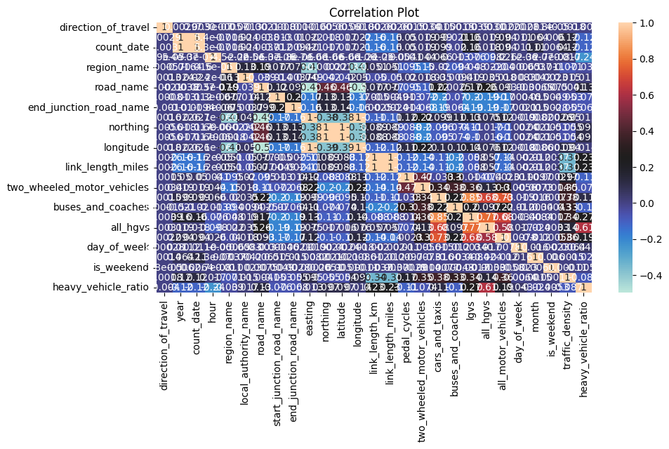

Figure (11): Correlation plot

Based on the correlation plot the columns or features that were strongly correlated to the target variable were found. As the number of cycles was being predicted now, the column ‘pedal_cycles’ was considered. The correlation between the column ‘pedal_cycles’ and the other remaining columns in the dataset was found. Based on the findings the columns with the least correlation with the ‘pedal_cycles’ column were removed from the loaded data.

The data that was remaining was separated into testing and training sets. The data in the training sets was used for training the machine learning models. The data was separated such that 20% of the data formed the testing dataset and 80% of the data formed the training dataset.

The data in the dataset was then scaled to make sure that the data in all the columns of the dataset were in comparable ranges, otherwise if the data associated with different features was in different numerical ranges, then during training the data associated with features whose values fall in lower numerical ranges are ignored by the machine learning models during training leading to the improper training of the model(Yuan & Xiao, 2019).

The data was then used for training the LSTM, SVM regression and GRU models. Firstly the SVM was trained.

|  |  |  |  |
| --- | --- | --- | --- |
| **Sl.No.** | **parameter** | **Description** | **Value given** |
| 1 | max_iter | The maximum number of iterations that will be run(LinearSVR, n.d.). | 5 |
| 2 | random_state | For training the same way in all iterations((LinearSVR, n.d.). | 42 |

Table (2): Parameters used for SVM Regression

From table(2), it can be seen that the maximum number of iterations that the SVM Regression model was run was 5, this was chosen because it was a relatively low value for the number of iterations and the number of iterations can be increased if that was needed, like for improving accuracy, however, 5 was enough for this study to carry out proper training. This meant that there was no time was wasted in training the SVM regression model as 5 was a relatively low value and that was apt for the study.

The training of the SVM Regression model is highly time-consuming and it takes several hours for training the model(Kalyanov, 2021). So for training the SVM Regression model, a parallelized approach was used, so that the training of the SVM Regression model was completed in a quick manner. The built function ‘MultiOutputRegressor’ was used for parallelly training the SVM Regression model.

|  |  |  |  |
| --- | --- | --- | --- |
| **Sl.No.** | **parameter** | **Description** | **Value given** |
| 1 | n_job | The number of jobs running in a parallel manner(MultiOutputRegressor, n.d.). | -1 |

Table (3): Parameters of MultipleOutputRgeressor

The parameter ‘n_job’ was given the value -1 to specify that all the processes and threads that were available were used for training the SVM Regression model(MultiOutputRegressor, n.d.)(Table(3)). The object of the SVM Regressor created was passed to the ‘MultiOutputRegressor’ and the SVM Regressor model was trained using the data in the training set.

The LSTM model was built using the sequential model in Keras and it is stack of layers arranged linearly(Aggarwal et al., 2021). The sequential model was used in the study because traffic prediction that is done in the study was a sequential model and since the data being used is sequential a model that processed inputs one step at a time was needed. The sequential model is straightforward making it apt for building the LSTM model(Kevinnjagi, 2023).

The layers in the Sequential model were the LSTM layer and the Dense layer. The parameters used for the LSTM layer are given in Table(4).

|  |  |  |  |
| --- | --- | --- | --- |
| **Sl.No.** | **parameter** | **Description** | **Value given** |
| 1 | units | dimensionality associated with the output space(Tf.keras.layers.LSTM | TensorFlow Core V2.3.0, n.d.). | 50 |
| 2 | activation | The activation function used(Tf.keras.layers.LSTM | TensorFlow Core V2.3.0, n.d.). | relu |

Table (4): Parameters of the LSTM

The data associated with traffic shows patterns that are affected by differing trends. The choice of setting 50 for the parameter ‘units’ ensures that the model has enough capability to learn patterns that are complex without overfitting occurring. The use of the ReLU activation function ensures that faster convergence happens and the possibility of vanishing gradient issues occurring during training was mitigated.

For the Dense layer the parameter seen in Table(4), ‘units’ was used and it was given the value 1, this value specifies that there was only a single output from this layer. As this was the output layer and the number of vehicles predicted is a single value only a single output was needed, so the value of ‘units’ was set as 1.

The LSTM model was then complied and for compiling the model, the optimizer function was set as ‘adam’, this ensured that the model converged quickly and effectively without parameter tuning occurring in an excessive manner. The loss function was set as ‘mse’ because it was apt for regression tasks.

The GRU model was also implemented as a Sequential model. Similar to the LSTM model the ‘units’ was set as 50 and the activation function was set as ‘relu’. The Dense layer was set similarly to the LSTM. The activation function and loss functions were also used similar to the LSTM. The GRU model was trained and saved.

The LSTM, GRU and SVM Regression models were trained to predict the number of people travelling in cycles.

**two-wheeled motor vehicles, cars and taxis, buses and coaches, light goods vehicles and heavy goods vehicles**

For each of the remaining kinds of vehicles, two-wheeled motor vehicles, cars and taxis, buses and coaches, light goods vehicles and heavy goods vehicles, models were built using the LSTM, GRU and SVM Regression models, so three models each based on the three machine learning models(LSTM, GRU and SVM Regression) were trained and saved for the different kinds of vehicles.

## 4.6 Performance Evaluation

The performance metrics that were chosen for evaluating the performances of the LSTM, GRU and SVM Regression models were Mean Squared Error(MSE), Root Mean Square Error (RMSE) and Mean absolute error (MAE). The lesser the values of these metrics the better the model performance.

**MSE**

MSE computes the average squared difference between actual and predicted values(Hubert et al., 2012). The MSE is sensitive to errors that are large and this makes it apt for regression tasks where reducing major deviations is important(Mean Square Error (MSE) | Machine Learning Glossary | EnCorD | EnCoRD, n.d.).

**RMSE**

RMSE is a significant metric for assessing the accuracy associated with regression models, specifically in situations where precision associated with prediction is highly important(SAP Help Portal, 2024). RMSE quantifies the average magnitude of the errors between observed and predicted values, with better model performance being represented by lower values.

**MAE**

MAE is found by computing the average absolute differences between actual and predicted values(Ahmed, 2023).

## 4.7 Testing

The web app built using the best performing machine learning models was tested using BlackBox testing. BlackBox testing involves the testing of the web app’s functionality without having knowledge of the code structure used internally in the web app(Špakova et al., 2019).

The web application mainly aims to deliver precise predictions in the backend and better user interfaces for them on front end. Black Box Testing can be used on an application by providing the inputs of the application as some sequence and looking for the outputs based on expected outputs. Black Box Testing does not need to have knowledge of how the application is structured inside or how the codebase handles I/O, which makes it very effective and simple for functionality (input/output) testing and error handling(Špakova et al., 2019).By concentrating on user scenarios, Black Box Testing ensures that the full feature set is tested including input validation, model integration and prediction accuracy.

Black Box testing was more suited for this study than White Box testing. White Box testing involved the testing of internal code paths and logic, this way of testing was not suited for this study as the primary focus of the study was functionality and not internal implementation(Gulzar et al., 2019). In the case of this study, Black Box testing was more suited than Grey Box Testing. Grey Box Testing is a mixture of Black and White Box testing methods(Sachtleben & Peleska, 2022). Several inputs were given into the web app and it was tested using Black Box testing methods.

Unit testing, integration testing and system testing were also done in the study to ensure that all the components of the web application were working properly.

# Chapter 5: Results

The results of the study ie., the details about the performance metrics of the machine learning models and the results of the testing of the web app is presented in this section.

## 5.1 Performance Metrics

The performance metrics for 18 different machine learning models were found out. The performance metrics for the models corresponding to the prediction of the different kinds of vehicles are given here.

**Cycles**

|  |  |  |  |
| --- | --- | --- | --- |
| **Machine learning model** | **MSE** | **RMSE** | **MAE** |
| SVM Regression | 188 | 13.71 | 2.89 |
| LSTM | 180.93 | 13.450955 | 3.73 |
| GRU | 181.04 | 13.478513 | 3.64 |

Table (5): performance metrics of the models for predicting the number of cycles

Based on the MSE, RMSE, and MAE values for the model predicting the number of cycles, it was observed that the LSTM model demonstrated the best performance, as it achieved the lowest MSE and RMSE values. However, the SVR model showed the best MAE value, as indicated in Table (5).

**Two wheeled motor vehicles**

|  |  |  |  |
| --- | --- | --- | --- |
| **Machine learning model** | **MSE** | **RMSE** | **MAE** |
| SVM Regression | 220.81 | 14.86 | 4.90 |
| LSTM | 200.12 | 14.146487 | 5.59 |
| GRU | 200.04 | 14.143452 | 5.72 |

Table (6): performance metrics of the models for predicting the number of two wheeled motor vehicles

From table(6) it can be seen that based on MSE and RMSE the best performance was shown by GRU but based on MAE the best performance was shown by the SVR.

**Cars and taxis**

|  |  |  |  |
| --- | --- | --- | --- |
| **Machine learning model** | **MSE** | **RMSE** | **MAE** |
| SVM Regression | 457075.85 | 676.07 | 361.44 |
| LSTM | 386718.42 | 621.866880 | 399.08 |
| GRU | 389730.43 | 624.283935 | 403.98 |

Table (7): performance metrics of the models for predicting the number of cars and taxis

As shown in Table (7), the SVR model exhibited the best performance based on MSE, while the LSTM model delivered the best performance according to RMSE. Additionally, the SVR model demonstrated the best performance in terms of MAE.

**Buses and Coaches**

|  |  |  |  |
| --- | --- | --- | --- |
| **Machine learning model** | **MSE** | **RMSE** | **MAE** |
| SVM Regression | 144.53 | 12.02 | 5.36 |
| LSTM | 120.75 | 10.988500 | 5.86 |
| GRU | 120.75 | 10.988575 | 5.90 |

Table (8): performance metrics of the models for predicting the number of buses and coaches

From table(8) it can be seen that based on MSE the best performance was shown by both the LSTM and GRU as both models achieved identical values. The best performance based on RMSE was shown by the LSTM. Based on the MAE the best performance was shown by the SVR.

**Light goods vehicles**

|  |  |  |  |
| --- | --- | --- | --- |
| **Machine learning model** | **MSE** | **RMSE** | **MAE** |
| SVM Regression | 16980.55 | 130.31 | 63.49 |
| LSTM | 14580.76 | 120.750798 | 73.45 |
| GRU | 14581.85 | 120.755317 | 71.70 |

Table (9): performance metrics of the models for predicting the number of light good vehicles

As shown in Table (9), the LSTM model achieved the best performance based on both MSE and RMSE, while the SVR model demonstrated the best performance in terms of MAE.

Heavy Goods Vehicles

|  |  |  |  |
| --- | --- | --- | --- |
| **Machine learning model** | **MSE** | **RMSE** | **MAE** |
| SVM Regression | 10430.51 | 102.13 | 41.26 |
| LSTM | 8560.39 | 92.522356 | 46.91 |
| GRU | 8558.95 | 92.514585 | 46.49 |

Table (10): performance metrics of the models for predicting the number of heavy good vehicles

As shown in Table (10), the GRU model delivered the best performance based on MSE, while the RMSE value of 92.514585 represented the best performance. Additionally, the SVR model achieved the best performance in terms of MAE.

## 5.2 Results of testing

**Black Box testing**

The results of Black Box testing are given in table(11).

|  |  |  |  |  |  |
| --- | --- | --- | --- | --- | --- |
| **Name of the test** | **Objective** | **Steps** | **Expected Outcome** | **Actual Outcome** | **Status** |
| User Authentication | Verify the functionality of the log in system and restrictions to access. | 1. Log in using valid credentials. 2. Log in using invalid credentials. 3. log in without entering any input. 4. Access protected pages without logging in. | * Redirects to index page. * An error message is displayed when invalid credentials are given as the input. * No input causes validation error. * Access to restricted pages via unauthenticated access redirects to login page. | Success- All scenarios produced the expected outcomes. | Pass |
| Input Form Functionality | Validating the input form for receiving data associated with traffic patterns and submission for prediction. | 1. Enter data that is valid and submit. 2. Enter data that is invalid and submit. 3. Submit by leaving one or more fields empty. 4. Submit the form with values that are extreme. | * Results page is displayed with predictions when valid data is given as input. * Empty or invalid input causes validation errors. * Extreme values are handled without any issues. | Success- All scenarios produced the expected outcomes. | Pass |
| Display results and predictions. | Making sure predictions are correctly displayed and show a summary of the total counts. | 1. Form submission with inputs that are valid. 2. Verify predictions shown on the results page. 3. Check the total summary of vehicle count for accuracy. 4. Test data persistence and the page for results. | * Predictions are accurate and the summary is produced correctly. * Form resubmission is caused when the page is refreshed. | Success- Total counts and results shown in an accurate manner. Data persisted on refreshing. | Pass |
| Navigation and Error Handling | Validating the navigation between pages and effective error handling for inputs that are unexpected or failures. | 1. Navigate from the results page to the index page using the browser back button. 2. Simulate the prediction errors of the model. 3. Test messages for errors for issues in both client-side and server-side. | * Form inputs are retained by back navigation. * The errors are handled properly. * Web app is stable even when unexpected outputs are encountered. | Success- Error handling and navigation work in the expected manner. | Pass |

Table (11): results of Blackbox testing

**Unit testing**

The results of Unit testing are given in table(12).

|  |  |  |  |  |
| --- | --- | --- | --- | --- |
| **Test cases** | **Inputs** | **Expected Outcome** | **Actual Outcome** | **Status** |
| Test success of login. | {username: 'admin', password: 'admin'} (POST to login_url) | Response status 200, response contains "Home" | Response status 200, "Home" not found in the response. | Fail |
| Test Home Page Authenticated | Session set with user: 'admin', GET request to home_url | Response status 200, response contains "admin". | Response status 200, "admin" not found in the response. | Fail |
| Test Login Failure | {username: 'wrong', password: 'wrong'} (POST to login_url) | Response status 200, response contains "Login Failed". | Response status 200, "Login Failed" found in the response. | Pass |
| Test Home Page Authenticated | Session set with user: 'admin', GET request to home_url | Response status 200, response contains "admin". | Response status 200, "admin" not found in the response. | Fail |
| Test inputs | Session set with user: 'admin', GET request to home_url and mocked methods | Response status 200, JSON contains {'status': 'success', 'vehicle_counts': ...}. | Response status 200, JSON contains {'status': 'success', 'vehicle_counts': ...}. | Pass |
| Test Result Page | Session with location, year, and vehicle counts data, GET to result_url | Response status 200, response contains location name, year, and total vehicle count. | Response status 200, response contains location name, year, and total vehicle count. | Pass |
| Test Logout | Session with user: 'admin', GET request to logout_url. | Response status 200, session no longer contains user. | Response status 200, session no longer contains user. | Pass |

Table (12): results of unit testing

**Integration and system testing**

The web app was built using Python Django. The web app has a login page. The web app has a prediction page which receives input values for location name, day of the week, year and month(Figure(12)). The LSTM and GRU models were used in the web app as these models showed the best performances for MSE and RMSE. The models that showed the best performances for predicting the different kinds of vehicles were used together in the web app. Based on the input values the models for predicting the count of Cycles, Two wheeled motor vehicles, Cars and taxis, Buses and Coaches, Light goods vehicles, and Heavy Goods Vehicles were loaded, and each of the models predicted an output. The count generated as output by the different models were summed and was shown as the output which was the total number of vehicles on the road(Figure(13)). The web app successfully carries out the prediction and the result is shown successfully in the web app.

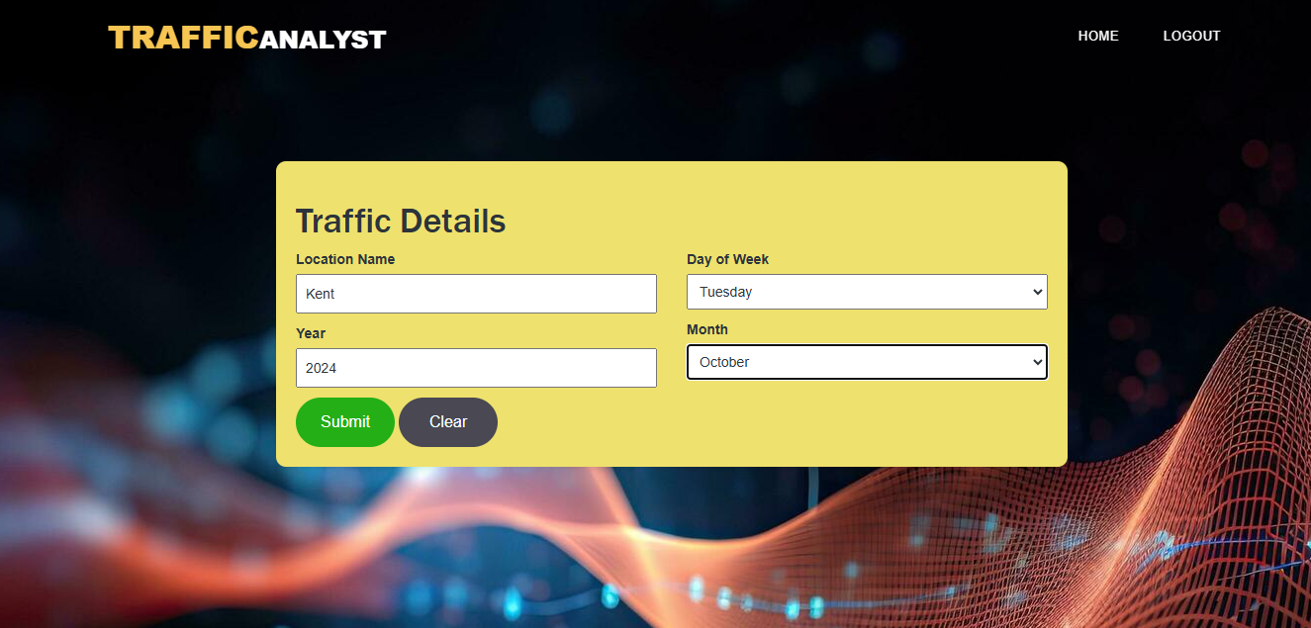

Figure (12): the input to the web app

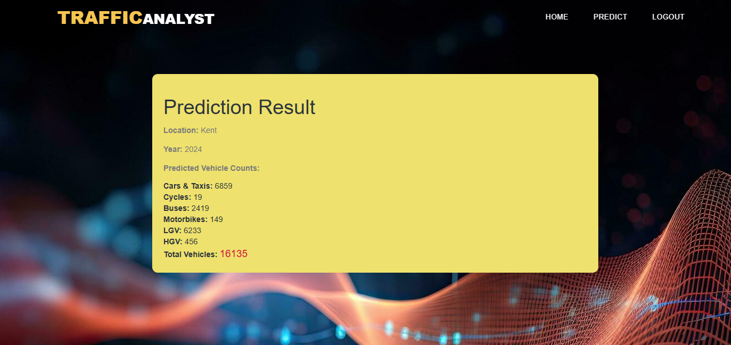

Figure (13): the result of prediction

# Chapter 6: Discussion and Evaluation

## 6.1 Discussion

The main aim of the study was achieved successfully and a model that predicted the count of vehicles based on factors like location, year, day of week and month was built. Machine learning models like LSTM, CNN and GRU were used for predicting the count associated with different kinds of vehicles. The data was pre-processed and EDA was performed successfully and visual plots were obtained. The LSTM, GRU and CNN models were trained successfully and the prediction performances of the models were evaluated by determining the values of performance metrics like RMSE, MSE and MAE. The LSTM and GRU models were used in the web app and the web app successfully predicted the vehicles count based on variables like location, year, day of week and month.

The results of the study carried out here supported the insights gained from the studies by Phapale & Shravagi(2024), Zhang(2023), Xu et al.(2024), (Essien et al., 2020) and Srinath(2023) as these studies showed that machine learning models can be used for the prediction of traffic , the results of the study carried out here showed that the machine learning models were able to successfully predict the count of vehicles ie., the traffic on the road based on factors like location, year, day of week and month. The results of the EDA also showed insights like the large vehicle count in London and that the type of road affected the number of vehicles on the road.

The research questions of the study were answered:

* How do traffic patterns differ in different regions in Great Britain over the years?

Based on the results of the EDA it was seen that over the years the traffic patterns in different regions of Great Britain change vastly. It was seen that the vehicle count in regions like London was way more in number than other regions in Great Britain.

* What is the impact of the type of road (e.g., minor vs. major highways) on the counts of vehicles?

From the results of the EDA it was seen that the type of road effects the counts of vehicles on the road. It was seen that more vehicles and large vehicles travel more on major roads compared to minor roads.

* What are the changes associated with the number of different kinds of vehicles(cars, buses etc.,) over the years?

From the results of the EDA it was seen that the number of vehicles was fluctuating over the years.

* How do the performances of the machine learning models compare with each other in forecasting future vehicle counts in different regions based on the historical trends in the regions?

The comparison of the performances of the machine learning models based on performance metrics like RMSE, MSE and MAE was done in tables(5) to (10). Based on the values of RMSE and MSE for machine learning models of the different kinds of vehicles the LTSM and GRU were the best models in the study.

* What kind of vehicles(cars, buses etc.,) make up the traffic in different regions and how does this affect the strategies for traffic management?

From the analysis of the data it was seen that regions with major roads had large vehicles and more number of vehicles while the regions with minor roads had less larger vehicles and the overall number of vehicles was comparatively less. So regions like cities that have major roads has large number of large vehicles while regions like the country side had lesser number of large vehicles. So for traffic management different strategies need to be formed for the different regions as the type of vehicles seen in different regions were different.

## 6.2 Evaluation

In the study the machine learning models were successfully implemented and the count of vehicles based on factors like location, year, day of week and month were predicted by the machine learning models. The training of the models was a time-consuming process however the models were trained successfully. Some difficulty was faced during the analysis of the data and gaining insights from the visual representations of the data was relatively hard, however the visual plots generated here were studied properly and insights were gained in a proper manner. The study carried out here can be useful for people in government as the policies that they may want to implement may be associated with the count of vehicles on the road. The policy makers can also learn how the type of road impacts the count of vehicles travelling on them. This study is a contribution on the analysis on the count of vehicles in Great Britain which has not been done in an extensive manner.

A dataset that has more features could have been used in the study as it would help in gaining more deeper insights about the factors that influence vehicle count and the trends associated with vehicle counts, this was a limitation of the study.

# 7 Conclusion and future enhancements

The aim of the study proposed here was to analyse the different trends associated with the road traffic in Great Britain over the years, and build machine learning models that predict the number of vehicles on the road based on factors like, location, year, day of week and month. This aim was achieved successfully. A dataset containing the traffic details of Great Britain was used in the study. EDA was performed on the data and visual plots of the data were generated. The visual plots generated helped in gaining insights associated with the traffic in different regions of Great Britain, like the count of vehicles over the years and how the type of road affects the vehicle count. Machine learning models like GRU, LSTM and SVM were used in the study. The machine learning models were trained using the data in the dataset. The performance metrics like , RMSE, MSE and MAE were determined for the trained machine learning models. Based on the values of the performance metrics it was seen that the best performance was shown by the LSTM and GRU models. A model each was built for predicting the numbers of different kinds of vehicles. The LSTM and GRU models were used for building a web app that predicted the number of vehicles on the road based on factors like, location, year, day of week and month. The count for the different types of vehicles were predicted separately and the sum of these counts were found to get the total count of vehicles. Python was used for implementing the machine learning models and the web app.

In the future a dataset that contains more number of features or variables can be used so that a more comprehensive analysis can be carried out. Machine learning models like hybrid models can be used in the future when more complex data that contains more number features are used in the study.

# References

Abid, F., Alam, M., Alamri, F. S., & Siddique, I. (2023). Multi-directional gated recurrent unit and convolutional neural network for load and energy forecasting: A novel hybridization. *AIMS Mathematics*, *8*(9), 19993–20017. <https://doi.org/10.3934/math.20231019>

Aggarwal, S., Bhatia, M., Madaan, R., & Pandey, H. M. (2021). Optimized Sequential model for Plant Recognition in Keras. *IOP Conference Series Materials Science and Engineering*, *1022*(1), 012118. https://doi.org/10.1088/1757-899x/1022/1/012118

Ahmad, M., Ali, M. A., Hasan, M. R., Mobo, F. D., & Rai, S. I. (2024). Geospatial machine learning and the power of Python programming. In *Advances in geospatial technologies book series* (pp. 223–253). https://doi.org/10.4018/979-8-3693-6381-2.ch010

Ahmad, R. T., & Ismaeel, S. S. (2023). A classification of outliers in transformed variables. *The Journal of the University of Duhok*, *26*(1), 12–21. https://doi.org/10.26682/sjuod.2022.26.1.2

Ahmed, M. W. (2023). Understanding mean Absolute error (MAE) in Regression: A Practical guide. *Medium*. <https://medium.com/@m.waqar.ahmed/understanding-mean-absolute-error-mae-in-regression-a-practical-guide-26e80ebb97df>

Akhtar, M., Tanveer, M., & Arshad, M. (2024). Enhancing Efficiency and Robustness in Support Vector Regression with  HawkEye Loss. *arXiv (Cornell University)*. https://doi.org/10.48550/arxiv.2401.16785

Alkahtani, M. (2022). Supply Chain Management Optimization and Prediction model based on projected stochastic gradient. *Sustainability*, *14*(6), 3486. <https://doi.org/10.3390/su14063486>

Baxi, J., & Bhatt, B. (2024). A bidirectional LSTM-based morphological analyzer for Gujarati. *Natural Language Processing.*, 1–17. https://doi.org/10.1017/nlp.2024.14

Bhaumik, K. K., Niloy, F. F., Mahmud, S., & Woo, S. (2022). STLGRU: Spatio-Temporal Lightweight Graph GRU for Traffic Flow Prediction. *arXiv (Cornell University)*. https://doi.org/10.48550/arxiv.2212.04548

Boulesteix, A., Janitza, S., Kruppa, J., & König, I. R. (2012). Overview of random forest methodology and practical guidance with emphasis on computational biology and bioinformatics. *Wiley Interdisciplinary Reviews Data Mining and Knowledge Discovery*, *2*(6), 493–507. https://doi.org/10.1002/widm.1072

Cabral, C., Curtis, K., Curcin, V., Domínguez, J., Prasad, V., Schilder, A., Turner, N., Wilkes, S., Taylor, J., Gallagher, S., Little, P., Delaney, B., Moore, M., Hay, A. D., & Horwood, J. (2021). Challenges to implementing electronic trial data collection in primary care: a qualitative study. *BMC Family Practice*, *22*(1). https://doi.org/10.1186/s12875-021-01498-6

Chai, W., Luo, Q., Lin, Z., Yan, J., Zhou, J., & Zhou, T. (2024). Spatiotemporal Dynamic Multi-Hop network for traffic flow forecasting. *Sustainability*, *16*(14), 5860. <https://doi.org/10.3390/su16145860>

Cheng, X., Khomtchouk, B., Matloff, N., & Mohanty, P. (2018,). *Polynomial regression as an alternative to neural nets*. arXiv.org. <https://arxiv.org/abs/1806.06850>

Chien, H. S., Turek, J. S., Beckage, N. M., Vo, V. A., Honey, C., & Willke, T. L. (2022). *Long Short-Term Memory with Slower Information Decay*. <https://doi.org/10.52591/2021072418>

Chien, H. S., Turek, J. S., Beckage, N., Vo, V. A., Honey, C. J., & Willke, T. L. (2021). *Slower is Better: Revisiting the Forgetting Mechanism in LSTM for Slower Information Decay*. arXiv.org. <https://arxiv.org/abs/2105.05944>

Conducting Quantitative Research Study: A Step-by-Step process. (2023). *Journal of Engineering Education/Journal of Engineering Education Transformations/Journal of Engineering Education Transformation*, *36*(4), 100–112. https://doi.org/10.16920/jeet/2023/v36i4/23120

Corchado, J. M., Larriba-Pey, J. L., Chamoso, P., & La Prieta Fernando, D. (2022). Advances in public Transport platform for the development of Sustainability Cities. In *MDPI eBooks*. <https://doi.org/10.3390/books978-3-0365-3979-9>

Cvetek, D., Muštra, M., Jelušić, N., & Tišljarić, L. (2021). A survey of Methods and Technologies for congestion estimation based on multisource data fusion. *Applied Sciences*, *11*(5), 2306. <https://doi.org/10.3390/app11052306>

Djaballah-Djeddour, K., & Tazerouti, M. (2022). Test for Linearity in Non-Parametric Regression Models. *Austrian Journal of Statistics*, *51*(1), 16–34. https://doi.org/10.17713/ajs.v51i1.1047

Donick, D., & Lera, S. C. (2021). Uncovering feature interdependencies in high-noise environments with stepwise lookahead decision forests. *Scientific Reports*, *11*(1). https://doi.org/10.1038/s41598-021-88571-3

Endahati, N. (2020). THE IMPLEMENTATION OF INDUCTIVE APPROACH IN PRE-INTERMEDIATE STRUCTURE SUBJECT TO ENGLISH EDUCATION STUDY PROGRAM STUDENTS PGRI UNIVERSITY OF YOGYAKARTA. *Journal of English Language Teaching and English Linguistics*, *4*(2). https://doi.org/10.31316/eltics.v4i2.520

Essien, A., Petrounias, I., Sampaio, P., & Sampaio, S. (2020b). A deep-learning model for urban traffic flow prediction with traffic events mined from twitter. *World Wide Web*, *24*(4), 1345–1368. <https://doi.org/10.1007/s11280-020-00800-3>

Fesalbon, D. (2024). Forecasting ferry passenger flow using Long-Short Term Memory neural networks. *arXiv (Cornell University)*. <https://doi.org/10.48550/arxiv.2405.02098>

Foster, C. (2023). Methodological pragmatism in educational research: from qualitative-quantitative to exploratory-confirmatory distinctions. *International Journal of Research & Method in Education*, *47*(1), 4–19. https://doi.org/10.1080/1743727x.2023.2210063

Gatarić, D., Ruškić, N., Aleksić, B., Đurić, T., Pezo, L., Lončar, B., & Pezo, M. (2023). Predicting Road Traffic Accidents—Artificial Neural Network Approach. *Algorithms*, *16*(5), 257. <https://doi.org/10.3390/a16050257>

Golovnin, O. (2019). *Data-driven profiling of traffic flow with varying road conditions*. <https://doi.org/10.18287/1613-0073-2019-2416-149-157>

Gulzar, M. A., Mardani, S., Musuvathi, M., & Kim, M. (2019). *White-box testing of big data analytics with complex user-defined functions*. https://doi.org/10.1145/3338906.3338953

Hanna, E., & Comín, F. A. (2021). Urban Green Infrastructure and Sustainable Development: a review. *Sustainability*, *13*(20), 11498. <https://doi.org/10.3390/su132011498>

Hayashi, T., Shimizu, T., & Fukami, Y. (2021, July 26). *Collaborative problem solving on a data platform Kaggle*. arXiv.org. <https://arxiv.org/abs/2107.11929>

Hoiruddin, M., & Ulfa, S. M. (2020). Inductive approach used in teaching speaking skill: a content analysis. *Linguista Jurnal Ilmiah Bahasa Sastra Dan Pembelajarannya*, *4*(2), 105. https://doi.org/10.25273/linguista.v4i2.7993

Hubert, M., Gijbels, I., & Vanpaemel, D. (2012). Reducing the mean squared error of quantile-based estimators by smoothing. *Test*, *22*(3), 448–465. https://doi.org/10.1007/s11749-012-0293-3

Hussain, Y., Huang, Z., Zhou, Y., & Wang, S. (2020). CodeGRU: Context-aware deep learning with gated recurrent unit for source code modeling. *Information and Software Technology*, *125*, 106309. https://doi.org/10.1016/j.infsof.2020.106309

Inrix. (2024). *INRIX 2023 Global Traffic Scorecard: London most congested city in Europe; congestion costing the UK £7.5 billion. - INRIX*. Inrix. <https://inrix.com/press-releases/2023-global-traffic-scorecard-uk/#:~:text=Due%20to%20the%20concentration%20of,63%20hours%20sitting%20in%20traffic>.

Isah, A., Shin, H., Oh, S., Oh, S., Aliyu, I., Um, T., & Kim, J. (2023). Digital Twins Temporal Dependencies-Based On Time Series using Multivariate Long Short-Term Memory. *Electronics*, *12*(19), 4187. <https://doi.org/10.3390/electronics12194187>

Jäger-Klein, C., Kodzoman, E., & Stampfer, L. (2023). SECONDARY DATA COLLECTION AND HERITAGE DOCUMENTATION - CASE STUDY OF a REMOTE DOCUMENTATION OF TRAVNIK’S VAROŠKA MOSQUE. *the International Archives of the Photogrammetry, Remote Sensing and Spatial Information Sciences/International Archives of the Photogrammetry, Remote Sensing and Spatial Information Sciences*, *XLVIII-M-2–2023*, 751–757. https://doi.org/10.5194/isprs-archives-xlviii-m-2-2023-751-2023

Kalyanov, D. (2021). From hours to minutes: 600x faster SVM - Intel Analytics Software - Medium. *Medium*. <https://medium.com/intel-analytics-software/from-hours-to-minutes-600x-faster-svm-647f904c31ae#:~:text=SVM%20has%20many%20advantages%2C%20but,can%20take%20a%20long%20time>. [ Accessed on : Dec 5 2024]

Kevinnjagi. (2023). Sequential & Functional APIs for neural networks - Kevinnjagi - Medium. *Medium*. https://medium.com/@kevinnjagi83/sequential-functional-apis-for-neural-networks-b76e37af0fc3#:~:text=The%20Sequential%20API%20is%20a,is%20the%20feature%20extraction%20part.

Kumar, N. M., & Nandal, N. D. R. (2024). Python’s Role in Accelerating Web Application Development with Django. *Deleted Journal*, *2*(06), 2092–2105. https://doi.org/10.47392/irjaem.2024.0307

Lahiri, S. (2023). A Qualitative Research Approach is an Inevitable Part of Research Methodology : An Overview. *International Journal for Multidisciplinary Research*, *5*(3). https://doi.org/10.36948/ijfmr.2023.v05i03.3178

Levterov, A., & Kozachok, L. (2022). Analysis and modeling of developing passenger traffic on public transport routes of urban transport systems. *Bulletin of Kharkov National Automobile and Highway University*, *98*, 19. <https://doi.org/10.30977/bul.2219-5548.2022.98.0.19>

Li, S. (2024). *Real-Time Traffic Congestion Detection Technology in Intelligent Transportation Systems* (pp. 1029–1033). <https://doi.org/10.1109/csnt60213.2024.10546078>

Li, Y., Zhao, Q., & Wang, M. (2022c). ANALYSIS THE INFLUENCING FACTORS OF URBAN TRAFFIC FLOWS BY USING NEW AND EMERGING URBAN BIG DATA AND DEEP LEARNING. *the International Archives of the Photogrammetry, Remote Sensing and Spatial Information Sciences/International Archives of the Photogrammetry, Remote Sensing and Spatial Information Sciences*, *XLIII-B4-2022*, 537–543. <https://doi.org/10.5194/isprs-archives-xliii-b4-2022-537-2022>

*LinearSVR*. (n.d.). Scikit-learn. [https://scikit-learn.org/1.5/modules/generated/sklearn.svm.LinearSVR.html[Accessed](https://scikit-learn.org/1.5/modules/generated/sklearn.svm.LinearSVR.html%5bAccessed) on : Dec 5 2024]

Liu, Z., Li, Y., Wei, M., Wan, G., Lau, M. S. Y., & Jin, W. (2024). EpiLearn: a Python library for machine learning in epidemic modeling. *arXiv (Cornell University)*. https://doi.org/10.48550/arxiv.2406.06016

Lu, M., Li, Y., Yu, M., Zhang, Q., Zhang, Y., Liu, B., & Wang, M. (2023). Spatiotemporal prediction of radar echoes based on CONVLSTM and multisource data. *Remote Sensing*, *15*(5), 1279. https://doi.org/10.3390/rs15051279

Ma, S. (2021). Principal Component Analysis in Linear Regression Survival Model with Microarray Data. *Journal of Data Science*, *5*(2), 183–198. https://doi.org/10.6339/jds.2007.05(2).326

Mallahi, I. E., Riffi, J., Mahraz, M. A., & Tairi, H. (2023). Severity of road accident classification using Machine Learning Models. *Research Square (Research Square)*. <https://doi.org/10.21203/rs.3.rs-3128674/v1>

Mazhar, S. A. (2021). Methods of data collection: a fundamental tool of research. *JOURNAL OF INTEGRATED COMMUNITY HEALTH*, *10*(01), 6–10. https://doi.org/10.24321/2319.9113.202101

*Mean Square Error (MSE) | Machine Learning Glossary | EnCorD | EnCoRD*. (n.d.). https://encord.com/glossary/mean-square-error-mse/#:~:text=The%20MSE%20measures%20the%20average,making%20it%20sensitive%20to%20outliers.

Menon, A. K. (2009). *Large-Scale Support Vector Machines: Algorithms and theory*. <https://users.cecs.anu.edu.au/~akmenon/papers/research-exam/research-exam-paper.pdf>

Midi, H., & Mohamed, J. (2020). A modified robust support vector regression approach for data containing high leverage points and outliers in the Y-direction. *Mathematics and Statistics*, *8*(5), 493–505. https://doi.org/10.13189/ms.2020.080502

Mohanty, S. (2023). An International Study of Application of Long Short-Term Memory (LSTM) Neural Networks for the prediction of stock and forex markets. *International Journal for Multidisciplinary Research*, *5*(3). https://doi.org/10.36948/ijfmr.2023.v05i03.3345

*MultiOutputRegressor*. (n.d.). Scikit-learn. <https://scikit-learn.org/dev/modules/generated/sklearn.multioutput.MultiOutputRegressor.html> [ Accessed on : Dec 5 2024]

Nakahara, Y., Saito, S., Ichijo, N., Kazama, K., & Matsushima, T. (2023). Prediction algorithms achieving Bayesian decision theoretical optimality based on decision trees as data observation processes. *arXiv (Cornell University)*. https://doi.org/10.48550/arxiv.2306.07060

Neves, F., Finamore, A. C., Madeira, S. C., & Henriques, R. (2021). Mining actionable patterns of road mobility from heterogeneous traffic data using biclustering. *IEEE Transactions on Intelligent Transportation Systems*, *23*(7), 6430–6445. <https://doi.org/10.1109/tits.2021.3057240>

Nickayin, S. S., Nosova, B., Turco, R., Giacalone, M., & Salvati, L. (2022). Demographic Change and the Urban–Rural Divide: Understanding the role of density and agglomeration in fertility transitions. *Land*, *11*(11), 1988. <https://doi.org/10.3390/land11111988>

Palanivinayagam, A., & Damaševičius, R. (2023). Effective handling of missing values in datasets for classification using machine learning methods. *Information*, *14*(2), 92. <https://doi.org/10.3390/info14020092>

Parishwad, O., Jiang, S., & Gao, K. (2023). Investigating machine learning for simulating urban transport patterns: A comparison with traditional macro-models. *Multimodal Transportation*, *2*(3), 100085. <https://doi.org/10.1016/j.multra.2023.100085>

Pazdriy, I. (2023). COMPARATIVE ANALYSIS OF SOFTWARE DEVELOPMENT SYSTEMS BASED ON FRAMEWORKS. *Herald of Khmelnytskyi National University Technical Sciences*, *317*(1), 155–161. https://doi.org/10.31891/2307-5732-2023-317-1-155-161

Pegin, P., Nemchinov, D., & Il’in, A. (2023). Conceptual Foundations of Projection Methodology for Road Transport System. *Proceedings of Petersburg Transport University*, *20*(1), 239–251. <https://doi.org/10.20295/1815-588x-2023-1-239-251>

Petković, D. (2016). Support of temporal data in database systems. *International Journal of Computer Applications*, *152*(4), 26–33. https://doi.org/10.5120/ijca2016911786

Phapale & Shravagi(2024), Zhang(2023), Xu et al.(2024), (Essien et al., 2020) and Srinath(2023). It was seen that the traffic flow can be predicted using machine learning models. However, none of these studies predicted the number of vehicles on the road based on variables like the kind of road, or region in Great Britain.

Phapale, N. A., & Shravagi, N. S. (2024). Traffic Flow Prediction on Road using Machine Learning. *International Journal of Applied and Advanced Multidisciplinary Research*, *2*(1), 31–38. <https://doi.org/10.59890/ijaamr.v2i1.690>

Prakash, M. R. U. (2023). Designing a better Support Vector Machines Classification Model for Multi-Class Category. *International Journal of Science and Research (IJSR)*, *12*(2), 905–909. <https://doi.org/10.21275/sr22517170244>

Qaiser, T., Altamimi, A. B., Khan, F. A., Alsaffar, M., Alreshidi, A., Khattak, K. S., Khan, Z. H., & Khan, W. (2023). A new macroscopic traffic flow characterization incorporating traffic emissions. *Applied Sciences*, *13*(9), 5545. <https://doi.org/10.3390/app13095545>

Qi, C., Ren, J., & Su, J. (2023). GRU Neural Network based on CEEMDAN–Wavelet for stock price prediction. *Applied Sciences*, *13*(12), 7104. <https://doi.org/10.3390/app13127104>

Rani, B. U., Sulthana, S. S., Kumar, P. K., & Bhavana, P. (2023). *Gridlock Prediction using a Gated Recurrent Neural Network for Smart Transport Systems*. <https://doi.org/10.1109/iccmc56507.2023.10084275>

Ranjbar, M. (2021). *Pragmatism As A Research Paradigm In The Social Study Of Children*. https://doi.org/10.32920/ryerson.14663718.v1

Rigopoulos, G. (2022). A long short-term memory algorithm-based approach for univariate time series forecasting with application to GDP forecasting. *International Journal of Financial Management and Economics*, *5*(2), 22–29. https://doi.org/10.33545/26179210.2022.v5.i2.139

*Road traffic statistics - Summary statistics*. (2024). <https://roadtraffic.dft.gov.uk/summary>

*Road Trafic Dataset*. (2021, February 9). Kaggle. https://www.kaggle.com/datasets/arashnic/road-trafic-dataset

Sachtleben, R., & Peleska, J. (2022). Effective grey‐box testing with partial FSM models. *Software Testing Verification and Reliability*, *32*(2). https://doi.org/10.1002/stvr.1806

Saha, A., Basu, S., & Datta, A. (2020, July 30). *Random Forests for dependent data*. arXiv.org. https://arxiv.org/abs/2007.15421

*SAP Help Portal*. (2024). <https://help.sap.com/docs/SAP_PREDICTIVE_ANALYTICS/41d1a6d4e7574e32b815f1cc87c00f42/5e5198fd4afe4ae5b48fefe0d3161810.html>

Schonlau, M., & Zou, R. Y. (2020). The random forest algorithm for statistical learning. *The Stata Journal Promoting Communications on Statistics and Stata*, *20*(1), 3–29. <https://doi.org/10.1177/1536867x20909688>

Shahraki, A., Abbasi, M., Taherkordi, A., & Jurcut, A. D. (2022). A comparative study on online machine learning techniques for network traffic streams analysis. *Computer Networks*, *207*, 108836. <https://doi.org/10.1016/j.comnet.2022.108836>

Špakova, A., Uhanova, M.(2019). AN OVERVIEW AND EVALUATION OF BLACK-BOX TESTING METHODS FOR SYSTEM TESTING [Journal-article]. *Riga Technical University (RTU)*, 225–226. https://web.archive.org/web/20200306091001id_/http://www.iadisportal.org/components/com_booklibrary/ebooks/201907C030.pdf

Srinath, M. (2023). Vehicular Traffic Flow Prediction Model Deep learning. *International Journal for Research in Applied Science and Engineering Technology*, *11*(7), 109–112. <https://doi.org/10.22214/ijraset.2023.54576>

Steurer, M., Hill, R. J., & Pfeifer, N. (2021). Metrics for evaluating the performance of machine learning based automated valuation models. *Journal of Property Research*, *38*(2), 99–129. https://doi.org/10.1080/09599916.2020.1858937

Sun, C., & Lu, J. (2022). The Relative Roles of socioeconomic factors and governance Policies in urban traffic congestion: A Global perspective. *Land*, *11*(10), 1616. <https://doi.org/10.3390/land11101616>

Švadlenka, M., & Chrpa, L. (2023). Towards a framework for intelligent urban traffic routing. *Proceedings of the . . . International Florida Artificial Intelligence Research Society Conference*, *36*. <https://doi.org/10.32473/flairs.36.133321>

Tancara, D., Dinani, H. T., Norambuena, A., Fanchini, F. F., & Coto, R. (2023). Kernel-based quantum regressor models learning non-Markovianity. *Physical Review. A/Physical Review, A*, *107*(2). <https://doi.org/10.1103/physreva.107.022402>

*tf.keras.layers.LSTM | TensorFlow Core v2.3.0*. (n.d.). TensorFlow. https://www.tensorflow.org/api_docs/python/tf/keras/layers/LSTM[ Accessed on : Dec 5 2024]

Velástegui, P. G. (2016). Beyond positivism: fuzzy set qualitative comparative analysis and pragmatist research. *Revistapuce*. https://doi.org/10.26807/revpuce.v0i103.50

Verbeek, M. (2017). Using linear regression to establish empirical relationships. *IZA World of Labor*. <https://doi.org/10.15185/izawol.336>

Wang, H., & Zhang, B. (2023). *Research on ARIMA Model for Short-Term Traffic Flow Prediction based on Time Series* (pp. 92–95). https://doi.org/10.1109/iciibms60103.2023.10347816

Wen, Z., Zhang, R., Ramamohanarao, K., & Yang, L. (2017). Scalable and fast SVM regression using modern hardware. *World Wide Web*, *21*(2), 261–287. <https://doi.org/10.1007/s11280-017-0445-1>

Wu, Z., Rincon, D., Luo, J., & Christofides, P. (2020). Machine learning modeling and predictive control of nonlinear processes using noisy data. *Authorea (Authorea)*. https://doi.org/10.22541/au.159846144.45151126

Xiong, H., Shen, G., Lan, X., Yuan, H., & Kong, X. (2023). HIT-GCN: Spatial-Temporal Graph Convolutional Network Embedded with Heterogeneous Information of Road Network for Traffic Forecasting. *Electronics*, *12*(6), 1306. <https://doi.org/10.3390/electronics12061306>

Xiong, W. (2024). A time-series model of GRUs based on attention mechanism for short-term load forecasting. *IEEE Access*, 1. <https://doi.org/10.1109/access.2024.3443876>

Xu, Z., Yuan, J., Yu, L., Wang, G., & Zhu, M. (2024). Machine Learning-Based traffic flow prediction and intelligent traffic management. *International Journal of Computer Science and Information Technology*, *2*(1), 18–27. <https://doi.org/10.62051/ijcsit.v2n1.03>

Yang, J., Li, J., Wei, L., Gao, L., & Mao, F. (2022). Spatiotemporal DeepWalk Gated Recurrent Neural Network: a deep learning framework for traffic learning and forecasting. *Journal of Advanced Transportation*, *2022*, 1–11. <https://doi.org/10.1155/2022/4260244>

Yang, L., Li, J., Dong, R., Zhang, Y., & Smyth, B. (2022). NUMHTML: Numeric-Oriented Hierarchical Transformer Model for Multi-Task Financial Forecasting. *Proceedings of the AAAI Conference on Artificial Intelligence*, *36*(10), 11604–11612. https://doi.org/10.1609/aaai.v36i10.21414

Yilmaz, D., & Büyüktahtakın, İ. E. (2023). Learning optimal solutions via an LSTM-Optimization framework. *Operations Research Forum*, *4*(2). https://doi.org/10.1007/s43069-023-00224-5

Yuan, Q., & Xiao, N. (2019). Scaling-Based weight normalization for deep neural networks. *IEEE Access*, *7*, 7286–7295. https://doi.org/10.1109/access.2018.2890373

Zeng, C., Zhao, Z., Wen, C., Yang, J., & Lv, T. (2020). Effect of complex road networks on intensive land use in China’s Beijing-Tianjin-Hebei urban agglomeration. *Land*, *9*(12), 532. <https://doi.org/10.3390/land9120532>

Zhang, X. (2023). Traffic flow prediction based on explainable machine learning. *Highlights in Science Engineering and Technology*, *56*, 56–64. <https://doi.org/10.54097/hset.v56i.9816>

# APPENDICES

## Appendix A – Research Project plan and Project Schedule

**Task 2: Research proposal**

**Understanding Traffic Patterns in Great Britain Using Machine Learning Models**

Student name: Arya Shibu

Student ID: 33070752

Contents

INTRODUCTION 4

BACKGROUND AND RATIONALE 5

RESEARCH QUESTIONS 5

AIMS AND OBJECTIVES 5

LITERATURE REVIEW 5

Traffic Patterns and Vehicle Counts: An Overview 5

Importance of Traffic Analysis 5

Challenges in Traffic Prediction 5

Existing Models for Traffic Analysis 6

Rationale for Using LSTM, GRU, and SVM 8

Related Work 9

Research Gap 12

RESEARCH DESIGN AND METHODOLOGY 13

Methodology: 13

Tools and Frameworks: 14

Deliverables 14

Expected Outcomes 14

ETHICS, RISKS, AND ISSUES 15

Timeline and project plan 16

CONCLUSION 17

Reference 17

# INTRODUCTION

Effective traffic management is a cornerstone of modern urban development, influencing economic productivity, environmental sustainability, and the overall quality of life. As urban areas in Great Britain experience increasing vehicular demands, understanding and predicting traffic patterns become vital for informed decision-making. Traffic congestion not only disrupts daily commutes but also contributes to higher emissions, fuel consumption, and economic inefficiencies. Addressing these issues requires innovative solutions that leverage cutting-edge technology and data-driven insights.

This study employs advanced machine learning models to analyze historical traffic data, identify trends, and provide accurate predictions of vehicle counts. By examining factors such as road types, regional variations, and temporal patterns, this research aims to develop tools that aid in traffic management and urban planning. The outcomes will not only assist policymakers and transportation authorities but also contribute to creating safer, more efficient, and sustainable road networks for all users. The integration of predictive tools into planning frameworks can lead to smarter infrastructure development and a significant reduction in traffic-related challenges.

# BACKGROUND AND RATIONALE

Traffic management is a critical component of urban planning, economic development, and environmental conservation. Great Britain faces significant challenges in traffic management due to its complex road networks, diverse regional demographics, and increasing vehicular demands. Predicting traffic patterns and understanding vehicle distributions across regions can help policymakers optimize resource allocation, improve safety, and enhance transportation efficiency.

The reliance on traditional methods of traffic analysis often falls short when dealing with the dynamic and nonlinear nature of modern transportation systems. In contrast, machine learning (ML) models, particularly Long Short-Term Memory (LSTM), Gated Recurrent Unit (GRU), and Support Vector Machine (SVM), have shown great promise in traffic analysis by addressing nonlinear dependencies and temporal patterns. These models enable the extraction of meaningful insights from large datasets, facilitating accurate forecasting and effective decision-making.

Despite numerous studies, a significant gap remains in region-specific and road-type-based traffic predictions in Great Britain. This study seeks to address this gap by leveraging ML models to analyze and forecast vehicle counts using a robust dataset. By incorporating advanced computational techniques, this research aims to provide actionable insights that align with the evolving needs of urban and regional planners.

# RESEARCH QUESTIONS

* How do traffic patterns differ in different regions in Great Britain over the years?
* What is the impact of the type of road (e.g., minor vs. major highways) on the counts of vehicles?
* What are the changes associated with the number of different kinds of vehicles(cars, buses etc.,) over the years?
* How do the performances of the machine learning models compare with each other in forecasting future vehicle counts in different regions based on the historical trends in the regions?
* What kind of vehicles(cars, buses etc.,) make up the traffic in different regions and how does this affect the strategies for traffic management?

# AIMS AND OBJECTIVES

**Aim:** To develop ML-based models for predicting vehicle counts and provide insights into traffic patterns across Great Britain.

**Objectives:**

1. Obtain the data in pre-processed form.
2. Generate visual representations of the patterns in the data.
3. Obtain trained machine learning models that predict the number of different kinds of vehicles.
4. Test the performance of the models.
5. Obtain a web app that predicts the count of vehicles based on like, location, year, day of week and month.

# LITERATURE REVIEW

This section contains the details associated with the background of the methods used in the study and the existing literature associated with the study performed here.

## Traffic Patterns and Vehicle Counts: An Overview

The count of the vehicles on roads and their traffic patterns are basic for tackling problems in urban planning, infrastructure development, traffic management, etc. Traffic has a direct correlation with economic activity, the environment and living quality in urban areas. Since Great Britain is a country where road transport makes up a huge part of daily transport, the analysis and prediction of traffic have been popular topics for optimal resource allocation and safety improvement.

## Importance of Traffic Analysis

Analysing traffic patterns, such as the types of vehicles, roads, timing in the day and region. These analyses give valuable information about urban mobility that helps decision-makers and urban planners in managing traffic congestion. Urban planners have the ability to anticipate congestion hotspots, develop mitigation strategies for future gridlocks, and optimize the transportation infrastructure based on predicted vehicle type distributions and traffic state patterns (Švadlenka & Chrpa, 2023).

Proper analysis of traffic data is central to reducing the environmental impact of vehicle emissions as well. knowing where and at what time intervals traffic flows are dense, planners can take relatively simple steps of emission control policy, promoting public transportation and encouraging transit-oriented development. Moreover, traffic studies help to the development of smarter cities by helping government differentiate and more informed decisions based on data for the placement of electric vehicle charging stations, road designs and green zone planning.

Unfortunately, information on traffic data goes beyond that of environmental benefits, and are essential to public safety. Using predictive modelling, high-risk times and locations for accidents can be identified, allowing for focused preventive action such as increased enforcement of speed limits and improved road signage (Mallahi et al., 2023). For instance, in urban areas where traffic from pedestrians and cyclists is prevalent, creating safer crosswalks and bike lanes to aid those traveling on foot or bike can be designed.

Additionally, with real-time traffic data you can build intelligent transportation systems (ITS), which improve the efficiency of signals, reduce travel times, and result in a better commuter experience (S. Li, 2024). Applying machine learning and deep learning methods to traffic data allows authorities in contemporary smart cities to act based on real-time traffic conditions. In the end, Traffic analysis promotes efficient transportation systems, improved city planning, environmental protection and increased road safety contributing to a better urban living space.

## Challenges in Traffic Prediction

The complexity of traffic data arises from the non-linear associations among numerous factors such as type of road, time period during the day or week, weather conditions, seasonal variations through holidays or special events with diverse types of vehicles. Traffic forecasting now becomes more challenging which is dynamic and interdependent and traditional statistical method will lose their effectiveness (Chai et al., 2024). In addition, the increasing volume and granularity of data available on vehicle numbers, geographic distributions and road properties is a complication that conventional methods are ill-equipped to efficiently address. It needed advanced computational methods to be able to analyse and interpret the data. In this sense, ML and DL models provide an important advantage, The ability to handle high-dimensional real-world data, with the capacity to learn complex interactions that cannot be detected by simpler statistical methods. Since ML algorithms like Support Vector Machine (SVM), Random Forests are really good in high-dimensional data, whereas deep learning models such as Long Short-Term Memory (LSTM) networks and Gated Recurrent Units (GRU) are suitable for modelling temporal dependencies in traffic (J. Yang et al., 2022). The improved forecasts can give further insights into traffic in Great Britain using these advanced models.

## Existing Models for Traffic Analysis

Different models were developed to study and forecast traffic flow over the years. These include numerous traditional statistical, as well as modern ML and DL approaches, each of which comes with somewhat different pros and cons (Parishwad et al., 2023).

**Traditional Models**

For many years, the auto regressive integrated moving average (ARIMA) model was a workhorse in traffic forecasting, especially for short term forecasts. The main advantage of ARIMA is that its very simple and easy to understand model for linear relationships in time-series data, which seem ideal for predicting traffic given some past history (Wang & Zhang, 2023). Using differencing to achieve stationarity, ARIMA combines autoregressive and moving average components based on past traffic observations. So, when the traffic data is complex and non-linear in nature then ARIMA has the big limitation to implement. ARIMA is linear so even if the method has proven well for normal periods with high and low flows but it does not capture the effects of special events, or any other factors like overdemand by climate condition (hot or rainy day) and road infrastructure. In addition to this, ARIMA performance is poor for large size, very volatile datasets with many influencing factors that interact in a non-linear manner. Though ARIMA has been proved to be effective for simple forecasting under laboratory environment, as the traffic data becomes complex and heterogeneous nature, it loses its reliability and higher level techniques are needed to deal with real life traffic characteristics.

One of the most used models to find the relationship between traffic counts and some of the influencing factors like an hour, climatic condition, or road type is linear regression (Li et al., 2022). This approach is computationally light and relatively simple to implement, which makes it a popular choice for initial traffic analysis. Performing linear regression can help determine how well, or poorly, one or more independent variables determine traffic volume by fitting a linear equation to the observed data (Verbeek, 2017). Linear regression is arguably the most commonly used statistical technique, but it has some key shortcomings for traffic analysis. It takes into consideration linear relationship between predictors and traffic counts, which is rarely the case in real life. Generally, the traffic data is non-linear which results from several interplaying actions like congestion, vehicle types & regional variations. This means that linear regression models can have high bias and weak predictive performance on traffic data with nonlinear relationships. In those situations, more advanced methods out like machine learning or deep models are needed since they can elaborate on the underlying complexities and provide higher forecast precision.

**Machine Learning Models**

Support Vector Machines (SVMs) are another popular ML model that can handle high-dimensional data and perform classification problems, including vehicle type classification and traffic prediction (Prakash, 2023). They perform good when the data is complex and non-linear so they can created decision boundaries in high-dimensional space. However, their computational cost grows with the size of the datasets involved, posing difficulties for real-time applications. However, SVMs are not always ideal as they have high computational cost which may be a disadvantage in the case of real-time traffic forecasting and yet still considered precious for handling classification problems where feature space is very large and varied.

Random Forests (RFs) are ensemble method working best in forecasting traffic volumes according to weather conditions and road type. RFs build multiple decision trees to mitigate overfitting, leading them to make reliable predictions (Schonlau & Zou, 2020). RFs, on the other hand, are easy to use and show very good performance out of the box but they need lots of feature engineering for best results, also training a lot of trees may be memory and time consuming if you have large datasets. However, due to their capacity of dealing with variety of data sources and overfitting prevention, they can be very useful in the task of traffic prediction especially where high accuracy is required.

**Deep Learning Models**

Recurrent neural networks (RNN), specifically Long short-term memory LSTMs, are capable of learning dependencies over long time-series sequence data which make it ideal for traffic dataset forecasting (Fesalbon, 2024). Experience gained from past traffic patterns enable them to learn complex non-linear modelling and short-term as well as long-term variance. Compared with traditional traffic flow prediction methods such as ARIMA and linear regression, LSTMs yield superior performances because of the ability to model seasonal variations and capture abrupt changes in a sequence. LSTMs are more suited for modelling temporal dependencies as they use memory cells (Isah et al., 2023).

GRUs are a very simplified form of LSTMs, posing lower computation complexity and providing similar performance. With a reduced no of gates, GRUs are more efficient and faster to train which suits the real-time traffic forecasting applications (Rani et al., 2023). They retain prominent sequential patterns in the traffic data and are proficient at predicting both short-term and long-period trends in flows. GRUs are especially beneficial in cases where fast predictions and real-time traffic management play an important role, which means the speed and low computational effort matter.

## Rationale for Using LSTM, GRU, and SVM

LSTM, GRU and SVM are selected in this study for their unique capabilities to handle challenges focused on the traffic analysis problem and prediction problem.

LSTM networks are very powerful in modelling the sequential and non-linear characteristics of the traffic data, therefore it is ideal for forecasting vehicle counts nationwide across Great Britain. The long short-term memory (LSTM) architecture is able to model complex dependencies with the help of a memory cell mechanism that can learn daily rush hours, weekly patterns, and seasonal variations in traffic data(Chien et al., 2022). This provides the ability to keep or forget information over time allows them to remember long-term dependencies on past experiences when making a prediction. The study dataset additionally contains multivariate attributes, such as date and time of day, region, street kind, vehicle type; sensory-driven features compounding non-linear interactions in traffic flow. This multivariate nature of the time series has been proven for an LSTM to find a relationship between features, and make an accurate, context-aware forecast. LSTM's ability to adjust for noise and heterogeneous data, therefore becomes complementary with the type of traffic data obtained in Great Britain which consist of diverse type of measurements, making it often noisy. Utilizing these capabilities, the predictions for vehicle counts will be more accurate, benefiting traffic management, urban planning and decision-making from the study. Not only does this model alleviate the limitations faced by classical models, it also opens scope for scalability and on-demand, real-time-forecasting.

This study leverages Gated Recurrent Units (GRU) because of their proved capability to model non-linear temporal data, which helps us in forecasting usage patterns and vehicle counts throughout Great Britain (Abid et al., 2023). GRUs are best suited for time-series data as they can capture short-term fluctuations and long-term dependencies, both of which are common with traffic datasets (daily rush hour or seasonal variation) (Xiong, 2024). Compared to other recurrent neural networks GRUs have a simpler architecture (fewer parameters) which helps in computational efficiency, thus making it less time consuming while still providing predictive power which was important when handling large datasets efficiently (Qi et al., 2023). The update and reset gates that are inherent in their gating mechanisms enable GRUs to conserve useful information while ignoring unimportant details, thus making them suitable for use case such as traffic data due to the noisy and inconsistent nature of those types of datasets. GRUs are also used in predictive models of real traffic, which have shown that they are superior in dynamic environments. Due to these merits, GRUs are a suitable candidate for vehicle counting and regional traffic patterns prediction in this study be they can achieve high forecasting accuracy without excessive computational cost which is crucial to build a solid web-based implementation for the application of traffic analysis.

Support Vector Machines (SVM) are also a powerful tool for forecasting traffic patterns, especially given the nature of the data as high-dimensional and non-linear, whose complex relationships should be measured in diverse input features that include vehicle types, time of day, road characteristics and regional differences. Within the framework of this paper, SVM can be an interesting candidate as it performs well on regression problems, which sound familiar to estimating continuous values (such as traffic volume) given multi-dimensional features (Wen et al., 2017). Traffic forecasting typically coordinate both sparse information and a variety of input variables, SVM avoids overfitting which is most useful in such scenarios. Moreover, SVM is able to deal with complex, non-linear relationships between the features because of the kernel trick, obviously a strong point when traffic patterns depend on non-linear interactions among variables. Although LSTM and GRU models can capture dependent patterns between time frames, SVM also proves to be advantageous where a clear decision boundary has to be made in high-dimensional space due to different traffic conditions and surroundings. In general, the SVM is a powerful approach for predicting counts of vehicle types or areas in Great Britain which are characterized by their robustness and efficiency as well as their capability to integrate heterogeneous information from different input sources such as time-series census traffic flow counts.

## Related Work

A deep learning approach, specifically AdaBoost regression and Long Short-Term Memory (LSTM) neural networks, to enhance traffic flow predictions was proposed in this study by (Srinath, 2023). The dataset used in the research comprises real-time traffic data that is collected through cameras and sensors at different junctions, with data features such as time of the day and the count of vehicles flowing from each junction. Apart from this, feature engineering is also added in the study which provides equality-based features that it extracts based on the timestamps to help in capturing temporal patterns of traffic flow. The results prove that the proposed model consistently outperforms traditional statistical models, achieving lower mean absolute error (MAE) and higher R2 scores under various experimental conditions, with an accuracy of 91.14%. These findings demonstrate the efficacy of the proposed model for traffic flow prediction.

A deep learning model featuring a bi-directional Long Short Term Memory (LSTM) stacked autoencoder architecture was proposed for predicting urban traffic flow using multi-source Twitter, traffic and weather data in the study by (Essien et al., 2020). For the case study, we have collected all of the tweets that filtered for relevancy with road traffic conditions (totally 9,275) from the initial tweet database which was previously built upon real-world traffic data streams in Greater Manchester, UK and weather observations. The study also incorporates, apart from the main model proposed here, a comparison against both classical or statistical as well as other machine learning models to perform an evaluation of effectiveness. The results with a, Mean Absolute Error (MAE) of 5.5 veh/h, highlight that the deep learning model can significantly enhance prediction accuracy, aiding road users and helping mitigate environmental impacts by in particular for non-recurring traffic events such as lane closures.

A multi-view convolution based spatiotemporal traffic flow prediction model, leveraging high computational efficiency and robust feature extraction capability, was proposed in this study by (Xu et al., 2024).The model achieved an accuracy of 72.43%.Extracting features and constructing traffic flow prediction models often rely on large-scale spatial-temporal datasets of urban traffic data. Existing methods such as ring neural network and graph network, transformer model are cited in this study. Traffic flow prediction has been a critical task in the field of urban computing, and it highlights that better traffic operation schedule and logistics efficiency is dependent on accurate traffic flow prediction, thus they propose to outperform the state-of-the-art models for high-accuracy flow predictions across different scales.

The machine learning methods, particularly RandomForest and CatBoost models, were used for predicting traffic flow and enhancing model explainability in the study by (Zhang, 2023). The dataset is abundant and the features are less correlated with each other as such that it can do good for traffic flow prediction tasks. Also besides RandomForest and CatBoost, this study compares these models with XGBoost and LightGBM to see how well they perform. The findings showed that the RandomForest and CatBoost models gave good predictive performance of traffic flow, and their corresponding feature importance matched well with the real traffic characteristics. CatBoost has the best performance among other models (MAE of 6.163), while RandomForest predicts fewer errors compared to XGBoost and LightGBM (which have larger and more fluctuated prediction errors).

A traffic flow prediction model was developed to predict the state estimate traffic conditions on an hourly basis, forecasting up to 24 hours in advance, as used in this study by (Phapale & Shravagi, 2024). The model improves predictive power by considering different environmental and weather conditions, including rainfall and thunderstorms. The predictions are improved further using Advanced Neural Network and Support Vector Machine methods. It is successful in dealing with the models of city congestion traffic flow problems, which is a predominant element in any intelligent transportation system.

The studies by Phapale & Shravagi(2024), Zhang(2023), Xu et al.(2024), (Essien et al., 2020) and Srinath(2023). It was seen that the traffic flow can be predicted using machine learning models. However, none of these studies predicted the number of vehicles on the road based on variables like the kind of road, or region in Great Britain.

## Research Gap

The existing literature studied here focused on the prediction of the flow of traffic and traffic trends using machine learning models. The existing studies showed that machine learning models are effective for traffic prediction. Additionally, the literature demonstrated that models like LSTM, GRU, and SVM could be employed for analysing traffic data and forecasting traffic flow. However, none of these studies considered the prediction of traffic (number of vehicles on the road) based on the geographical region (in Great Britain) and the type of road.

Furthermore, the dataset used in this study, sourced from Kaggle, has not been employed in any previous research. This dataset, which contains detailed information on traffic counts, vehicle categories, and temporal patterns, offers unique insights into traffic patterns across Great Britain. Its application in this study provides an opportunity to address the gaps in existing research by analysing previously unexplored data for uncovering trends and making predictions.

This study uses LSTM, GRU, and SVM models to predict the number of vehicles on the road based on variables such as the type of road and geographical region in Great Britain. Additionally, the traffic data is analysed, and visual representations are generated to provide new insights into the dataset.

# RESEARCH DESIGN AND METHODOLOGY

**Data Source:** Traffic dataset sourced from Kaggle (Road Traffic Dataset). The dataset includes historical vehicle counts, road characteristics, and temporal information, making it ideal for exploring traffic patterns across Great Britain.

### Methodology:

* **Data Preprocessing:**
  + Handle missing values, duplicates, and irrelevant records.
  + Transform features such as dates, times, and region names into usable formats for analysis.
  + Perform feature engineering to extract additional insights, such as traffic density and time-based patterns.
* **Exploratory Data Analysis (EDA):**
  + Generate visualizations to identify trends and patterns in vehicle counts.
  + Conduct region-specific and road-type analyses to explore geographical variations.
  + Analyze temporal trends, such as daily, weekly, and seasonal patterns.
* **Model Training:**
  + Train three ML models—LSTM, GRU, and SVM—on the preprocessed dataset.
  + Focus on forecasting vehicle counts for six categories: pedal cycles, two-wheeled motor vehicles, cars and taxis, buses and coaches, light goods vehicles, and heavy goods vehicles.
* **Model Evaluation:**
  + Evaluate models using Mean Squared Error (MSE), Root Mean Squared Error (RMSE), and Mean Absolute Error (MAE).
  + Select the best-performing model based on comprehensive performance metrics.
* **Application Development:**
  + Deploy the best model in a Django-based web application for real-time predictions.
  + Integrate visualizations into the application for user-friendly insights.

### Tools and Frameworks:

* Python (Pandas, NumPy, TensorFlow, Keras, Scikit-learn)
* Visualization (Matplotlib, Seaborn, Plotly)
* Web Development (Django, HTML, CSS)

### Deliverables

1. A comprehensive report detailing the analysis, findings, and model performances.
2. A web-based application for real-time traffic prediction.
3. Visual insights into regional and road-type traffic patterns.
4. Recommendations for traffic management and policy planning.

### Expected Outcomes

* Enhanced understanding of traffic dynamics in Great Britain.
* Reliable traffic predictions to aid urban planning and reduce congestion.
* Practical insights for improving transportation systems and ensuring sustainable growth.
* Development of a scalable framework that can be adapted to other regions or countries.

# ETHICS, RISKS, AND ISSUES

Conducting research involving traffic data and machine learning necessitates careful consideration of ethical practices, potential risks, and associated issues to ensure the integrity and societal impact of the study.

**Ethical Considerations**

1. **Data Privacy and Anonymity**: While the dataset utilized is sourced from publicly available platforms (e.g., Kaggle), ensuring that no personally identifiable information (PII) is present or derivable from the data is paramount. Adherence to data protection laws such as the UK General Data Protection Regulation (UK-GDPR) is necessary to safeguard privacy.
2. **Transparency in Model Deployment**: The web application developed as part of this study should transparently communicate its purpose, limitations, and intended usage. Users should be informed about the scope of predictions and cautioned against relying on these models for critical safety or legal decisions.
3. **Bias and Fairness**: Machine learning models can inadvertently learn and amplify biases present in the training data. For example, regional discrepancies in traffic data may lead to biased predictions. Mitigation strategies, such as careful dataset curation and algorithmic fairness techniques, will be implemented.

**Risks**

1. **Misuse of Predictions**: Predictions generated by the models may be misinterpreted or misapplied, potentially leading to flawed policy decisions or inefficient traffic management interventions.
2. **System Vulnerabilities**: As the application will be web-based, it is crucial to address cybersecurity risks, such as unauthorized data access or model exploitation, to maintain the trustworthiness and reliability of the tool.
3. **Accuracy and Generalization**: The predictive models may underperform in scenarios not well-represented in the training data, such as unusual traffic conditions during major events or extreme weather. This limitation could result in unreliable predictions.

**Mitigation Strategies**

1. **Ethical Review**: The research will undergo an ethics review process to identify and address potential issues before proceeding with the study.
2. **Secure Data Handling**: Ensuring robust data security measures to prevent unauthorized access or breaches during data processing and application deployment.
3. **Validation and Monitoring**: Conducting thorough validation of the models to assess their accuracy across various scenarios. Periodic updates and re-training of models will help maintain relevance and reliability.
4. **Public Communication and Education**: Educating users of the web application about the appropriate use of predictions and promoting awareness of its limitations

Timeline and project plan

|  |  |  |  |  |
| --- | --- | --- | --- | --- |
| **Sl no.** | **Name of the task** | **Hours needed** | **Start date** | **End date** |
| 1 | Initial study | 11 days | 25-10-2024 | 06-11-2024 |
| 2 | Data collection | 3 days | 07-11-2024 | 08-11-2024 |
| 3 | Literature review and Data pre-processing | 10 days | 09-10-2024 | 18-11-2024 |
| 4 | Perform EDA | 7 days | 19-11-2024 | 25-11-2024 |
| 5 | Train the machine learning models | 12 days | 26-11-2024 | 08-12-2025 |
| 6 | Testing the prediction performance of the machine learning models | 2 days | 09-12-2024 | 10-12-2024 |
| 7 | Build a web application | 9 days | 10-12-2024 | 18-12-2024 |

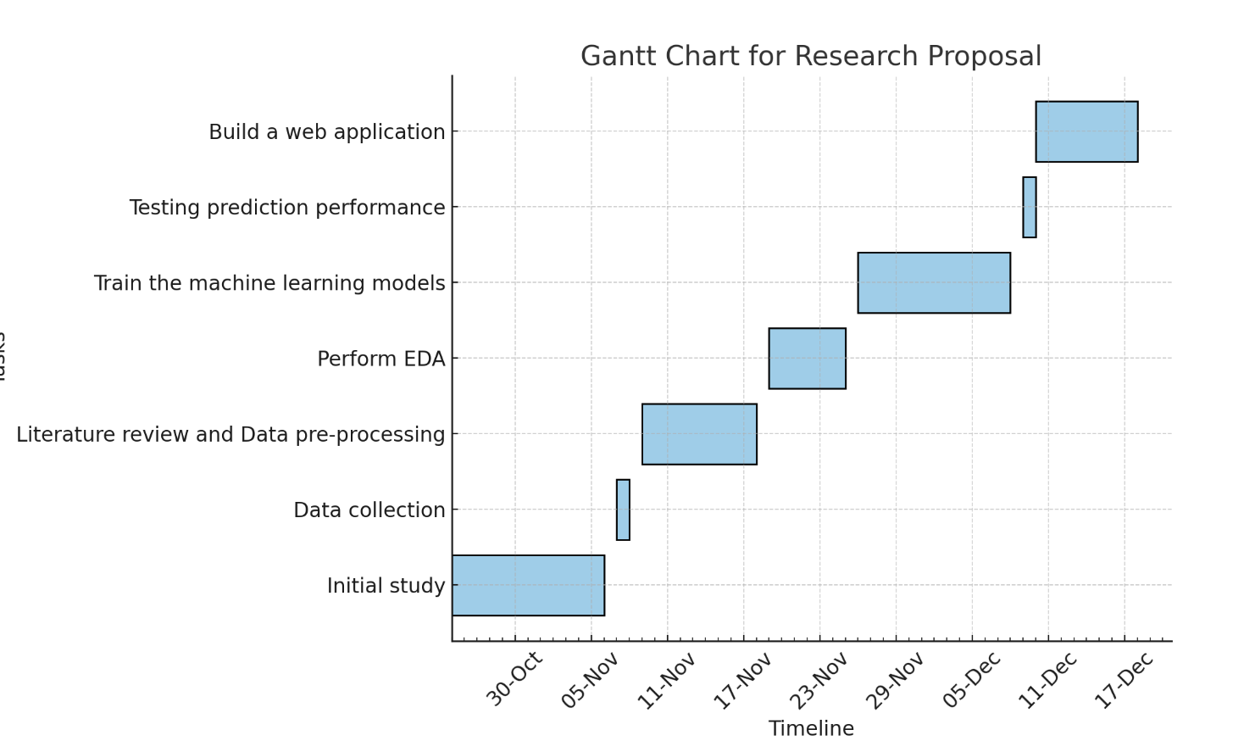

# CONCLUSION

This study addresses critical challenges in traffic management by leveraging advanced machine learning models to analyse and predict traffic patterns across Great Britain. By focusing on region-specific and road-type-based predictions, it aims to fill significant research gaps and provide actionable insights for urban planners, policymakers, and transportation stakeholders. Through the development of predictive tools and a user-friendly web application, the project seeks to enable smarter infrastructure planning, enhance transportation efficiency, and reduce congestion. The integration of cutting-edge computational techniques, ethical considerations, and robust validation processes ensures the reliability and relevance of the findings. Ultimately, this research aspires to contribute to the creation of sustainable, efficient, and safe transportation systems, thereby improving mobility and quality of life for communities across Great Britain.

# Reference

Abid, F., Alam, M., Alamri, F. S., & Siddique, I. (2023). Multi-directional gated recurrent unit and convolutional neural network for load and energy forecasting: A novel hybridization. *AIMS Mathematics*, *8*(9), 19993–20017. <https://doi.org/10.3934/math.20231019>

Chai, W., Luo, Q., Lin, Z., Yan, J., Zhou, J., & Zhou, T. (2024). Spatiotemporal Dynamic Multi-Hop network for traffic flow forecasting. *Sustainability*, *16*(14), 5860. <https://doi.org/10.3390/su16145860>

Chien, H. S., Turek, J. S., Beckage, N. M., Vo, V. A., Honey, C., & Willke, T. L. (2022). *Long Short-Term Memory with Slower Information Decay*. <https://doi.org/10.52591/2021072418>

Essien, A., Petrounias, I., Sampaio, P., & Sampaio, S. (2020b). A deep-learning model for urban traffic flow prediction with traffic events mined from twitter. *World Wide Web*, *24*(4), 1345–1368. <https://doi.org/10.1007/s11280-020-00800-3>

Fesalbon, D. (2024). Forecasting ferry passenger flow using Long-Short Term Memory neural networks. *arXiv (Cornell University)*. <https://doi.org/10.48550/arxiv.2405.02098>

Isah, A., Shin, H., Oh, S., Oh, S., Aliyu, I., Um, T., & Kim, J. (2023). Digital Twins Temporal Dependencies-Based On Time Series using Multivariate Long Short-Term Memory. *Electronics*, *12*(19), 4187. <https://doi.org/10.3390/electronics12194187>

Li, S. (2024). *Real-Time Traffic Congestion Detection Technology in Intelligent Transportation Systems* (pp. 1029–1033). <https://doi.org/10.1109/csnt60213.2024.10546078>

Li, Y., Zhao, Q., & Wang, M. (2022c). ANALYSIS THE INFLUENCING FACTORS OF URBAN TRAFFIC FLOWS BY USING NEW AND EMERGING URBAN BIG DATA AND DEEP LEARNING. *the International Archives of the Photogrammetry, Remote Sensing and Spatial Information Sciences/International Archives of the Photogrammetry, Remote Sensing and Spatial Information Sciences*, *XLIII-B4-2022*, 537–543. <https://doi.org/10.5194/isprs-archives-xliii-b4-2022-537-2022>

Mallahi, I. E., Riffi, J., Mahraz, M. A., & Tairi, H. (2023). Severity of road accident classification using Machine Learning Models. *Research Square (Research Square)*. <https://doi.org/10.21203/rs.3.rs-3128674/v1>

Neves, F., Finamore, A. C., Madeira, S. C., & Henriques, R. (2021). Mining actionable patterns of road mobility from heterogeneous traffic data using biclustering. *IEEE Transactions on Intelligent Transportation Systems*, *23*(7), 6430–6445. <https://doi.org/10.1109/tits.2021.3057240>

Parishwad, O., Jiang, S., & Gao, K. (2023). Investigating machine learning for simulating urban transport patterns: A comparison with traditional macro-models. *Multimodal Transportation*, *2*(3), 100085. <https://doi.org/10.1016/j.multra.2023.100085>

Phapale, N. A., & Shravagi, N. S. (2024). Traffic Flow Prediction on Road using Machine Learning. *International Journal of Applied and Advanced Multidisciplinary Research*, *2*(1), 31–38. <https://doi.org/10.59890/ijaamr.v2i1.690>

Prakash, M. R. U. (2023). Designing a better Support Vector Machines Classification Model for Multi-Class Category. *International Journal of Science and Research (IJSR)*, *12*(2), 905–909. <https://doi.org/10.21275/sr22517170244>

Qi, C., Ren, J., & Su, J. (2023). GRU Neural Network based on CEEMDAN–Wavelet for stock price prediction. *Applied Sciences*, *13*(12), 7104. <https://doi.org/10.3390/app13127104>

Rani, B. U., Sulthana, S. S., Kumar, P. K., & Bhavana, P. (2023). *Gridlock Prediction using a Gated Recurrent Neural Network for Smart Transport Systems*. <https://doi.org/10.1109/iccmc56507.2023.10084275>

Schonlau, M., & Zou, R. Y. (2020). The random forest algorithm for statistical learning. *The Stata Journal Promoting Communications on Statistics and Stata*, *20*(1), 3–29. <https://doi.org/10.1177/1536867x20909688>

Srinath, M. (2023). Vehicular Traffic Flow Prediction Model Deep learning. *International Journal for Research in Applied Science and Engineering Technology*, *11*(7), 109–112. <https://doi.org/10.22214/ijraset.2023.54576>

Švadlenka, M., & Chrpa, L. (2023). Towards a framework for intelligent urban traffic routing. *Proceedings of the . . . International Florida Artificial Intelligence Research Society Conference*, *36*. <https://doi.org/10.32473/flairs.36.133321>

Verbeek, M. (2017). Using linear regression to establish empirical relationships. *IZA World of Labor*. <https://doi.org/10.15185/izawol.336>

Wang, H., & Zhang, B. (2023). *Research on ARIMA Model for Short-Term Traffic Flow Prediction based on Time Series* (pp. 92–95). https://doi.org/10.1109/iciibms60103.2023.10347816

Wen, Z., Zhang, R., Ramamohanarao, K., & Yang, L. (2017). Scalable and fast SVM regression using modern hardware. *World Wide Web*, *21*(2), 261–287. <https://doi.org/10.1007/s11280-017-0445-1>

Xiong, W. (2024). A time-series model of GRUs based on attention mechanism for short-term load forecasting. *IEEE Access*, 1. <https://doi.org/10.1109/access.2024.3443876>

Xu, Z., Yuan, J., Yu, L., Wang, G., & Zhu, M. (2024). Machine Learning-Based traffic flow prediction and intelligent traffic management. *International Journal of Computer Science and Information Technology*, *2*(1), 18–27. <https://doi.org/10.62051/ijcsit.v2n1.03>

Yang, J., Li, J., Wei, L., Gao, L., & Mao, F. (2022). Spatiotemporal DeepWalk Gated Recurrent Neural Network: a deep learning framework for traffic learning and forecasting. *Journal of Advanced Transportation*, *2022*, 1–11. <https://doi.org/10.1155/2022/4260244>

Zhang, X. (2023). Traffic flow prediction based on explainable machine learning. *Highlights in Science Engineering and Technology*, *56*, 56–64. <https://doi.org/10.54097/hset.v56i.9816>





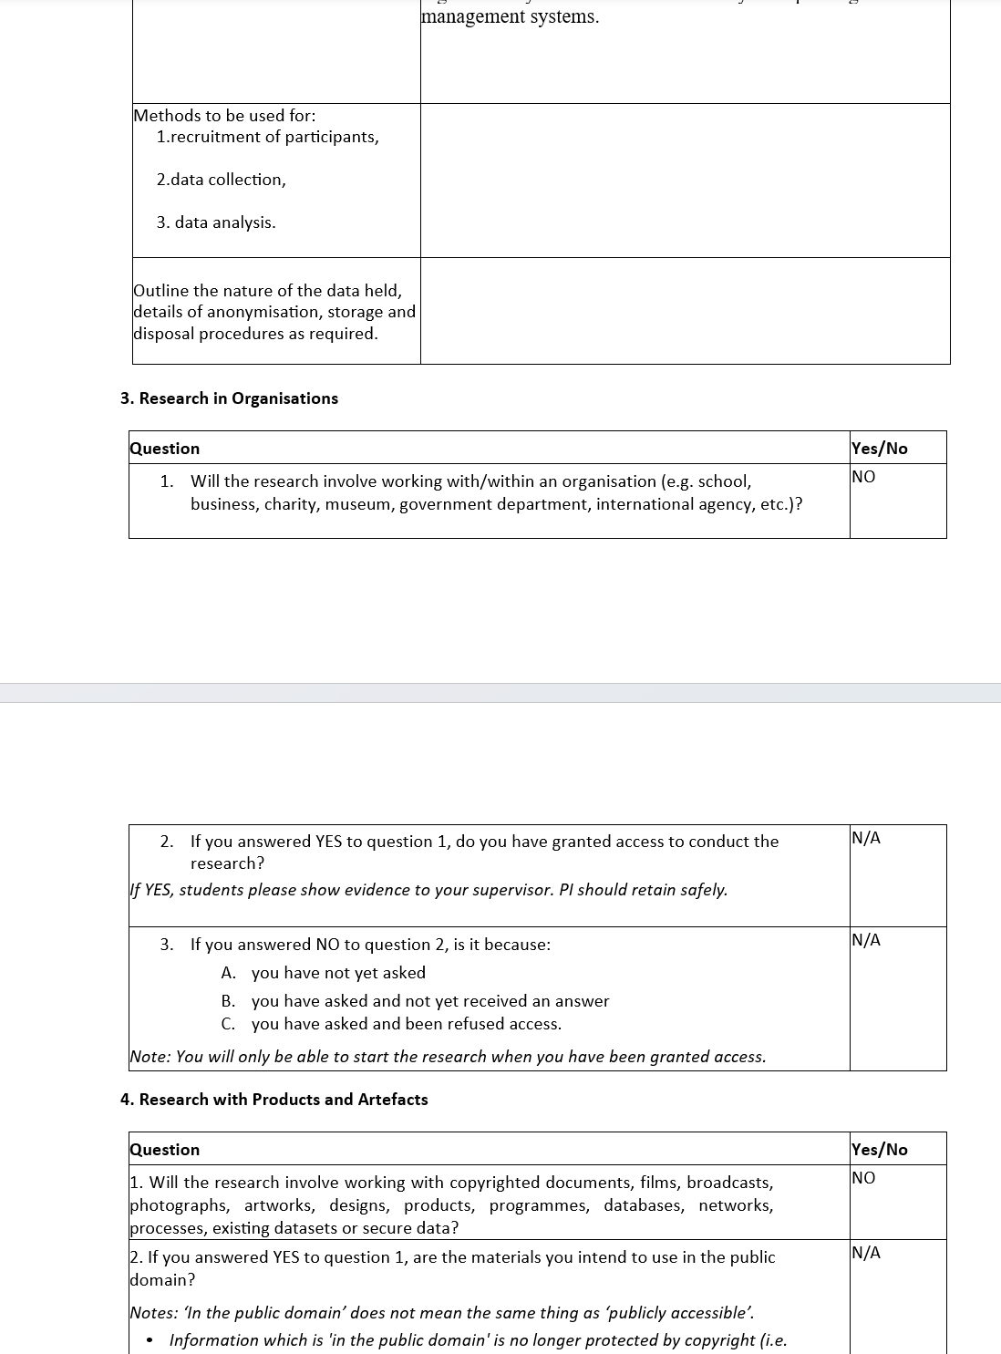



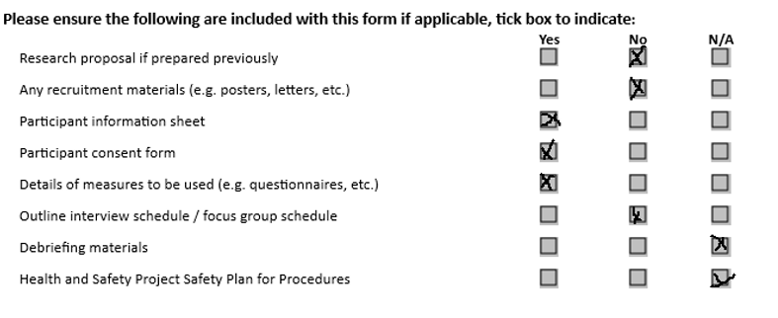

## Appendix B – Ethics Form and Publication Procedure Form

**UREC2 RESEARCH ETHICS PROFORMA FOR STUDENTS**

**UNDERTAKING LOW RISK PROJECTS WITH HUMAN PARTICIPANTS**

This form is designed to help students and their supervisors to complete an ethical scrutiny of proposed research. The University Research Ethics Policy

[(www.shu.ac.uk/research/excellence/ethics-and-integrity/policies](http://www.shu.ac.uk/research/excellence/ethics-and-integrity/policies)) should be consulted before completing this form. The initial questions are there to check that completion of the UREC 2 is appropriate for this study. The final responsibility for ensuring that ethical research practices are followed rests with the supervisor for student research.

Note that students and staff are responsible for making suitable arrangements to ensure compliance with the General Data Protection Act (GDPR). This involves informing participants about the legal basis for the research, including a link to the University research data privacy statement and providing details of who to complain to if participants have issues about how their data was handled or how they were treated (full details in module handbooks). In addition, the act requires data to be kept securely and the identity of participants to be anonymised. They are also responsible for following SHU guidelines about data encryption and research data management. Guidance can be found on the SHU Ethics Website [www.shu.ac.uk/research/excellence/ethics-and-integrity](http://www.shu.ac.uk/research/excellence/ethics-and-integrity)

Please note that it is mandatory for all students to only store data on their allotted networked F drive space and not on individual hard drives or memory sticks etc.

The present form also enables the University and College to keep a record confirming that research conducted has been subjected to ethical scrutiny.

The UREC2 form must be completed by the student. Supervisors will review their students’ completed UREC forms and, if necessary, inform students of any required changes. For UREC2* (Low Risk Research with Human Participants), the supervisor then signs off the form. Additional guidance can be obtained from your College Research Ethics Chair[1]

* If the supervisor thinks that the project is likely to result in a publication then the UREC2 form ***must*** be reviewed by an **independent reviewer**, drawn from the module teaching team, before data collection begins.

Students should retain a copy for inclusion in their research project, and a copy should be uploaded to the relevant module Blackboard site.

Please note that it may be necessary to conduct a health and safety risk assessment for the proposed research. Further information can be obtained from the University’s Health and Safety Website https://sheffieldhallam.sharepoint.com/sites/3069/SitePages/RiskAssessment.aspx

**SECTION A**

**1. Checklist questions to ensure that this is the correct form:**

Health Related Research within the NHS, or His Majesty’s Prison and Probation Service (HMPPS), or with participants unable to provide informed consent check list.

|  |  |
| --- | --- |
| **Question** | **Yes/No** |
| Does the research involve?  • Patients recruited because of their past or present use of the NHS | NO |
| • Relatives/carers of patients recruited because of their past or present use of the NHS | NO |
| • Access to NHS staff, premises, or resources | NO |
| • Access to data, organs, or other bodily material of past or present NHS patients | NO |
| • Foetal material and IVF involving NHS patients | NO |
| • The recently dead in NHS premises | NO |
| • Prisoners or others within the criminal justice system recruited for health-related research | NO |
| • Police, court officials, prisoners, or others within the criminal justice system | NO |
| • Participants who are unable to provide informed consent due to their incapacity even if the project is not health related | NO |
| • Is this an NHS research project, service evaluation or audit?  *For NHS definitions please see the following website* <http://www.hra.nhs.uk/documents/2013/09/defining-research.pdf> | NO |

If you have answered **YES** to any of the above questions, then you **MUST consult with your supervisor** to obtain research ethics from the appropriate institution outside the university. This could be from the NHS or Her Majesty’s Prison and Probation Service (HMPPS) under their independent Research Governance schemes. Further information is provided below. <https://www.myresearchproject.org.uk/>**2. Checks for Research with Human Participants**

|  |  |
| --- | --- |
| **Question** | **Yes/No** |
| 1. Will any of the participants be vulnerable?  *Note: Vulnerable people include children and young people, people with learning disabilities, people who may be limited by age or sickness, pregnancy, people*  *researched because of a condition they have, etc. See full definition on ethics website in the document* [***Code of Practice for Researchers Working with Vulnerable***](https://www.shu.ac.uk/research/excellence/ethics-and-integrity/guidance)  [***Populations***](https://www.shu.ac.uk/research/excellence/ethics-and-integrity/guidance) *(under the Supplementary University Polices and Good Research Practice Guidance)* | NO |
| 2. Are drugs, placebos, or other substances (e.g., food substances, vitamins) to be administered to the study participants or will the study involve invasive, intrusive, or potentially harmful procedures of any kind? | NO |
| 3. Will tissue samples (including blood) be obtained from participants? | NO |
| **Question** | **Yes/No** |
| 4. Is pain or more than mild discomfort likely to result from the study? | NO |
| 5. Will the study involve prolonged or repetitive testing? | NO |
| 6. Is there any reasonable and foreseeable risk of physical or emotional harm to any of the participants?  *Note: Harm may be caused by distressing or intrusive interview questions, uncomfortable procedures involving the participant, invasion of privacy, topics relating to highly personal information, topics relating to illegal activity, or topics that are anxiety provoking, etc.* | NO |
| 7. Will anyone be taking part without giving their informed consent? | NO |
| 8. Is the research covert?  *Note: ‘Covert research’ refers to research that is conducted without the knowledge of participants.* | NO |
| 9. Will the research output allow identification of any individual who has not given their express consent to be identified? | NO |

If you have answered **YES** to any of these questions you are **REQUIRED** to complete and submit a UREC3 or UREC4 form. Your supervisor will advise. If you have answered **NO** to all these questions, then proceed with this form (UREC2).

1. **General Project Details**

|  |  |
| --- | --- |
| **Details** |  |
| Name of student | ARYA SHIBU |
| SHU email address | c3070752@hallam.shu.ac.uk |
| Department/College | Department of Computing, Sheffield Halllam University |
| Name of supervisor | Dani Papamaximou |
| Supervisor’s email address | d.papamaximou@shu.ac.uk |
| Title of proposed research | Understanding Traffic Patterns: A Comprehensive Analysis of  Vehicle Counts in Great Britain |
| Proposed start date | 22-10-2024 |
| Proposed end date | 08-01-2025 |
| Background to the study and the rationale (reasons) for undertaking the research (500 words) | This project focuses on the analysis and forecasting of road  traffic patterns in Great Britain using a comprehensive dataset  that includes traffic figures for various regions. The dataset  comprises detailed records of vehicle counts categorized by  vehicle types—such as pedal cycles, two-wheeled motor  vehicles, cars and taxis, buses and coaches, and heavy goods  vehicles (HGVs)—alongside essential information like year,  date, time, region, and road characteristics.  The primary aim is to conduct both region-based and roadtype-based analyses to identify trends and patterns in traffic  flow. By exploring the impact of different road types and  regional characteristics on vehicle counts, we can gain insights  into traffic dynamics across Great Britain. Additionally, the  project will leverage historical traffic data to develop machine  learning-based predictive models that forecast vehicle counts  for future years, aiding in transportation planning and  infrastructure development. |
| Aims & research question(s) | Aim:  The primary aim is to conduct both region-based and road-type-based analyses to identify trends and patterns in traffic flow. Additionally, the project will leverage historical traffic data to develop machine learning-based predictive models that forecast vehicle counts for future years, aiding in transportation planning and infrastructure development.  Research Questions:     * How do traffic patterns differ in different regions in Great Britain over the years? * What is the impact of the type of road (e.g., minor vs. major highways) on the counts of vehicles? * What are the changes associated with the number of different kinds of vehicles(cars, buses etc.,) over the years? * Which Machine learning algorithms perform better in predicting traffic loads and types of vehicles in different regions? * What kind of vehicles(cars, buses etc.,)  make up the traffic in different regions and how does this affect the strategies for traffic management? |
| Methods to be used for:  1. Recruitment of participants | No participants involved. |
| **Details** |  |
| 1. Data collection 2. Data analysis | This data is collected from [www.kaggle.com](https://www.kaggle.com) and its licenced under “ CC0 ” which gives the user “ to copy, modify, distribute and perform the work, even for commercial purposes, all without asking permission”  The analysis focused on exploring traffic patterns in Great Britain using a publicly available dataset. Key aspects included identifying trends in vehicle counts by region, road type, and time of day, as well as examining seasonal and annual variations. Data visualization techniques such as bar plots and heatmaps were used to highlight these patterns. Machine learning models (LSTM, GRU, and SVM) were applied to predict traffic counts based on factors like location, day, and road type. These methods provided insights into traffic management and forecasting while ensuring the integrity of anonymized . |
| Outline the nature of the data held, details of anonymisation, storage and disposal procedures as required. | The dataset analysed in the study contains traffic-related data from Great Britain, including numerical and categorical variables such as vehicle counts, road types, and timestamps. All personal identifiers were absent, ensuring anonymization. Data was stored securely in standardized formats during processing, with measures to prevent unauthorized access. Upon completion of the project, the dataset and related temporary files were scheduled for secure deletion to maintain confidentiality and data integrity. |

1. **Research in External Organisations**

|  |  |
| --- | --- |
| **Question** | **Yes/No** |
| 1. Will the research involve working with/within an external organisation (e.g., school, business, charity, museum, government department, international agency, etc.)? | N/A |
| 2. If you answered YES to question 1, do you have granted access to conduct the research from the external organisation?  *If YES, students please show evidence to your supervisor. You should retain this evidence safely.* | N/A |
| 3. If you do not have permission for access is this because:   1. you have not yet asked 2. you have asked and not yet received an answer 3. you have asked and been refused access   *Note: You will only be able to start the research when you have been granted access.* | N/A |

1. **Research with Products and Artefacts**

|  |  |
| --- | --- |
| **Question** | **Yes/No** |
| 1. Will the research involve working with copyrighted documents, films, broadcasts, photographs, artworks, designs, products, programs, databases, networks, processes, existing datasets, or secure data? | Yes |
| **Question** | **Yes/No** |
| 2. If you answered YES to question 1, are the materials you intend to use in the public domain?  *Notes: ‘In the public domain’ does not mean the same thing as ‘publicly accessible’.*   * *Information which is 'in the public domain' is no longer protected by copyright (i.e., copyright has either expired or been waived) and can be used without permission.* * *Information which is 'publicly accessible' (e.g., TV broadcasts, websites, artworks, newspapers) is available for anyone to consult/view. It is still protected by copyright even if there is no copyright notice. In UK law, copyright protection is automatic and does not require a copyright statement, although it is always good practice to provide one. It is necessary to check the terms and conditions of use to find out exactly how the material may be reused etc.*   *If you answered YES to question 1, be aware that you may need to consider other ethics codes. For example, when conducting Internet research, consult the code of the Association of Internet Researchers; for educational research, consult the Code of*  *Ethics of the British Educational Research Association.* | N/A |
| 3. If you answered NO to question 2, do you have explicit permission to use these materials as data?  *If YES, please show evidence to your supervisor.* | N/A |
| 4. If you answered NO to question 3, is it because:   1. you have not yet asked permission 2. you have asked and not yet received and answer 3. you have asked and been refused access.   *Note: You will only be able to start the research when you have been granted permission to use the specified material.* | **A/B/C** |

**SECTION B**

**HEALTH AND SAFETY RISK ASSESSMENT FOR THE RESEARCHER**

1. **Does this research project require a health and safety risk assessment for the procedures to be used?** (Discuss this with your supervisor)

Yes

No

If **YES** the completed Health and Safety Risk Assessment form should be attached. A standard risk assessment form can be generated through the Awaken system [(https://shu.awaken-be.com](https://shu.awaken-be.com/)). Alternatively if you require more specific risk assessment, e.g. a COSHH, attach that instead.

1. **Will the data be collected fully online (no face-to-face contact with participants)?**

Yes (See the safety guidance for online research[2] and **go to question 7b**)

No (Go to question 3)

1. **Will the proposed data collection take place on campus?**

Yes (Please answer questions 5 to 8)

No (Please complete all questions and consult with your supervisor))

1. **Where will the data collection take place?**

(Tick as many as apply if data collection will take place in multiple venues)

**Location Please specify**

Researcher's Residence

Participant's Residence

Education Establishment

Other e.g., business/voluntary

organisation, public venue

Outside UK

1. **How will you travel to and from the data collection venue?**

On foot By car Public Transport Other (Please specify)

Please outline how you will ensure your personal safety when travelling to and from the data collection venue.

1. **How will you ensure your own personal safety whilst at the research venue?**
2. **Are there any potential risks to your health and wellbeing associated with either (a) the venue where the research will take place and/or (b) the research topic itself?**

None that I am aware of

Yes (Please outline below including steps taken to minimise risk)

1. **If you are carrying out research off-campus, you must ensure that each time you go out to collect data you ensure that someone you trust knows where you are going (without breaching the confidentiality of your participants), how you are getting there (preferably including your travel route), when you expect to get back, and what to do should you not return at the specified time.**

Please outline here the procedure you propose using to do this.

**Insurance Check**

The University’s standard insurance cover will not automatically cover research involving any of the following:

1. Participants under 5 years old
2. Pregnant womeniii) 5000 or more participants

iv) Research being conducted in an overseas country v) Research involving aircraft and offshore oil rigs vi) Nuclear research vii) Any trials/medical research into Covid 19

If your proposals do involve any of the above, please contact the Insurance Manager directly (fin-insurancequeries-mb@exchange.shu.ac.uk) to discuss this element of your project.

**Adherence to SHU Policy and Procedures**

|  |  |
| --- | --- |
| **Ethics sign-off** | |
| **Personal statement** | |
| I can confirm that:  • I have read the Sheffield Hallam University Research Ethics Policy and Procedures • I agree to abide by its principles. | |
| **Student** | |
| Name: Arya Shibu | Date: 17/12/2024 |
|  | |
| **Supervisor ethical sign-off** | |
| I can confirm that completion of this form has not identified the need for ethical approval by the TPREC/CREC or an NHS, Social Care, or other external REC. The research will not commence until any approvals required under Sections 4 & 5 have been received and any necessary health and safety measures are in place. | |
| Name: Dani Papamaximou | Date: 17/12/2024 |
| Signature:  Dani Papamaximou | |
| **Independent Reviewer ethical sign off** | |
| Name: | Date: |
| Signature: | |

**Please ensure that you have attached all relevant documents. Your supervisor must approve them before you start data collection:**

**Documents Yes No N/A** Research proposal if prepared previously



Any recruitment materials (e.g., posters, letters, emails, etc.)



Participant information sheet[3]



Participant consent form[4]



Details of measures to be used (e.g., questionnaires, etc.)



Outline interview schedule / focus group schedule



Debriefing materials



Health and Safety Risk Assessment Form



## Appendix C – Publication Procedure Form

## 



College of Business,

Technology and   
Engineering

## Dissertation for Computing (55-708541)*.*

## PUBLICATION PROCEDURE FORM

## In this module, while you create your own research question or topic area, your supervisor makes a significant intellectual contribution to this work as the research progresses. Your supervisor will make the decision on whether your work merits publication based on the quality of the work you have produced. Your supervisor will co-author the paper for publication with you and your supervisor will both be listed as authors. You are required to sign the declaration below to confirm that you understand and will follow this procedure.

## Declaration:

|  |  |  |
| --- | --- | --- |
| I …… confirm that I understand will comply with the Publication Procedure outlined in the Module Handbook and the Blackboard Site. | | |
| Student: | Signature | Date15/01/2025 |
| Supervisor: | Signature | Date |

## Appendix D – Code

The code for Exploratory Data Analysis and Visualisations

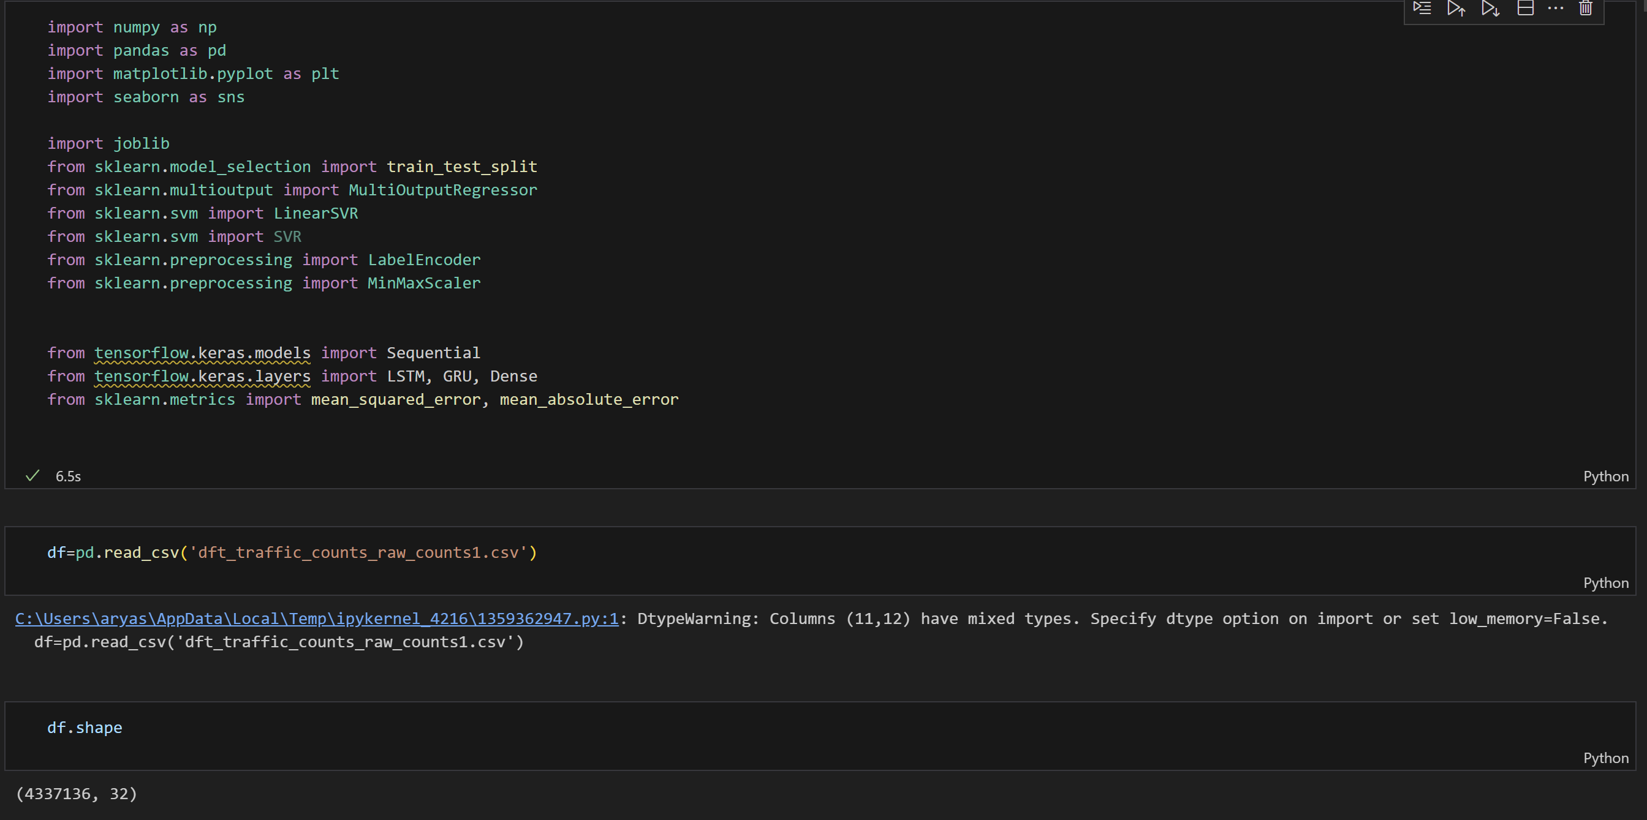

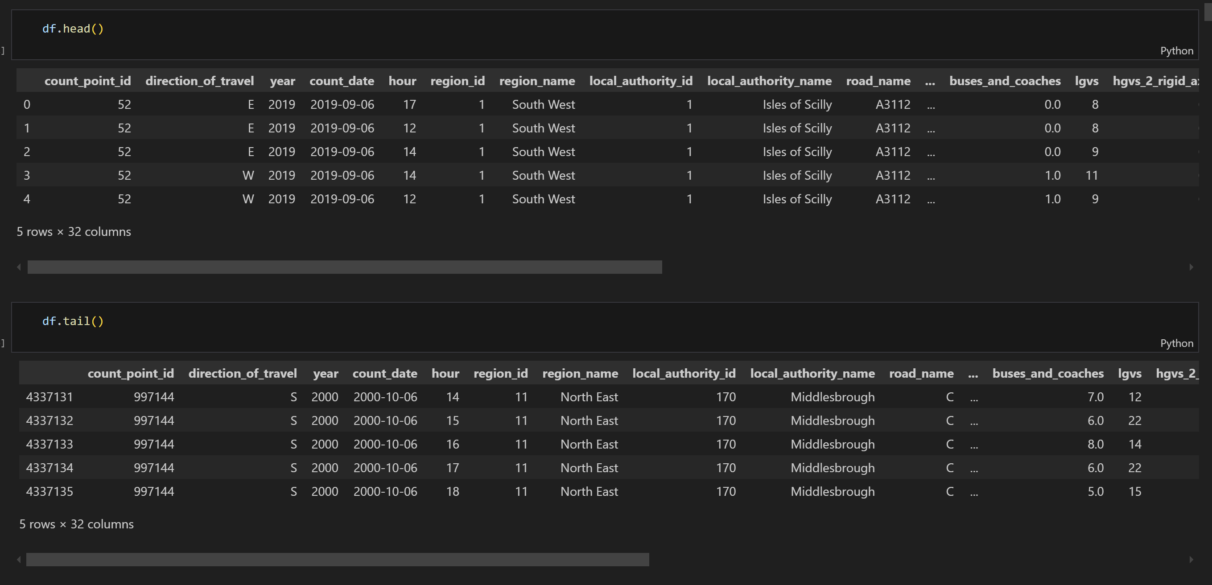

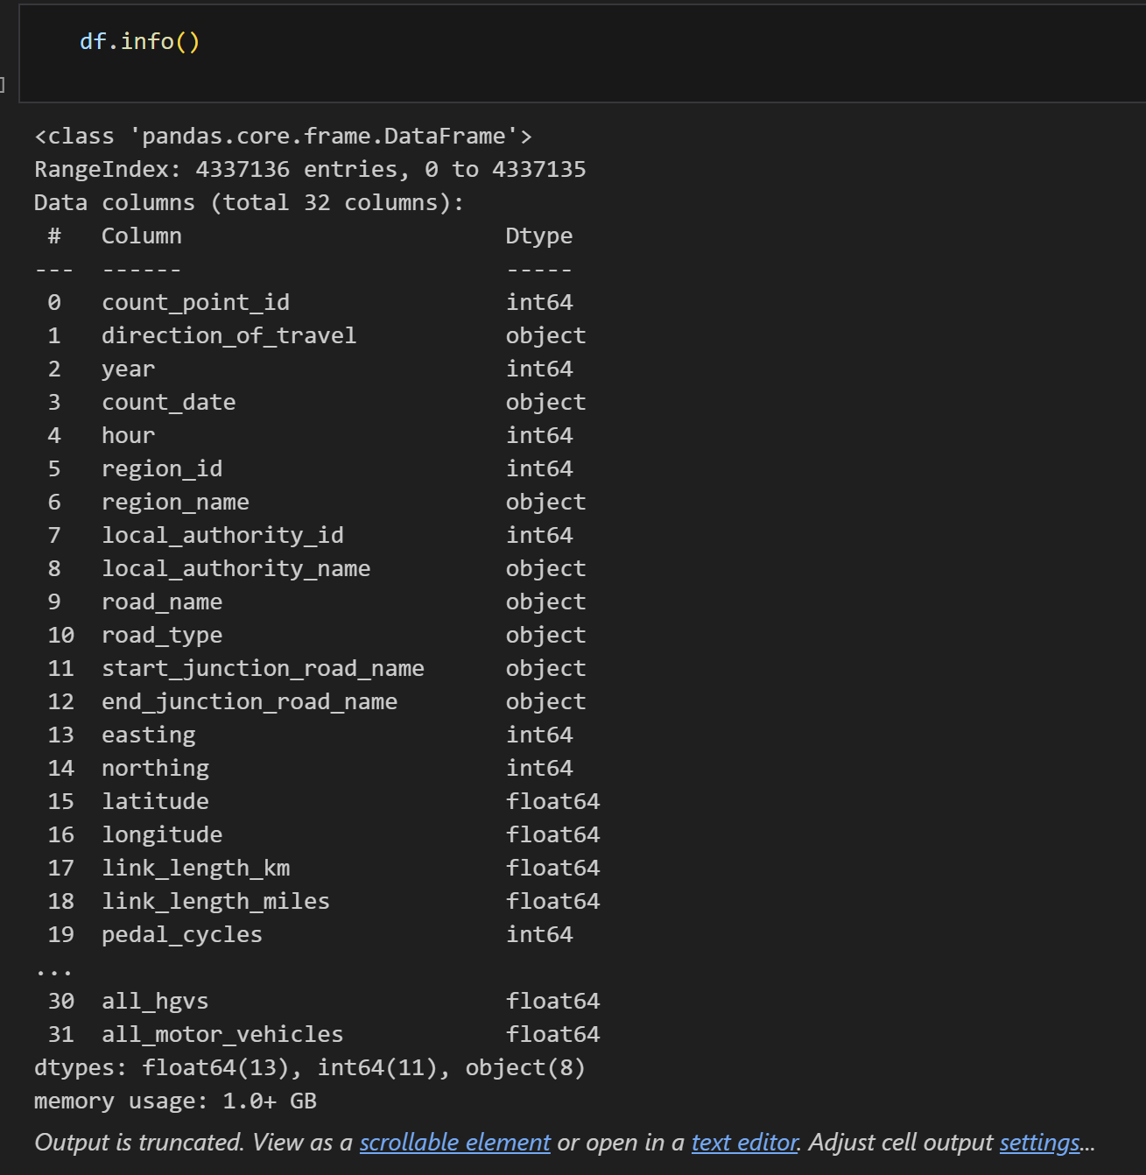

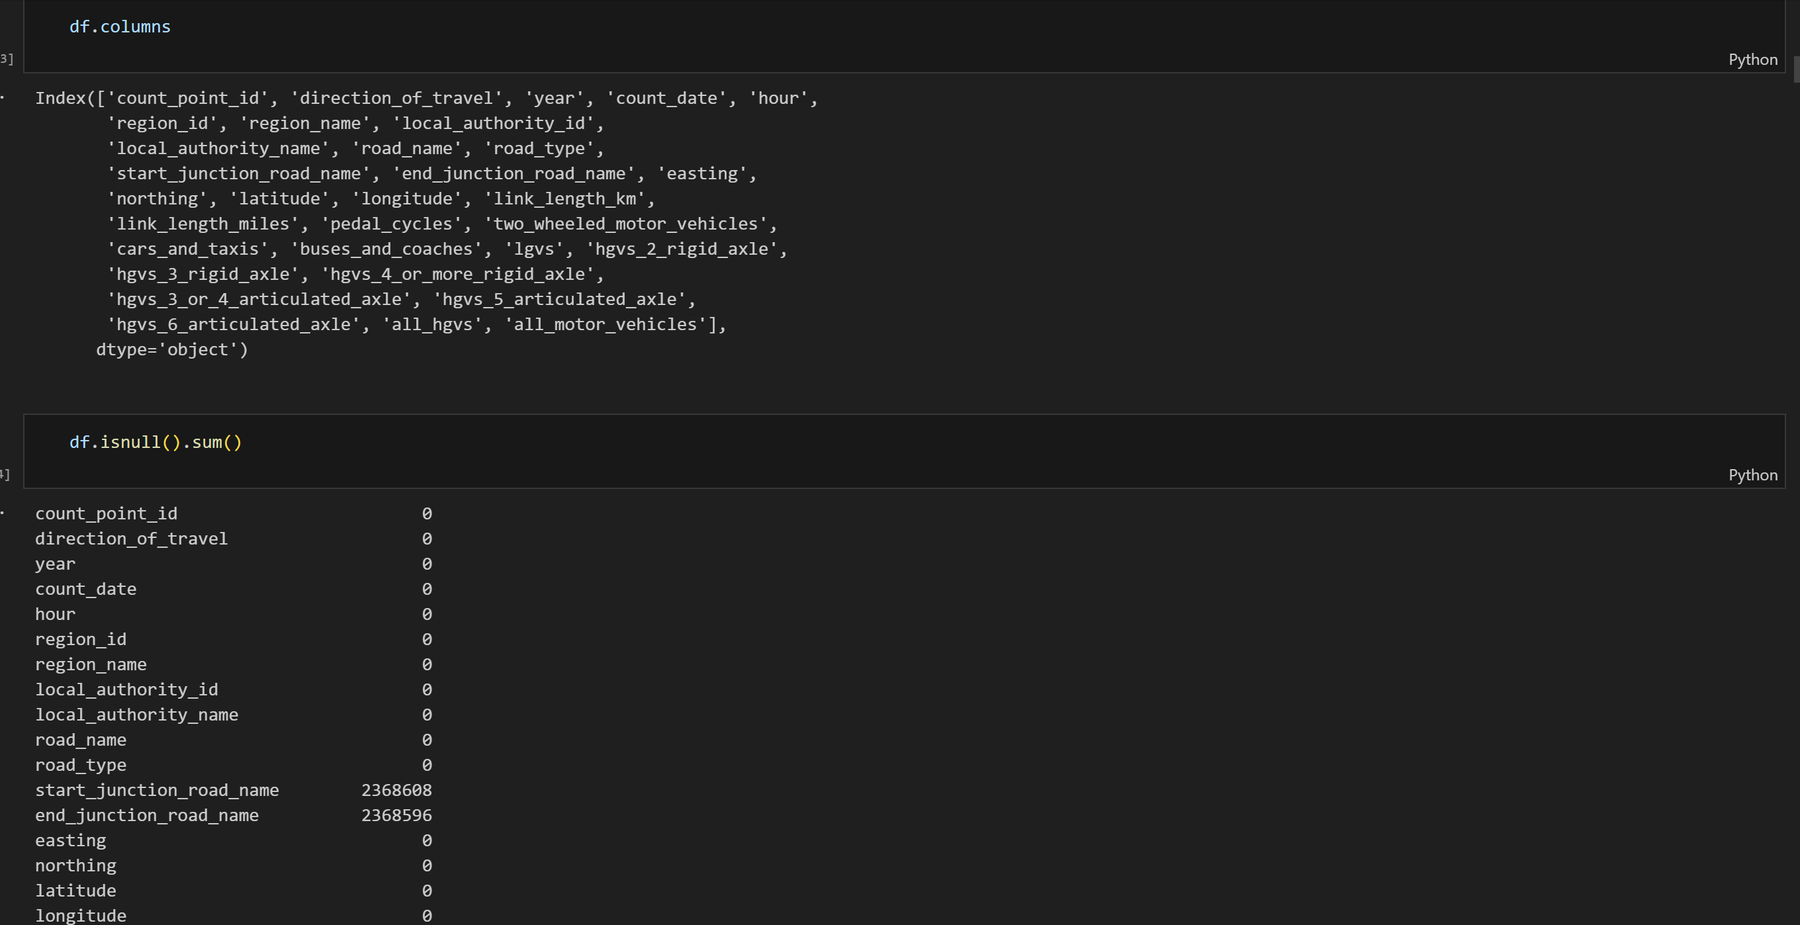

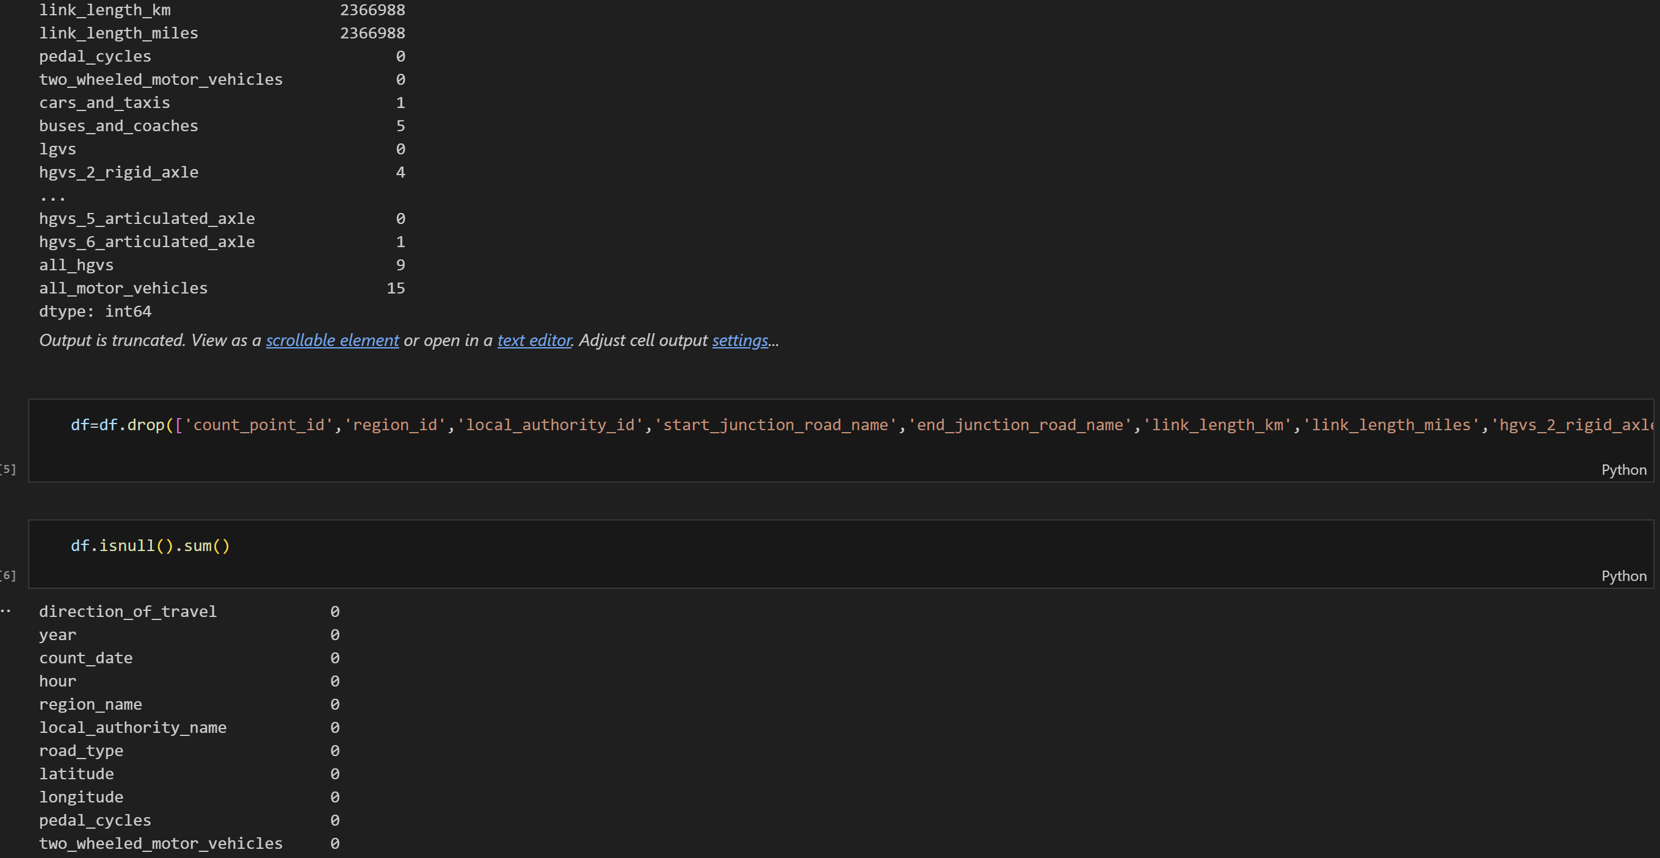

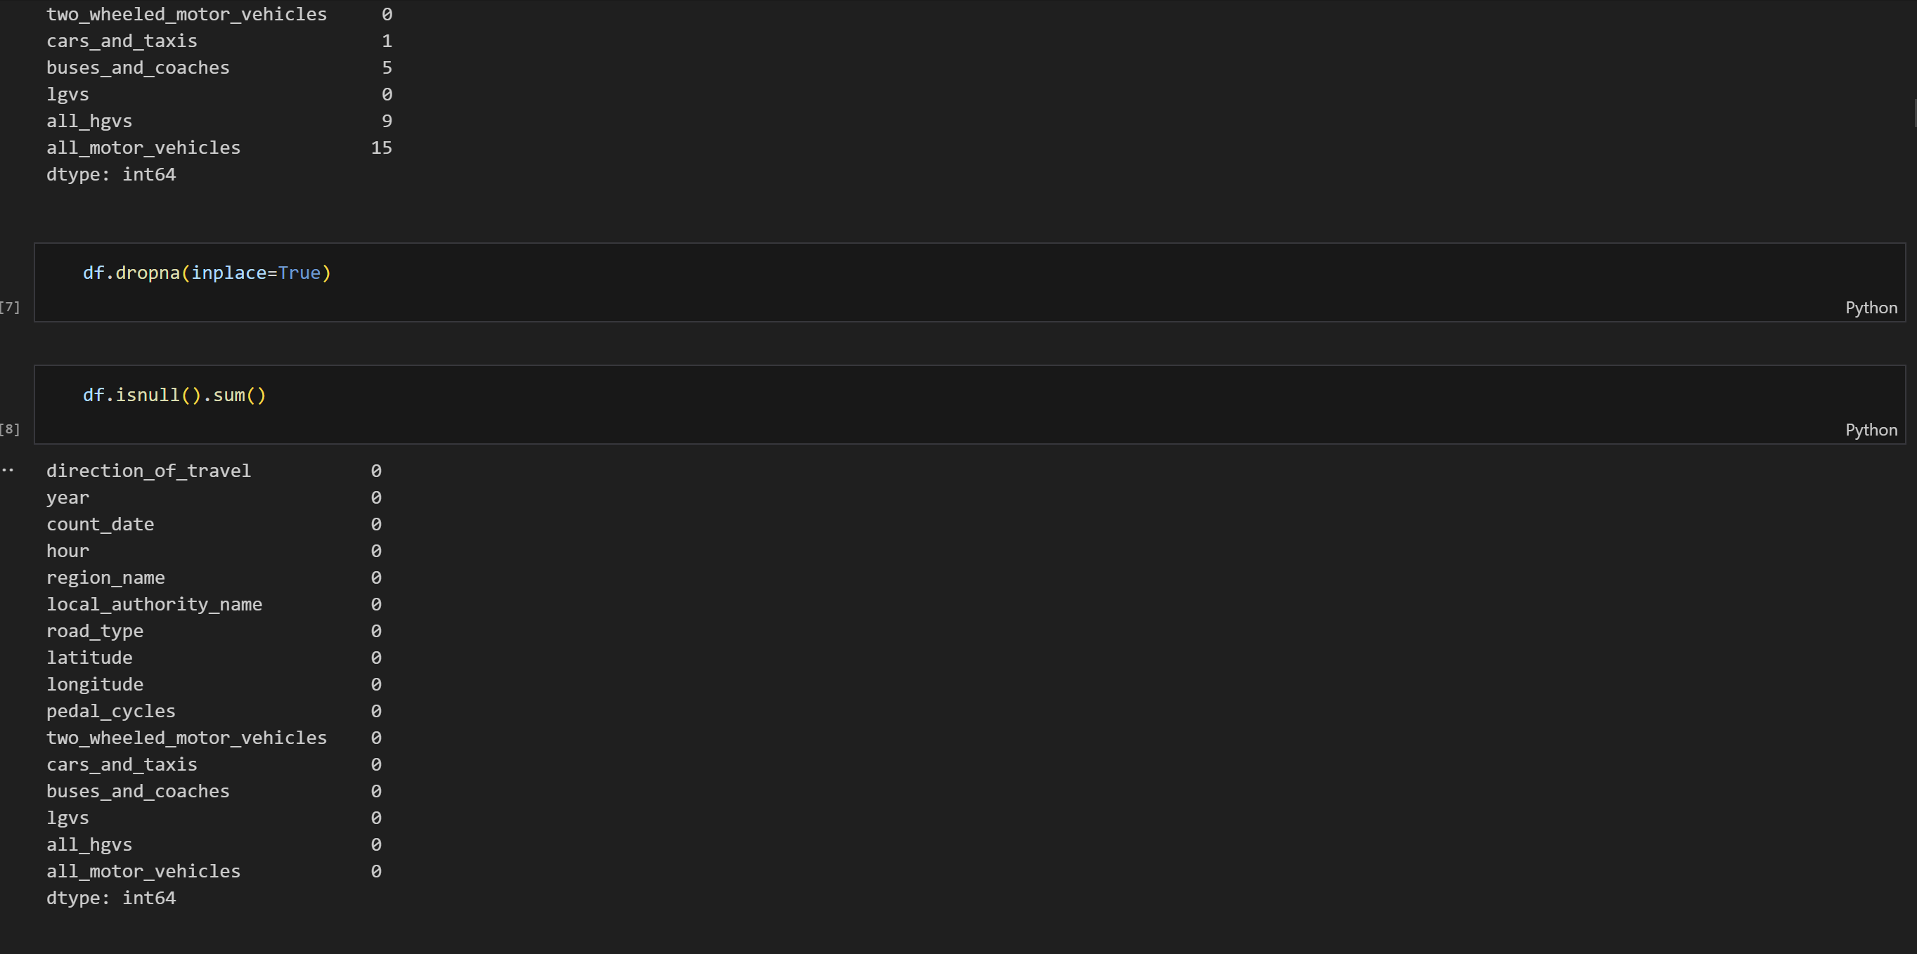

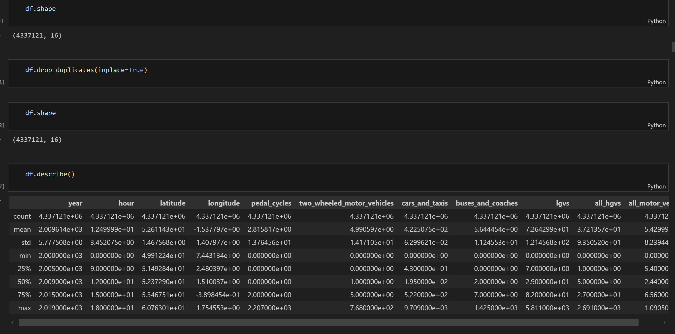

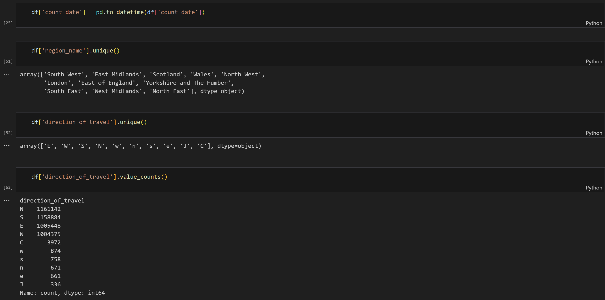

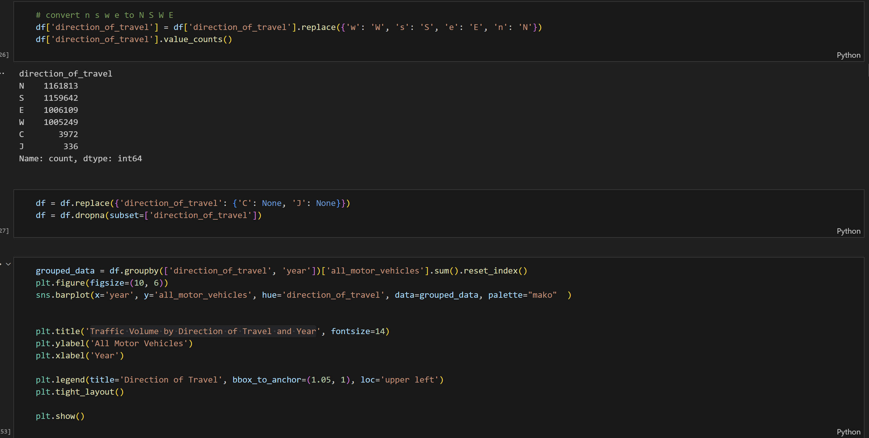

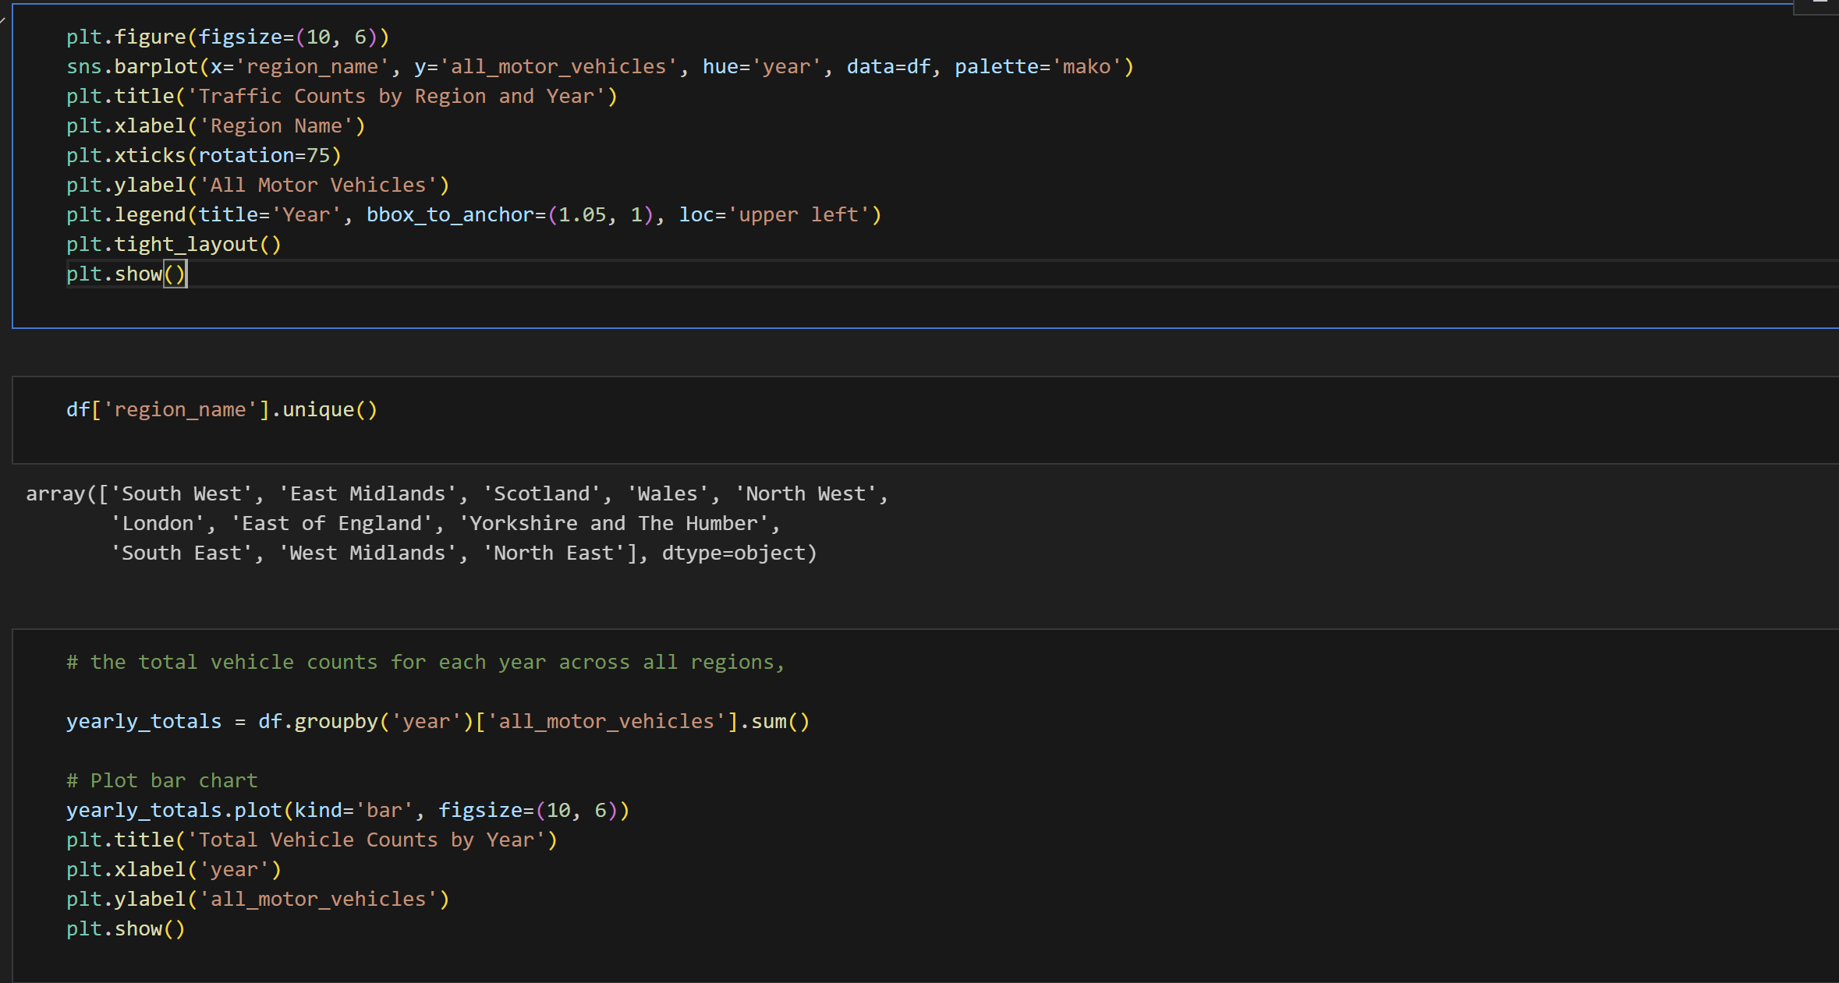

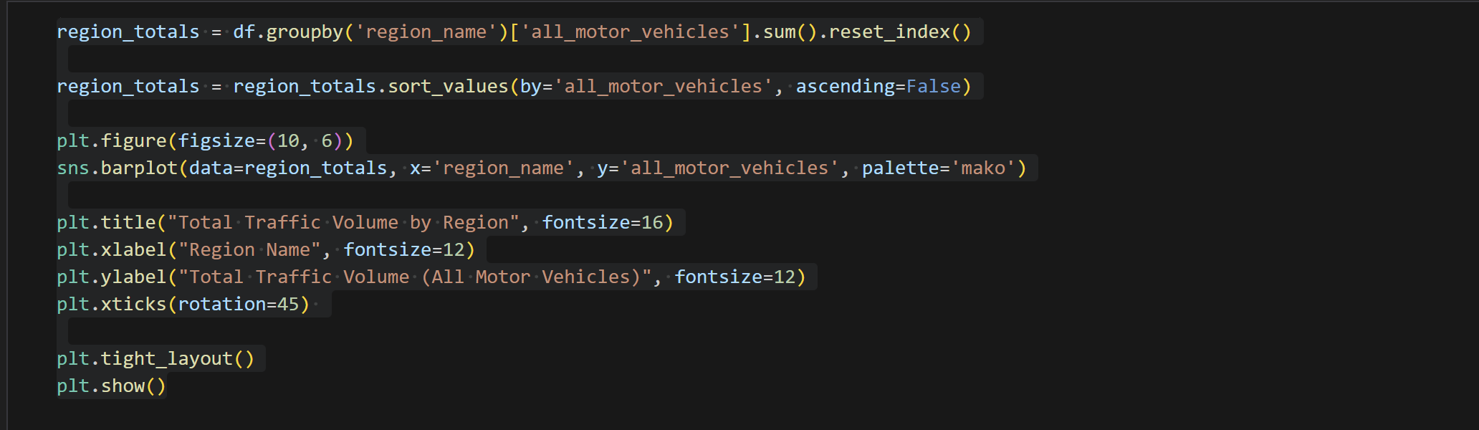

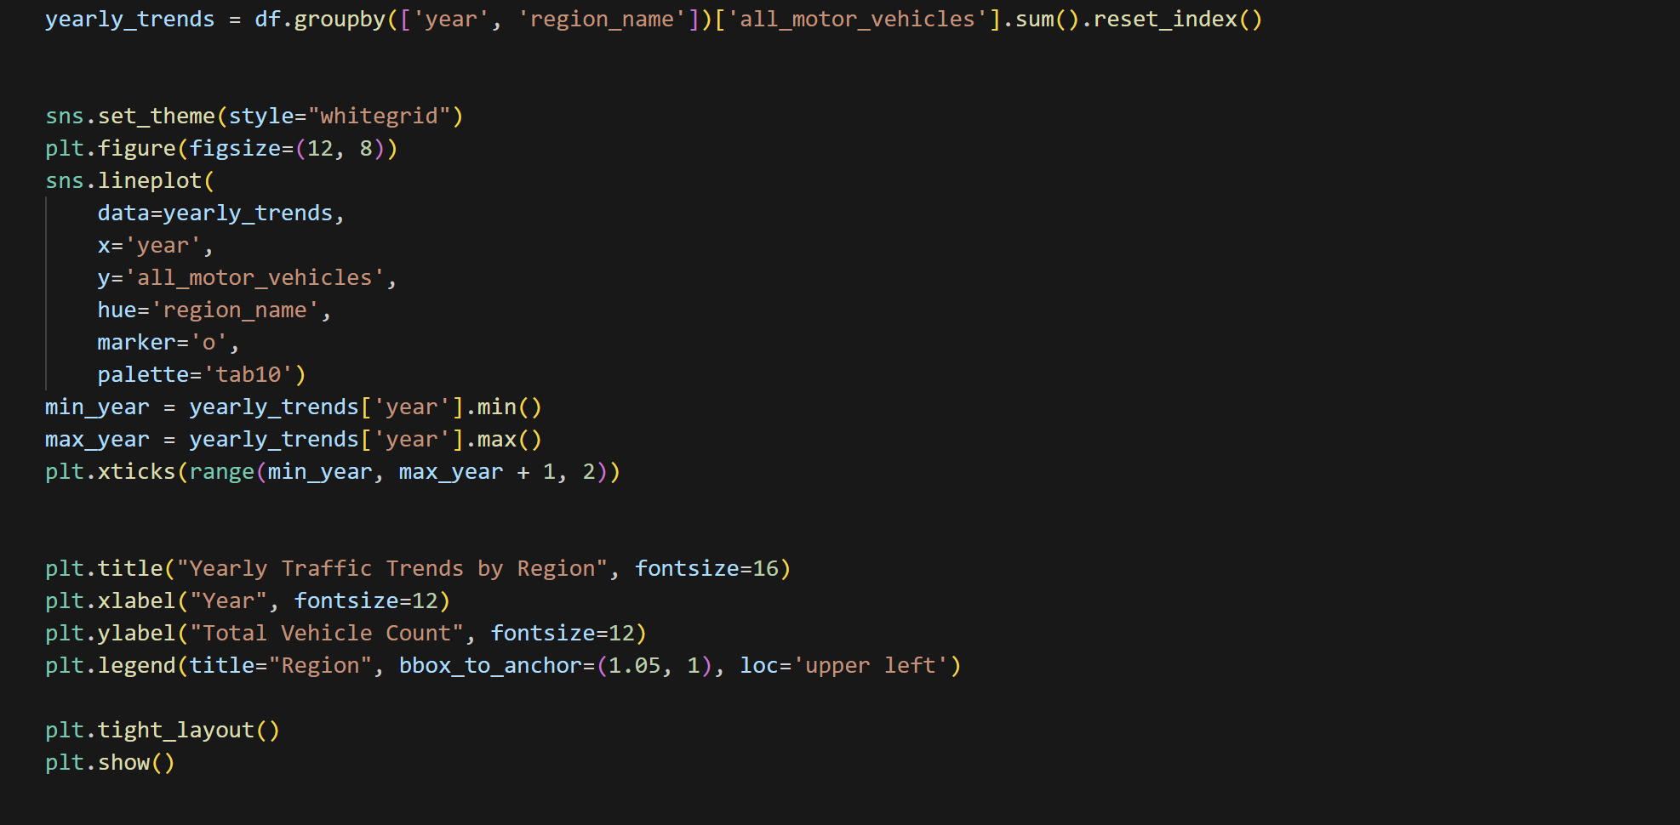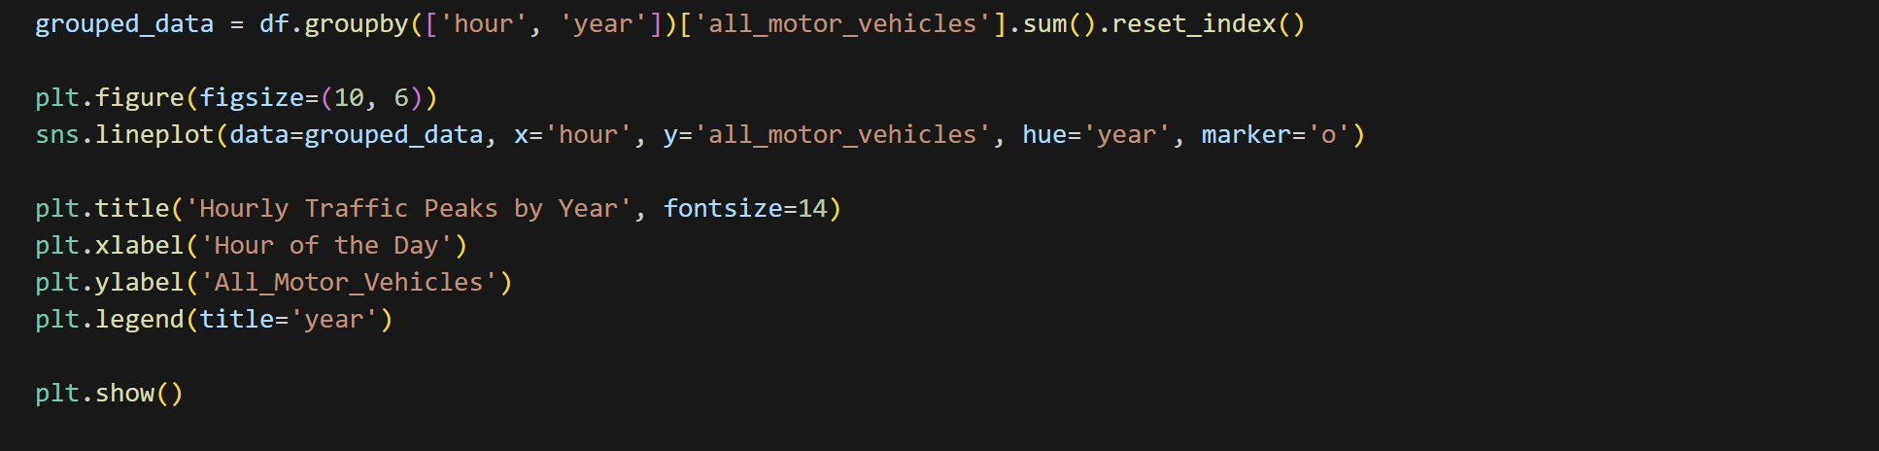

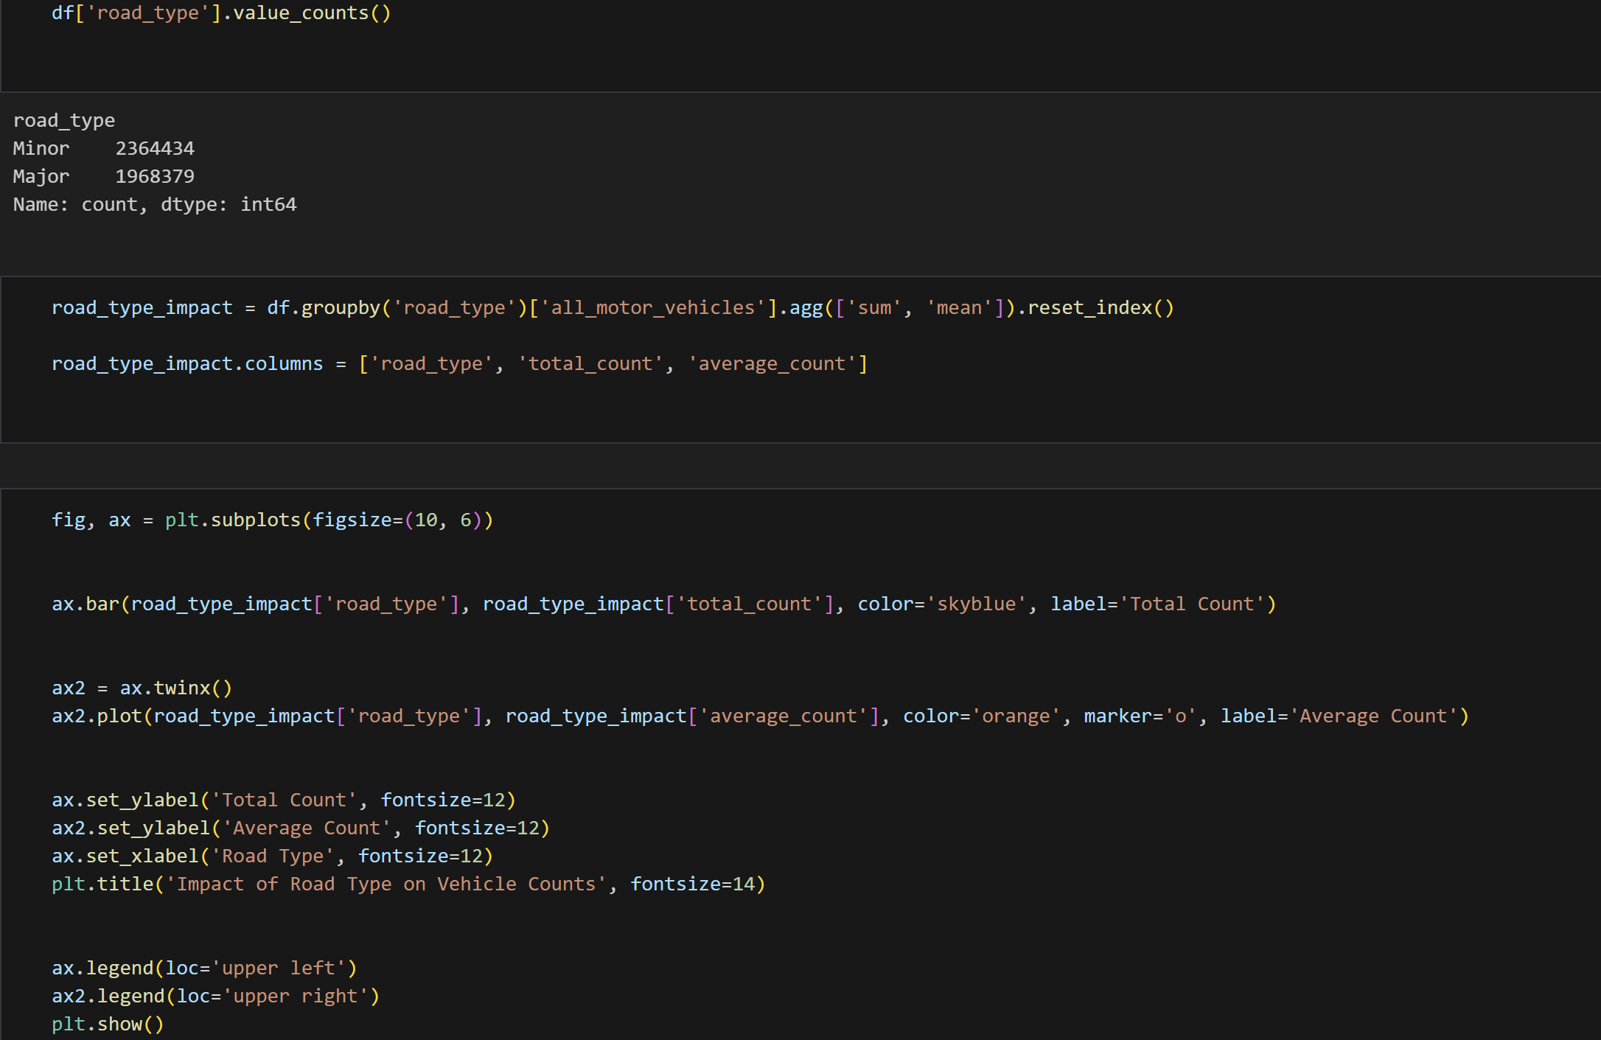

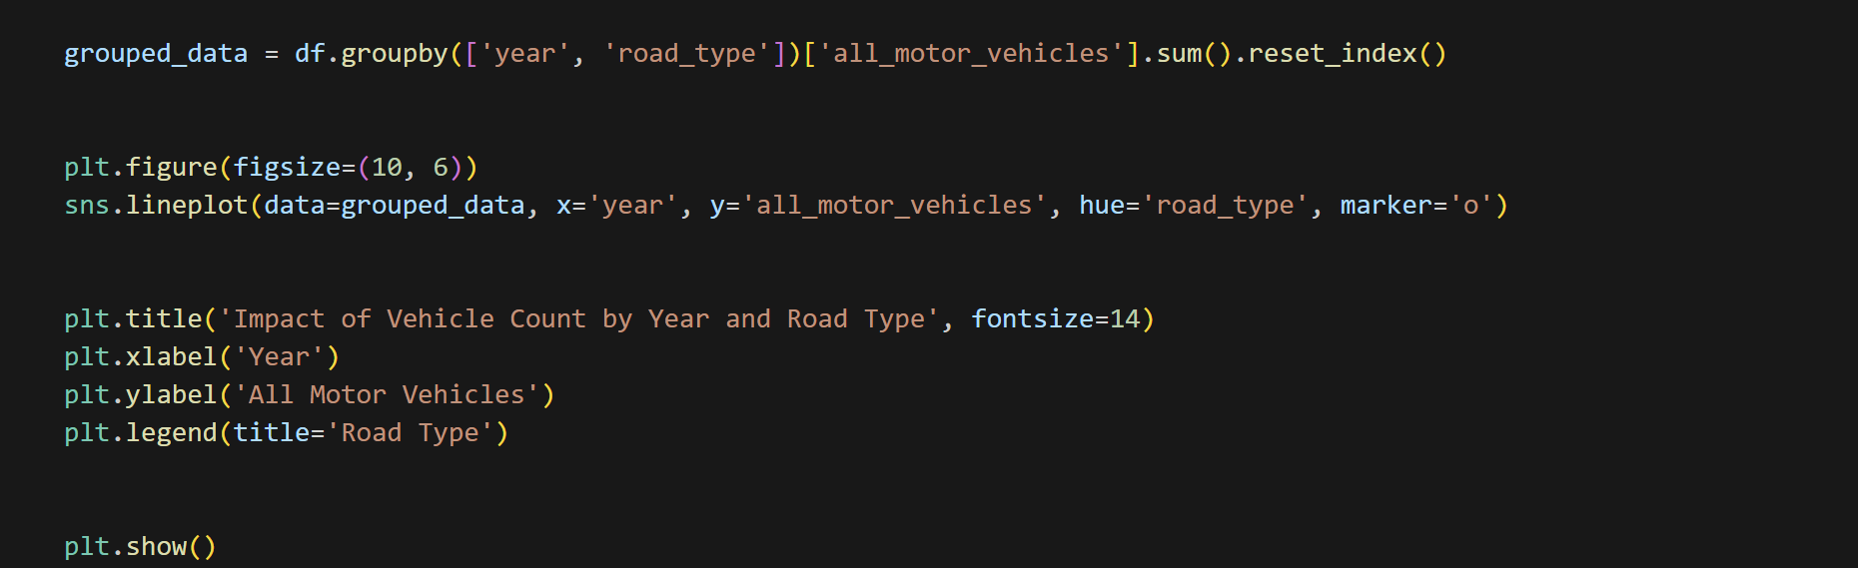

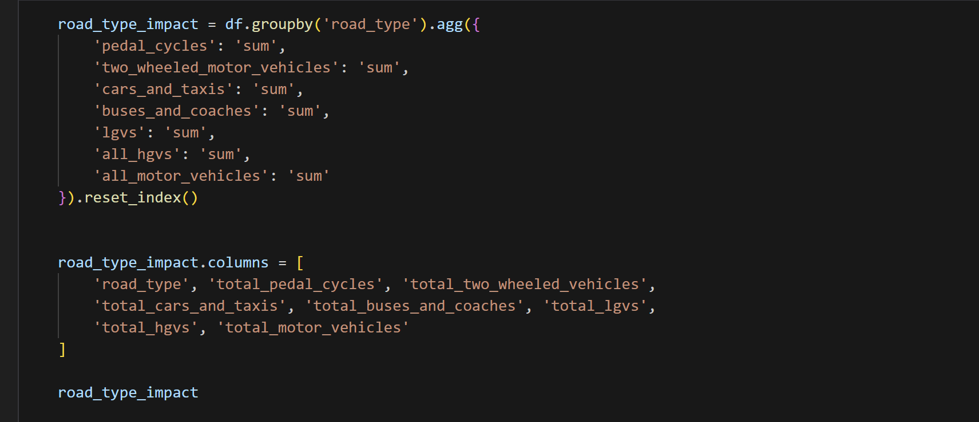

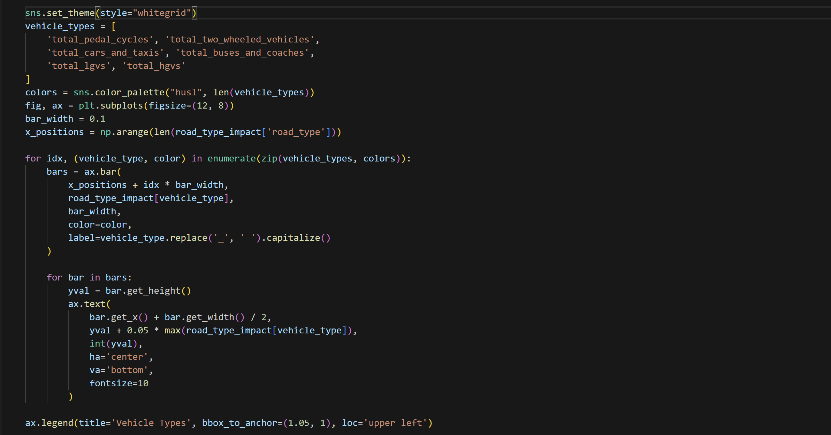

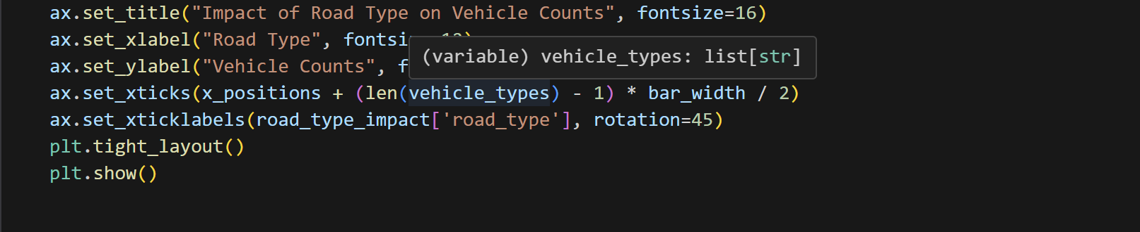



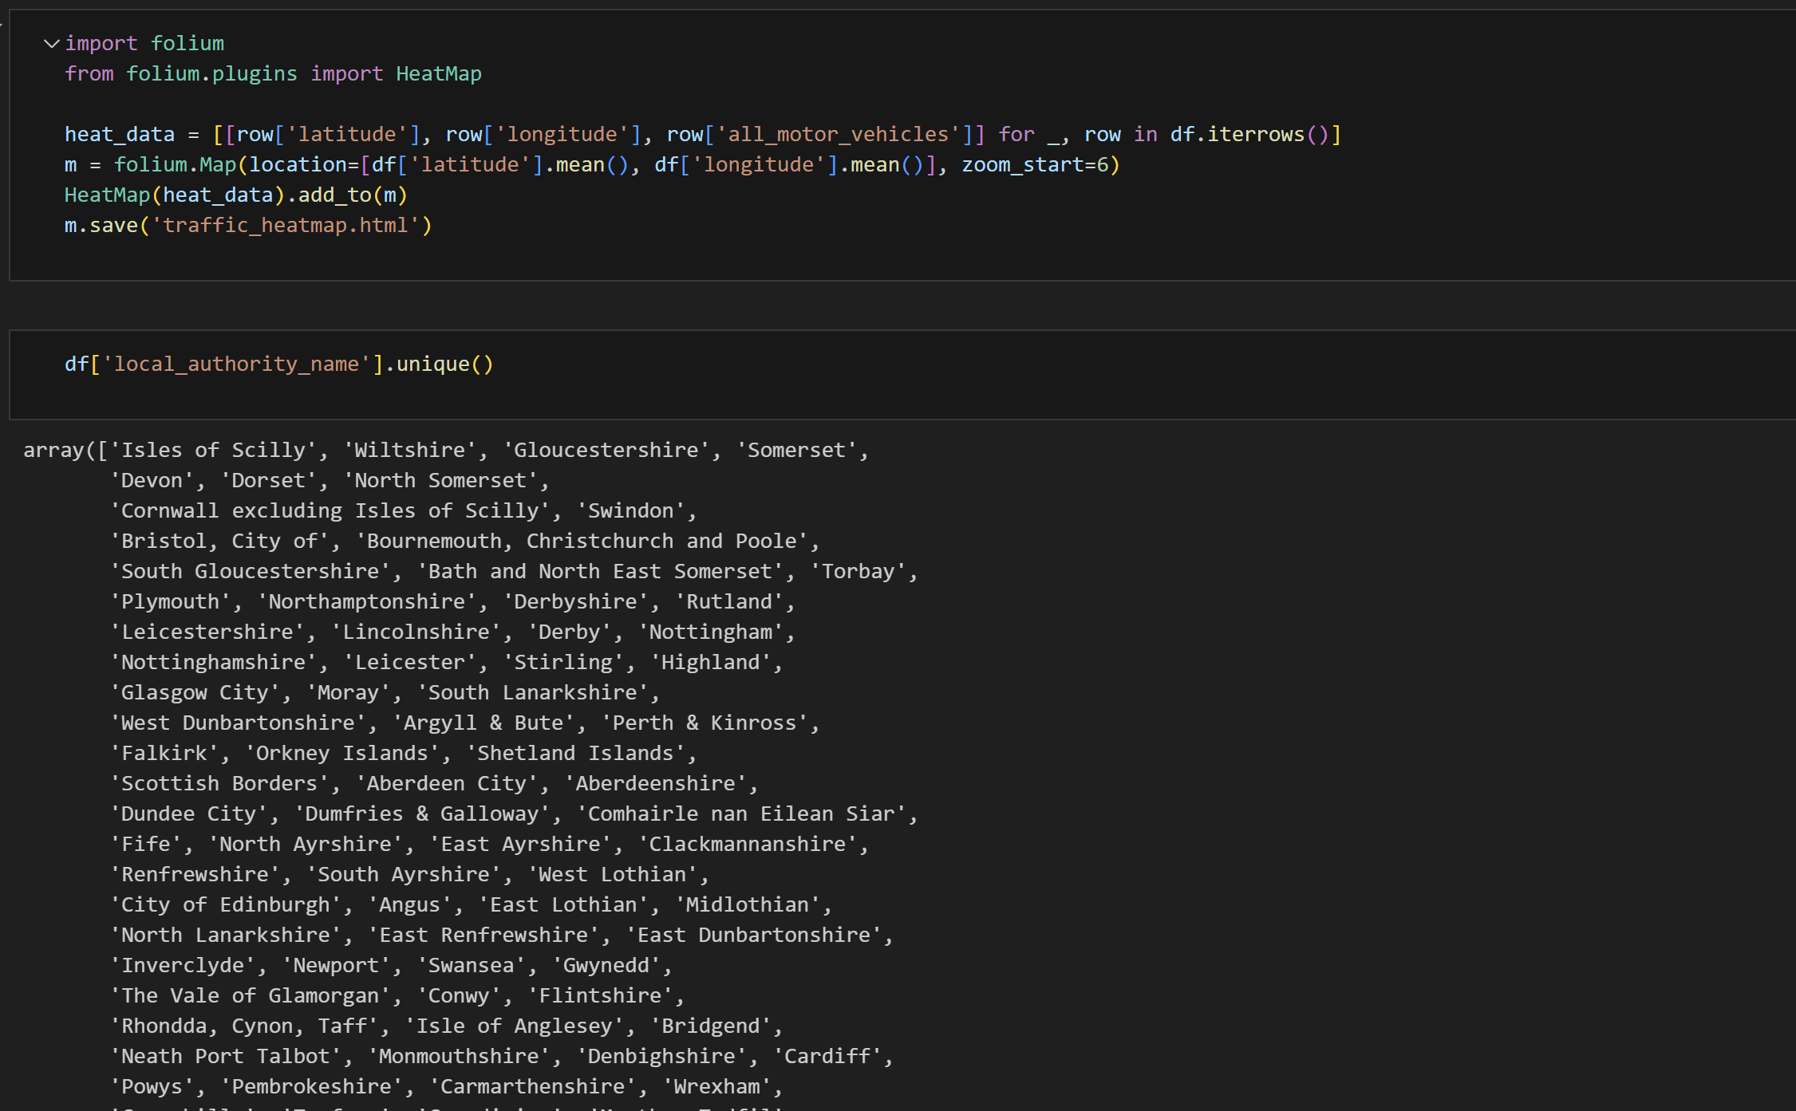

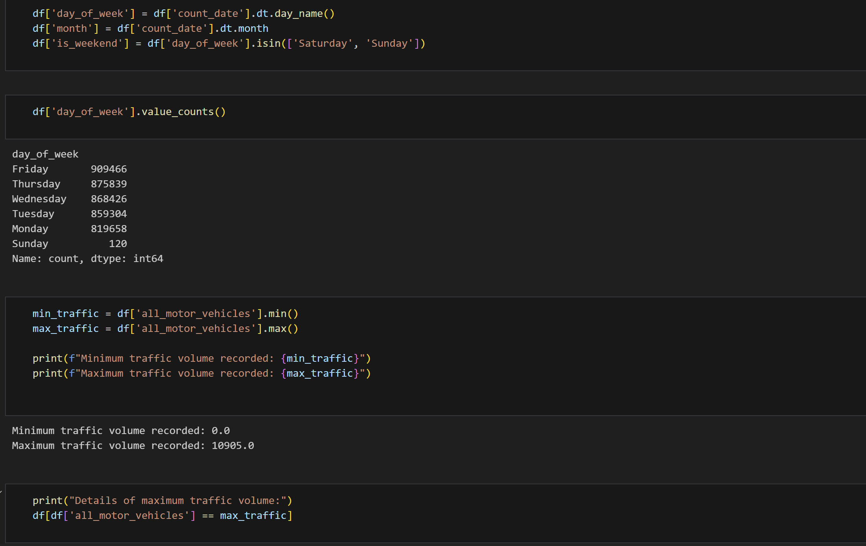

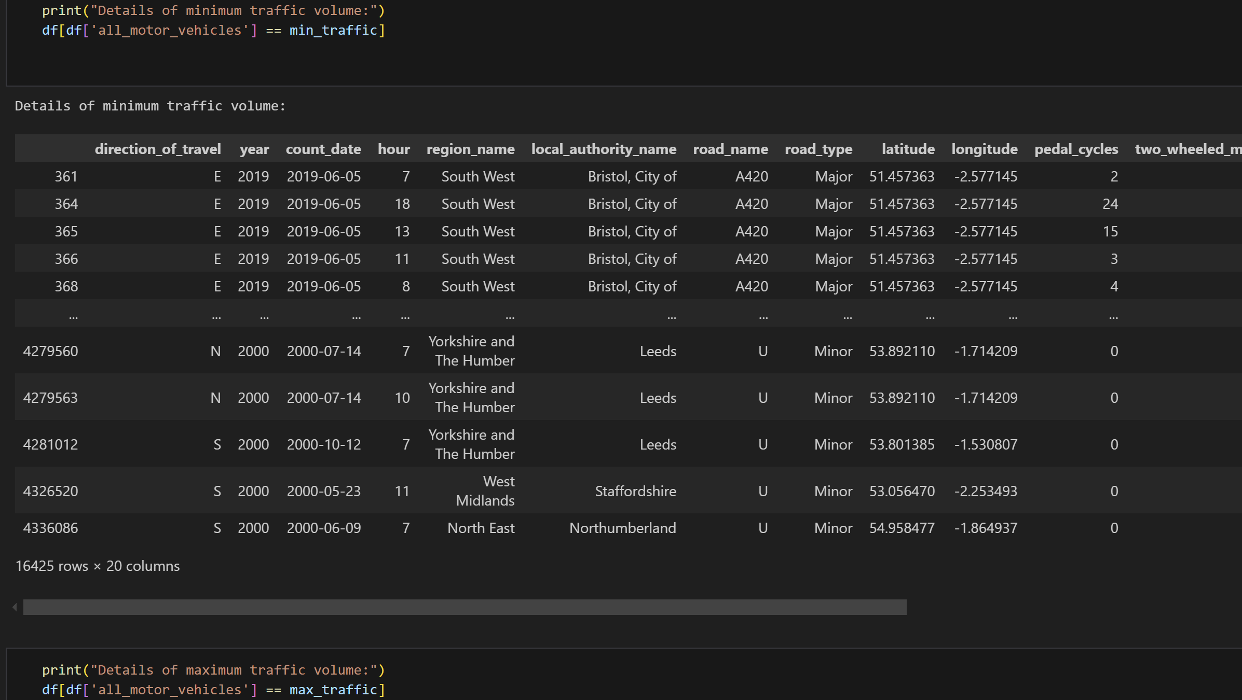

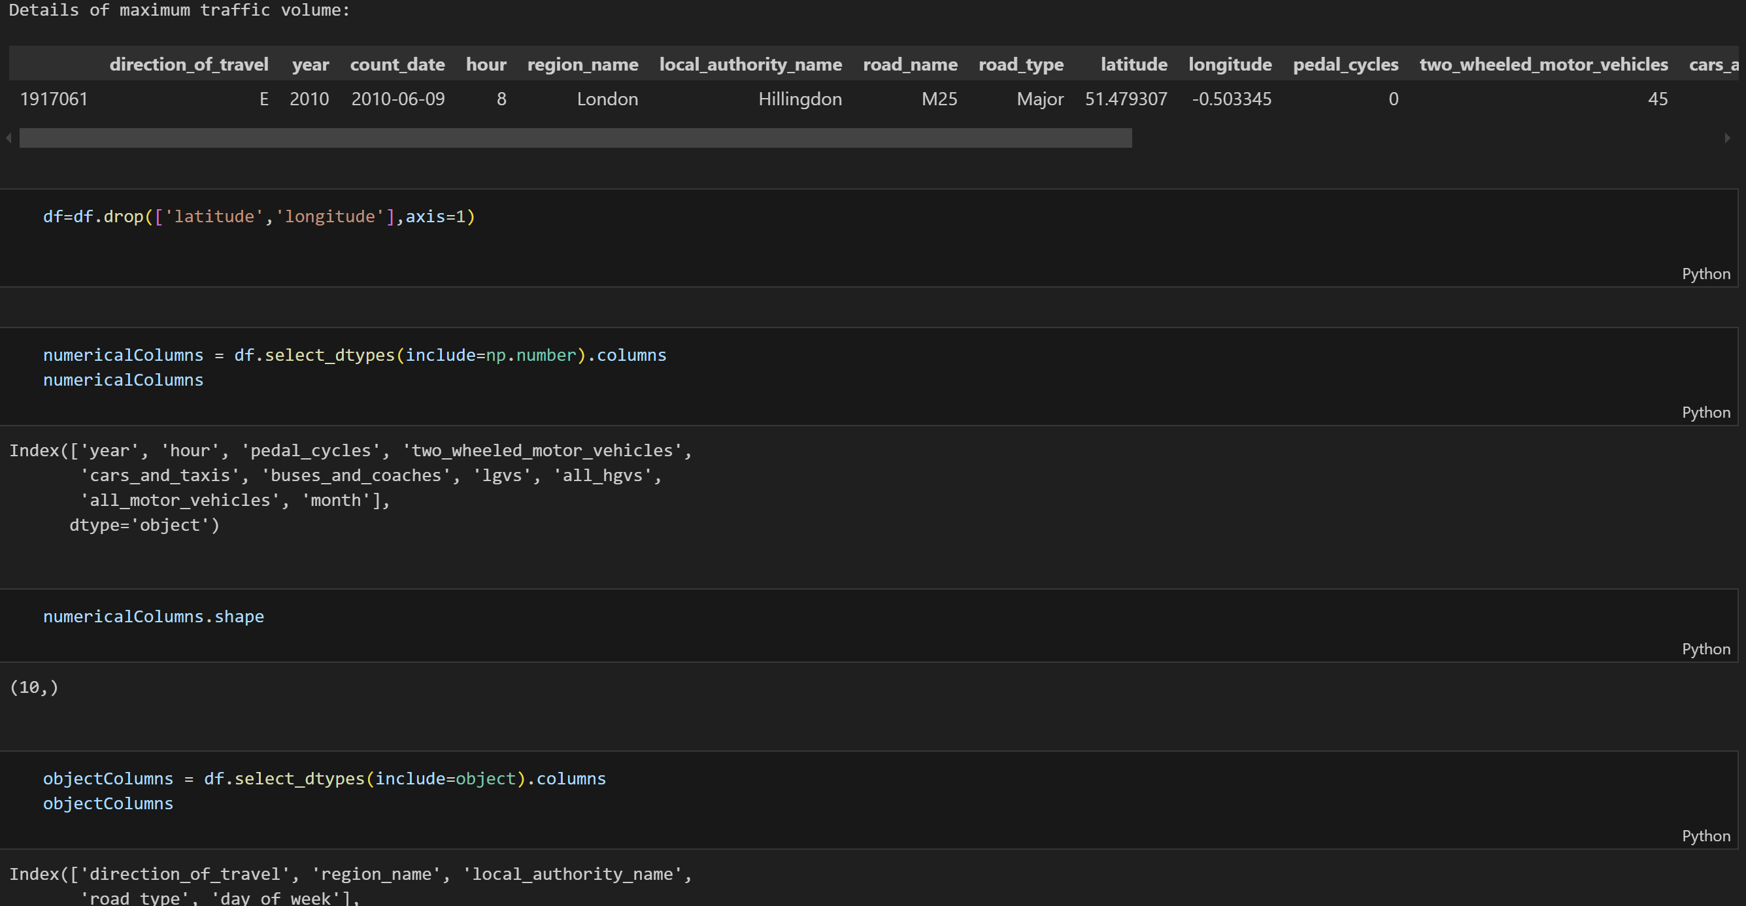

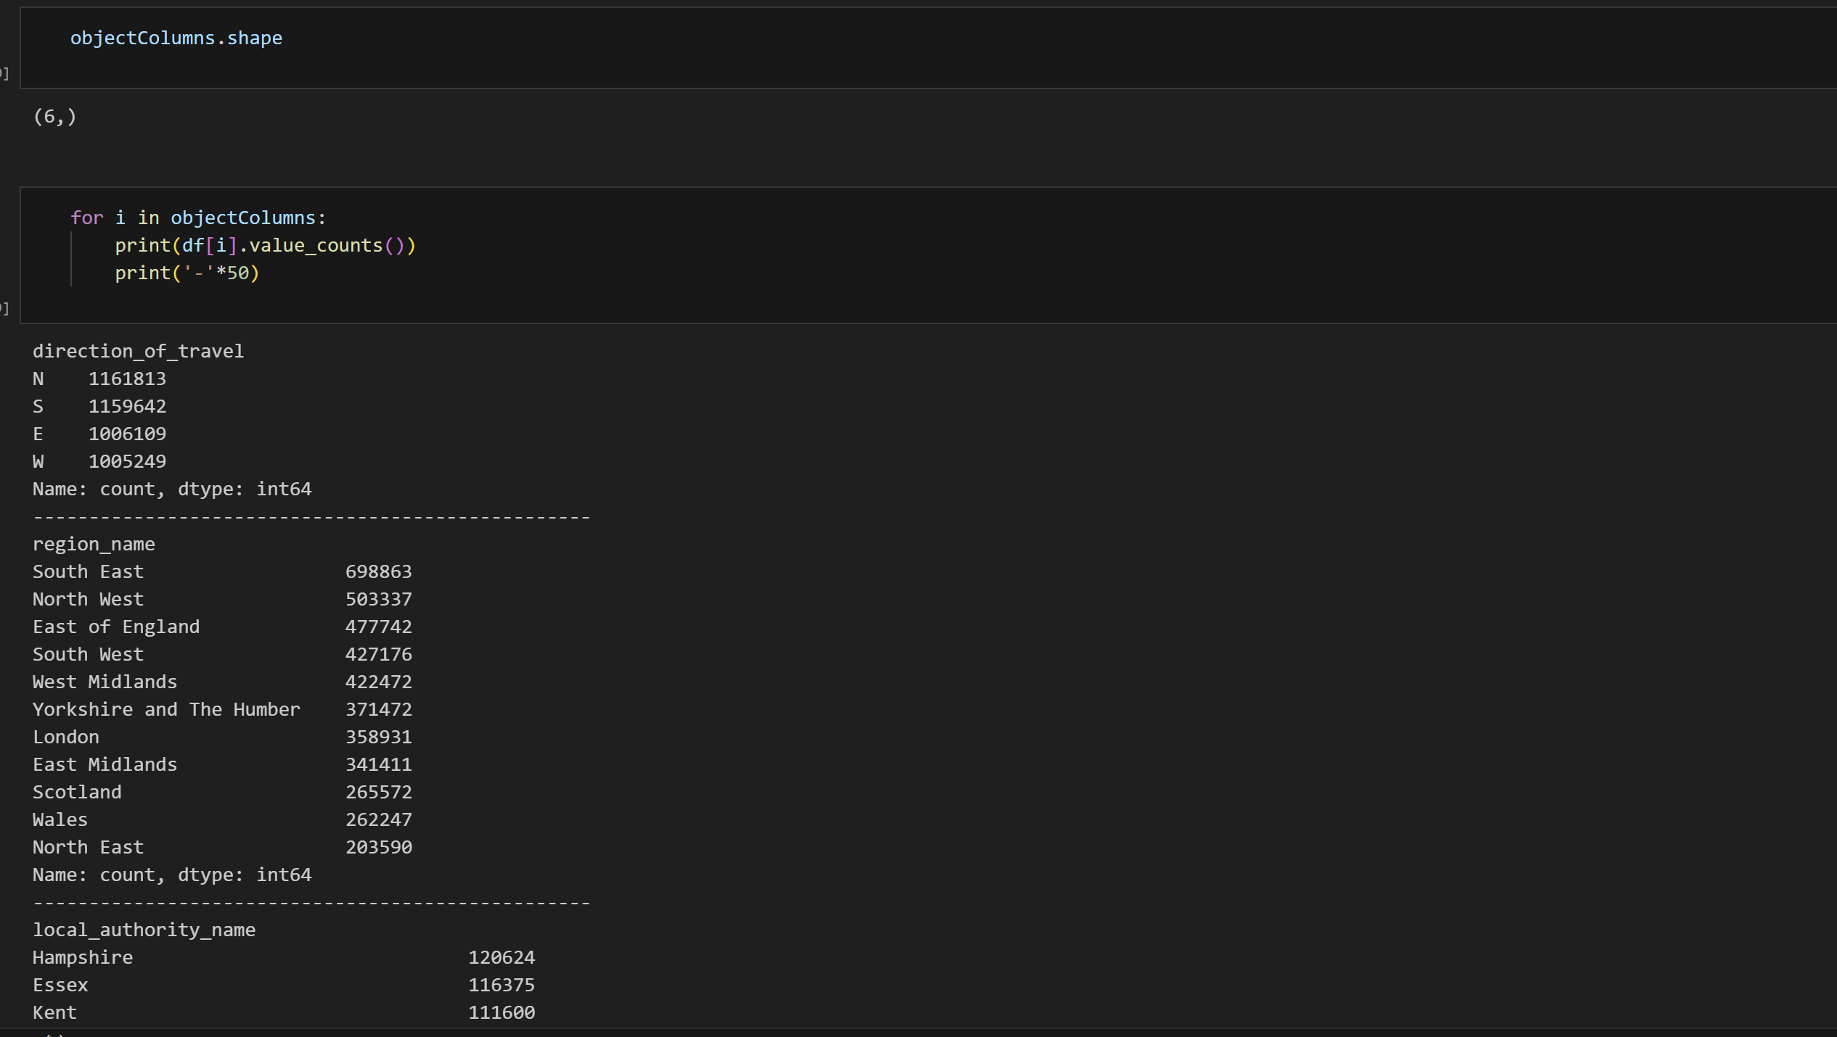

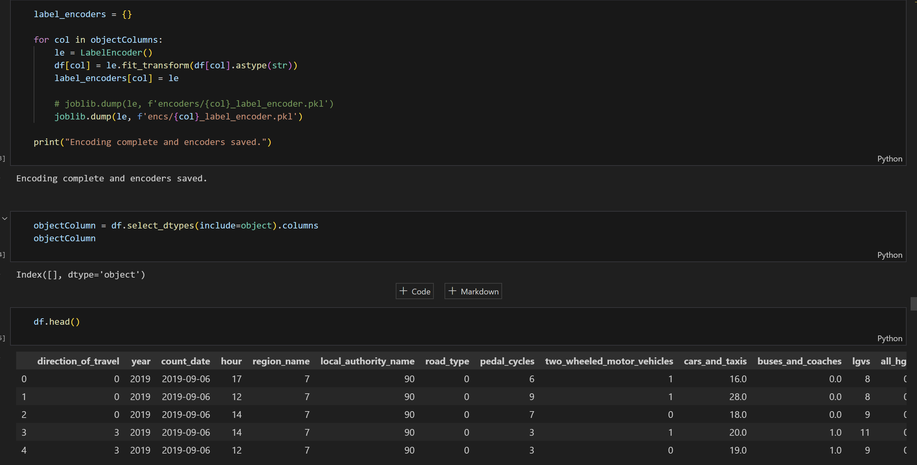

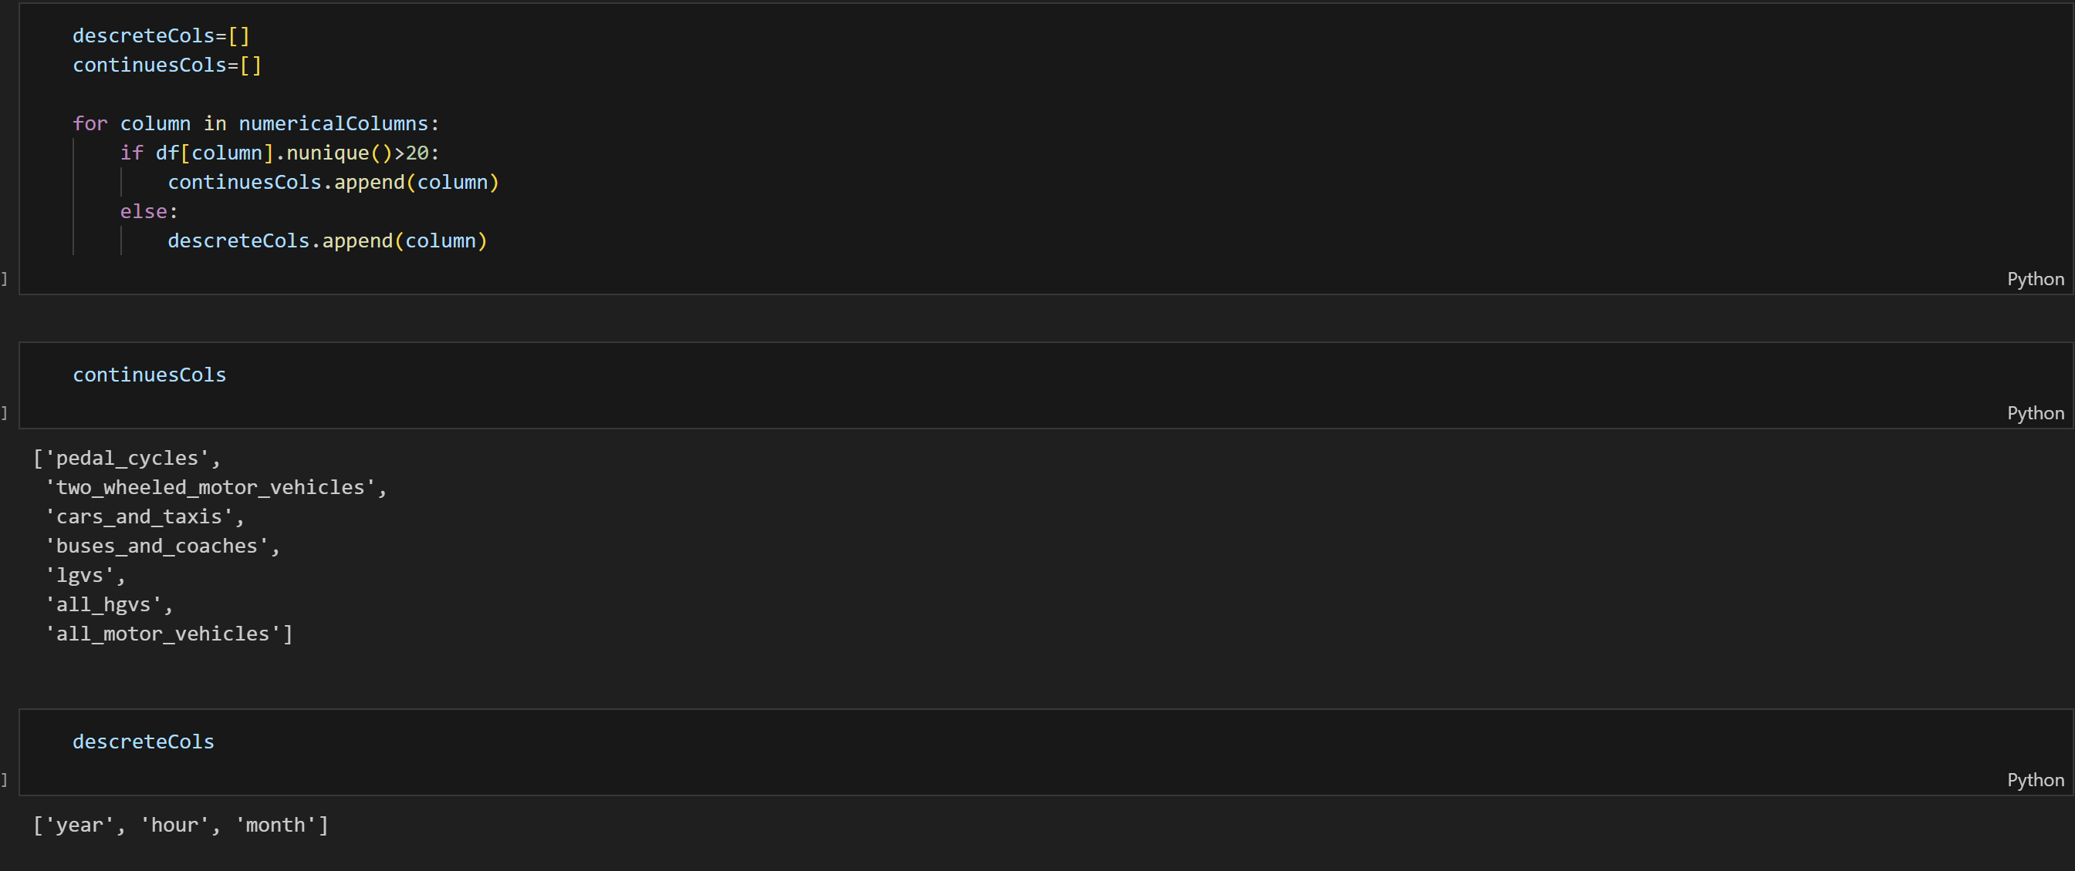

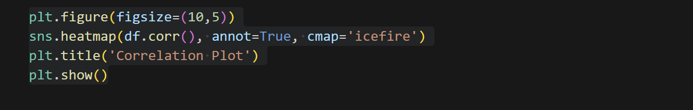

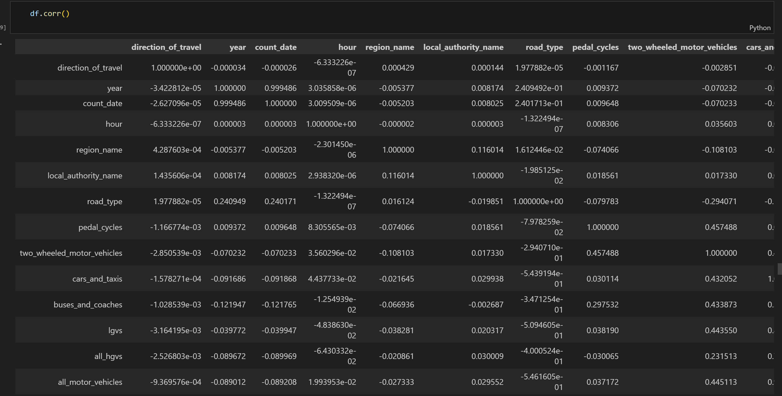

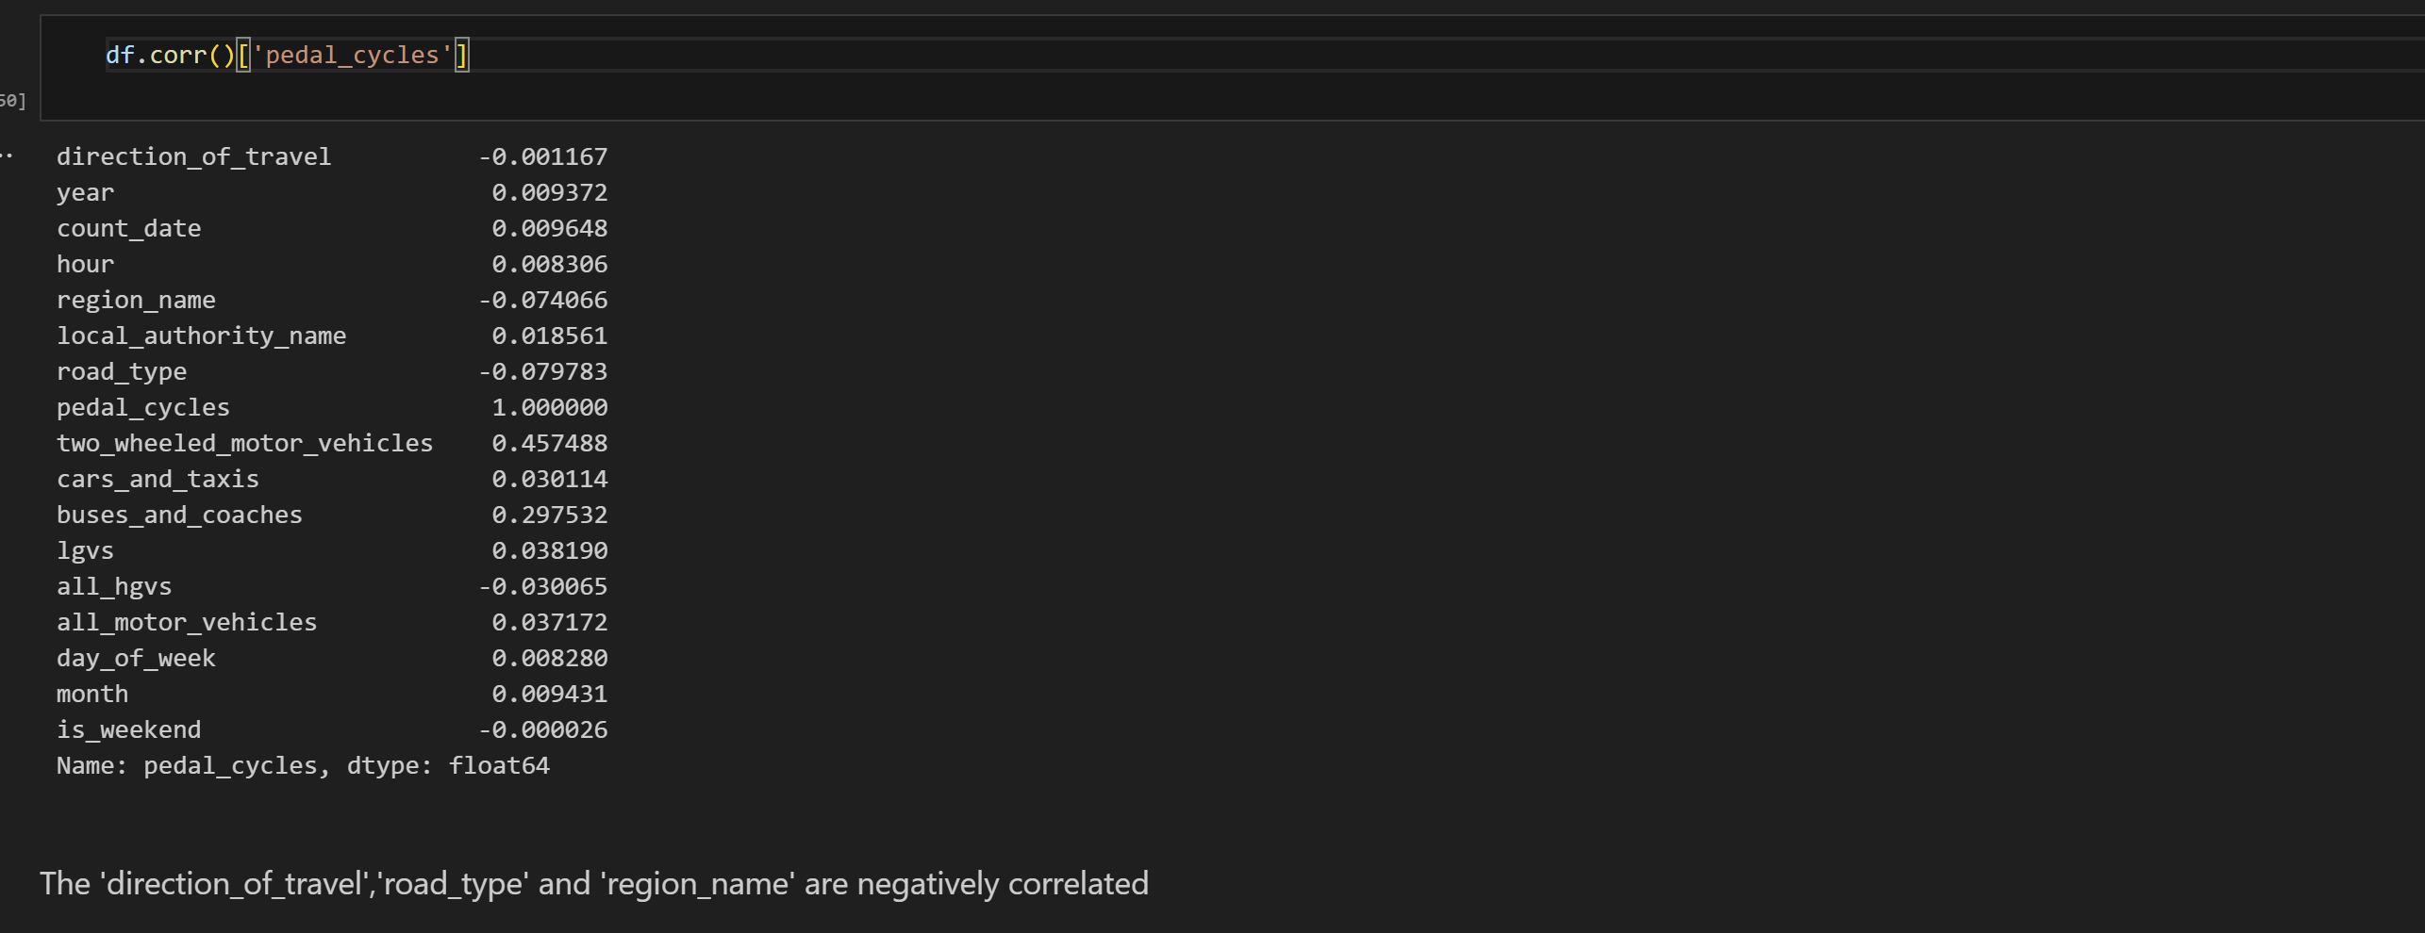

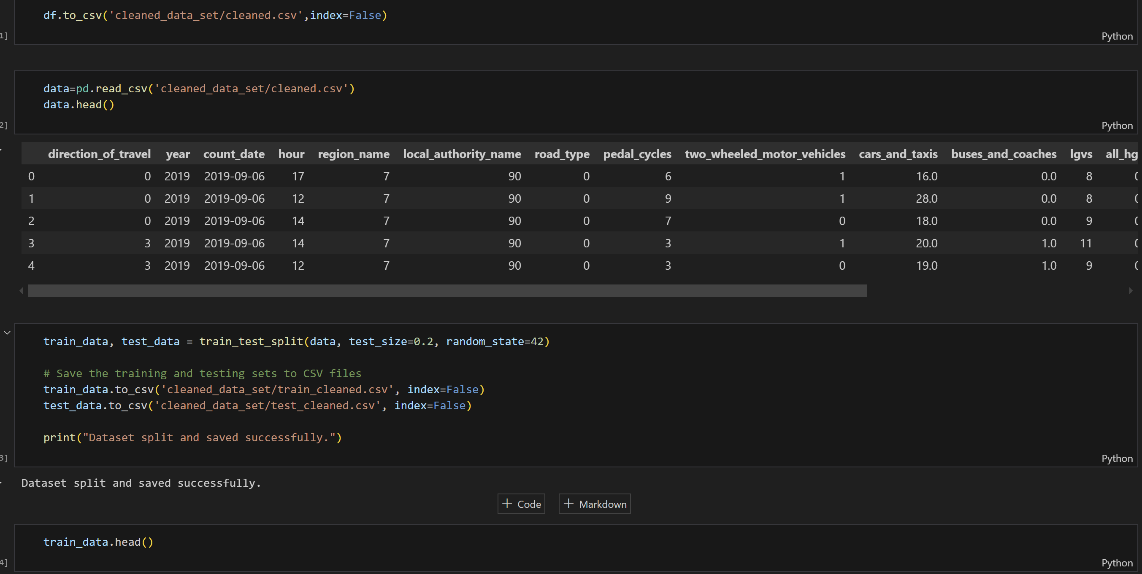

The code for training of the machine learning models.

1. Pedal cycles

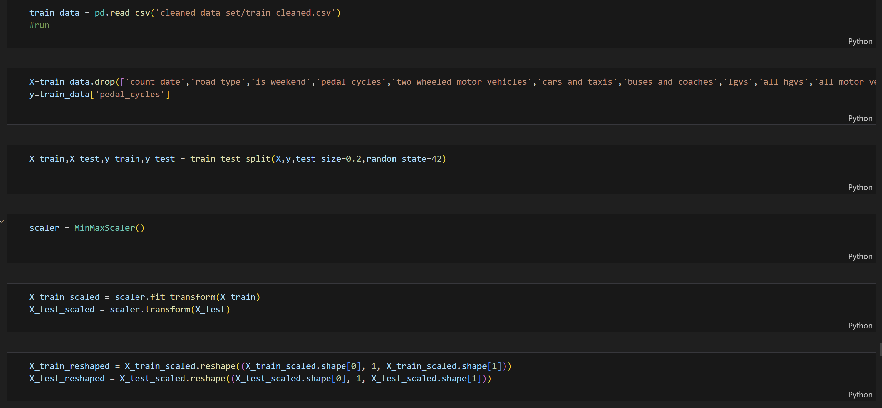

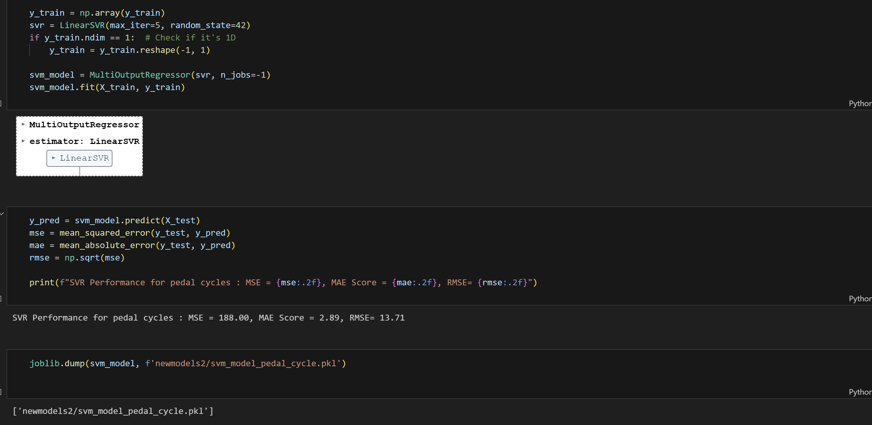

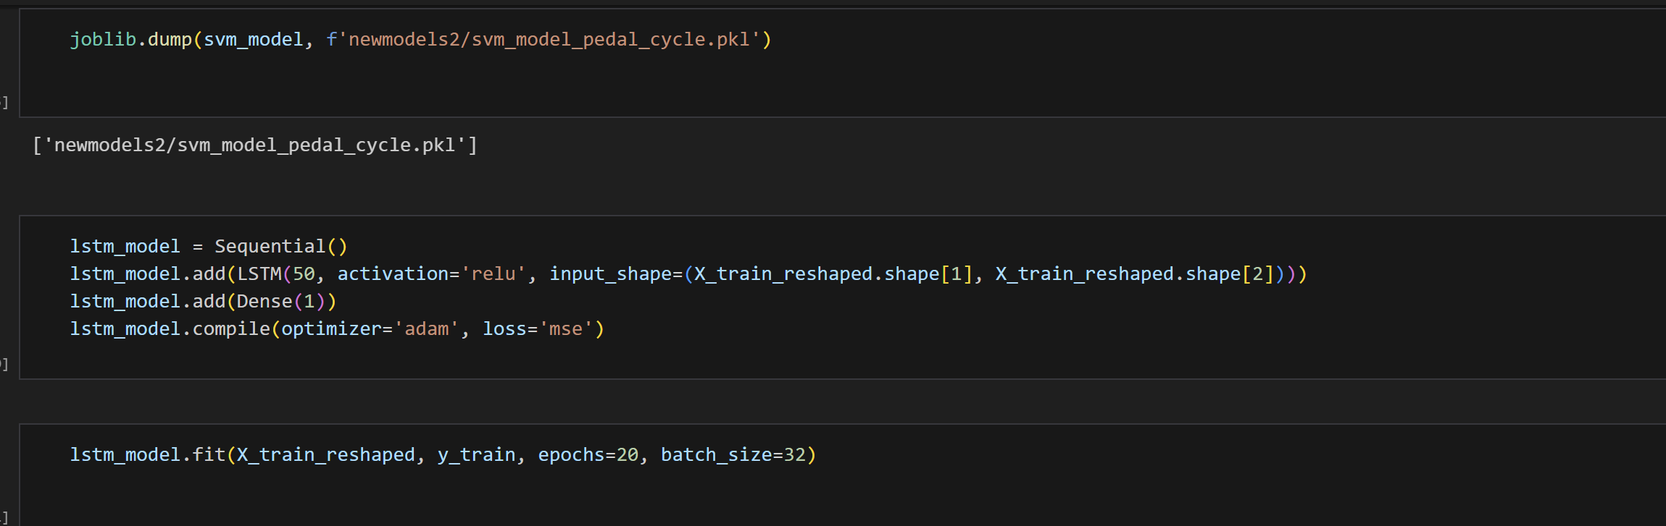

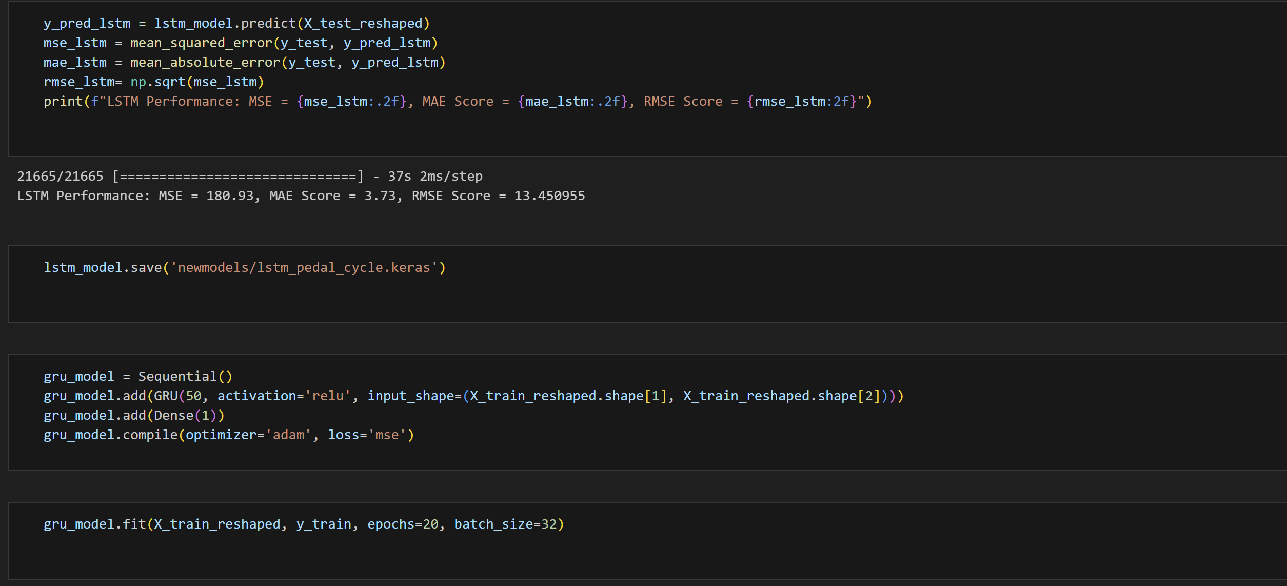

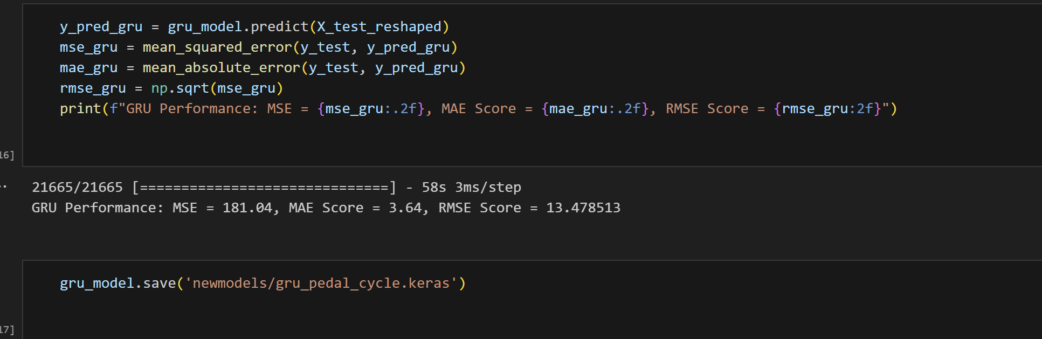

1. Cars and Taxis

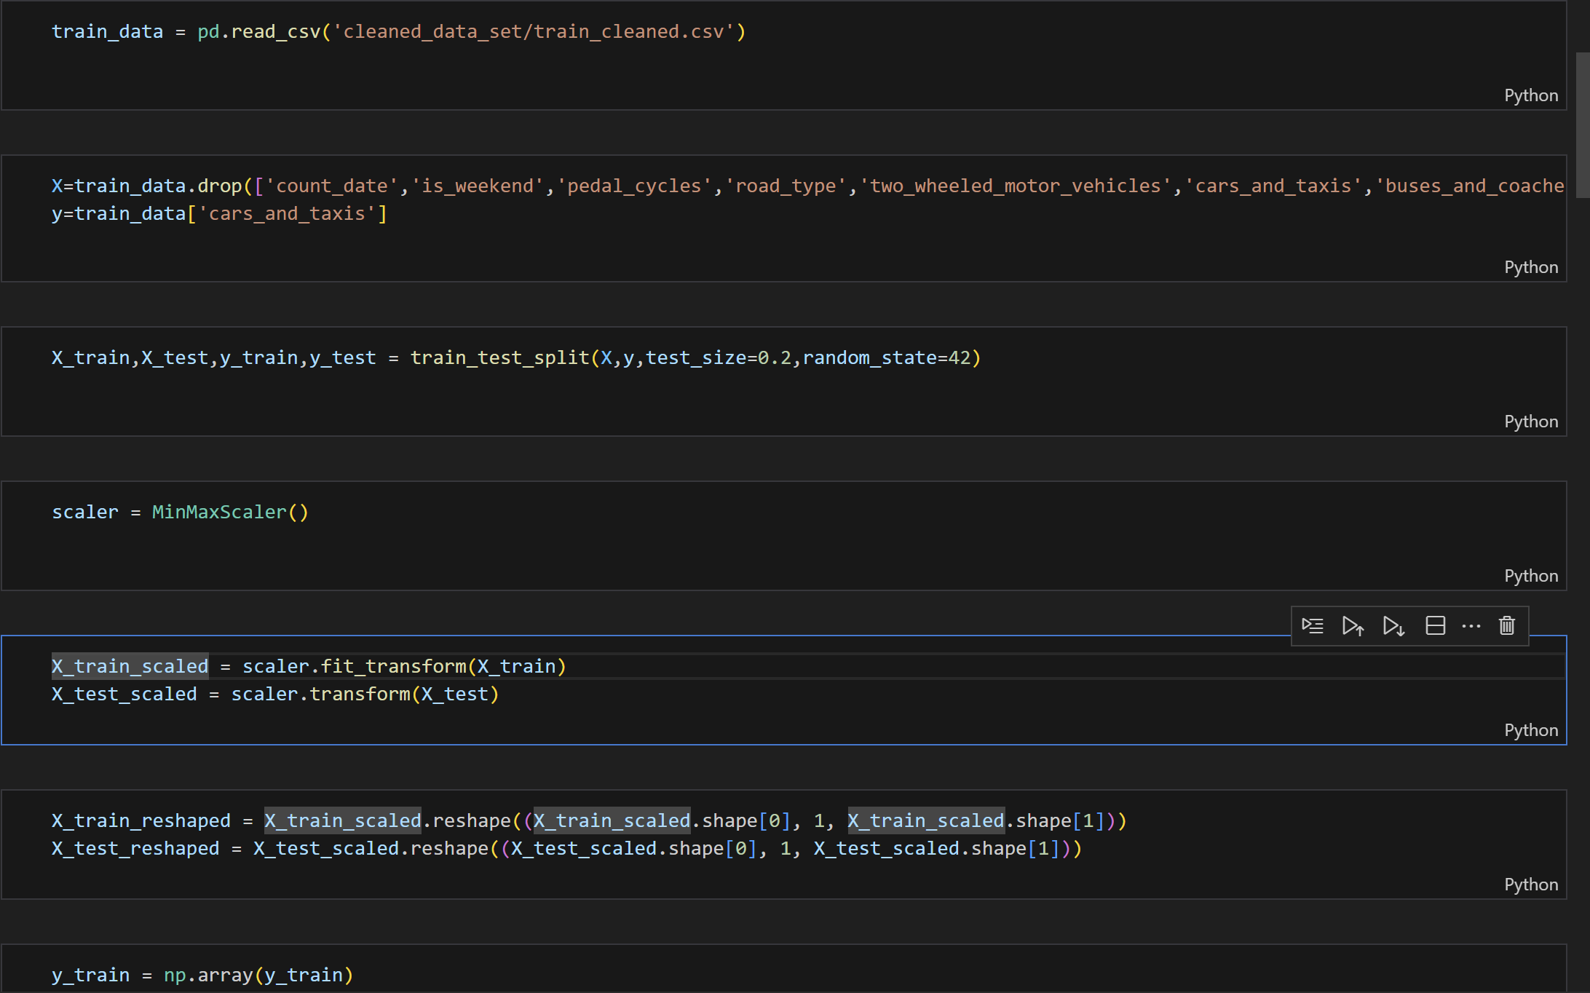

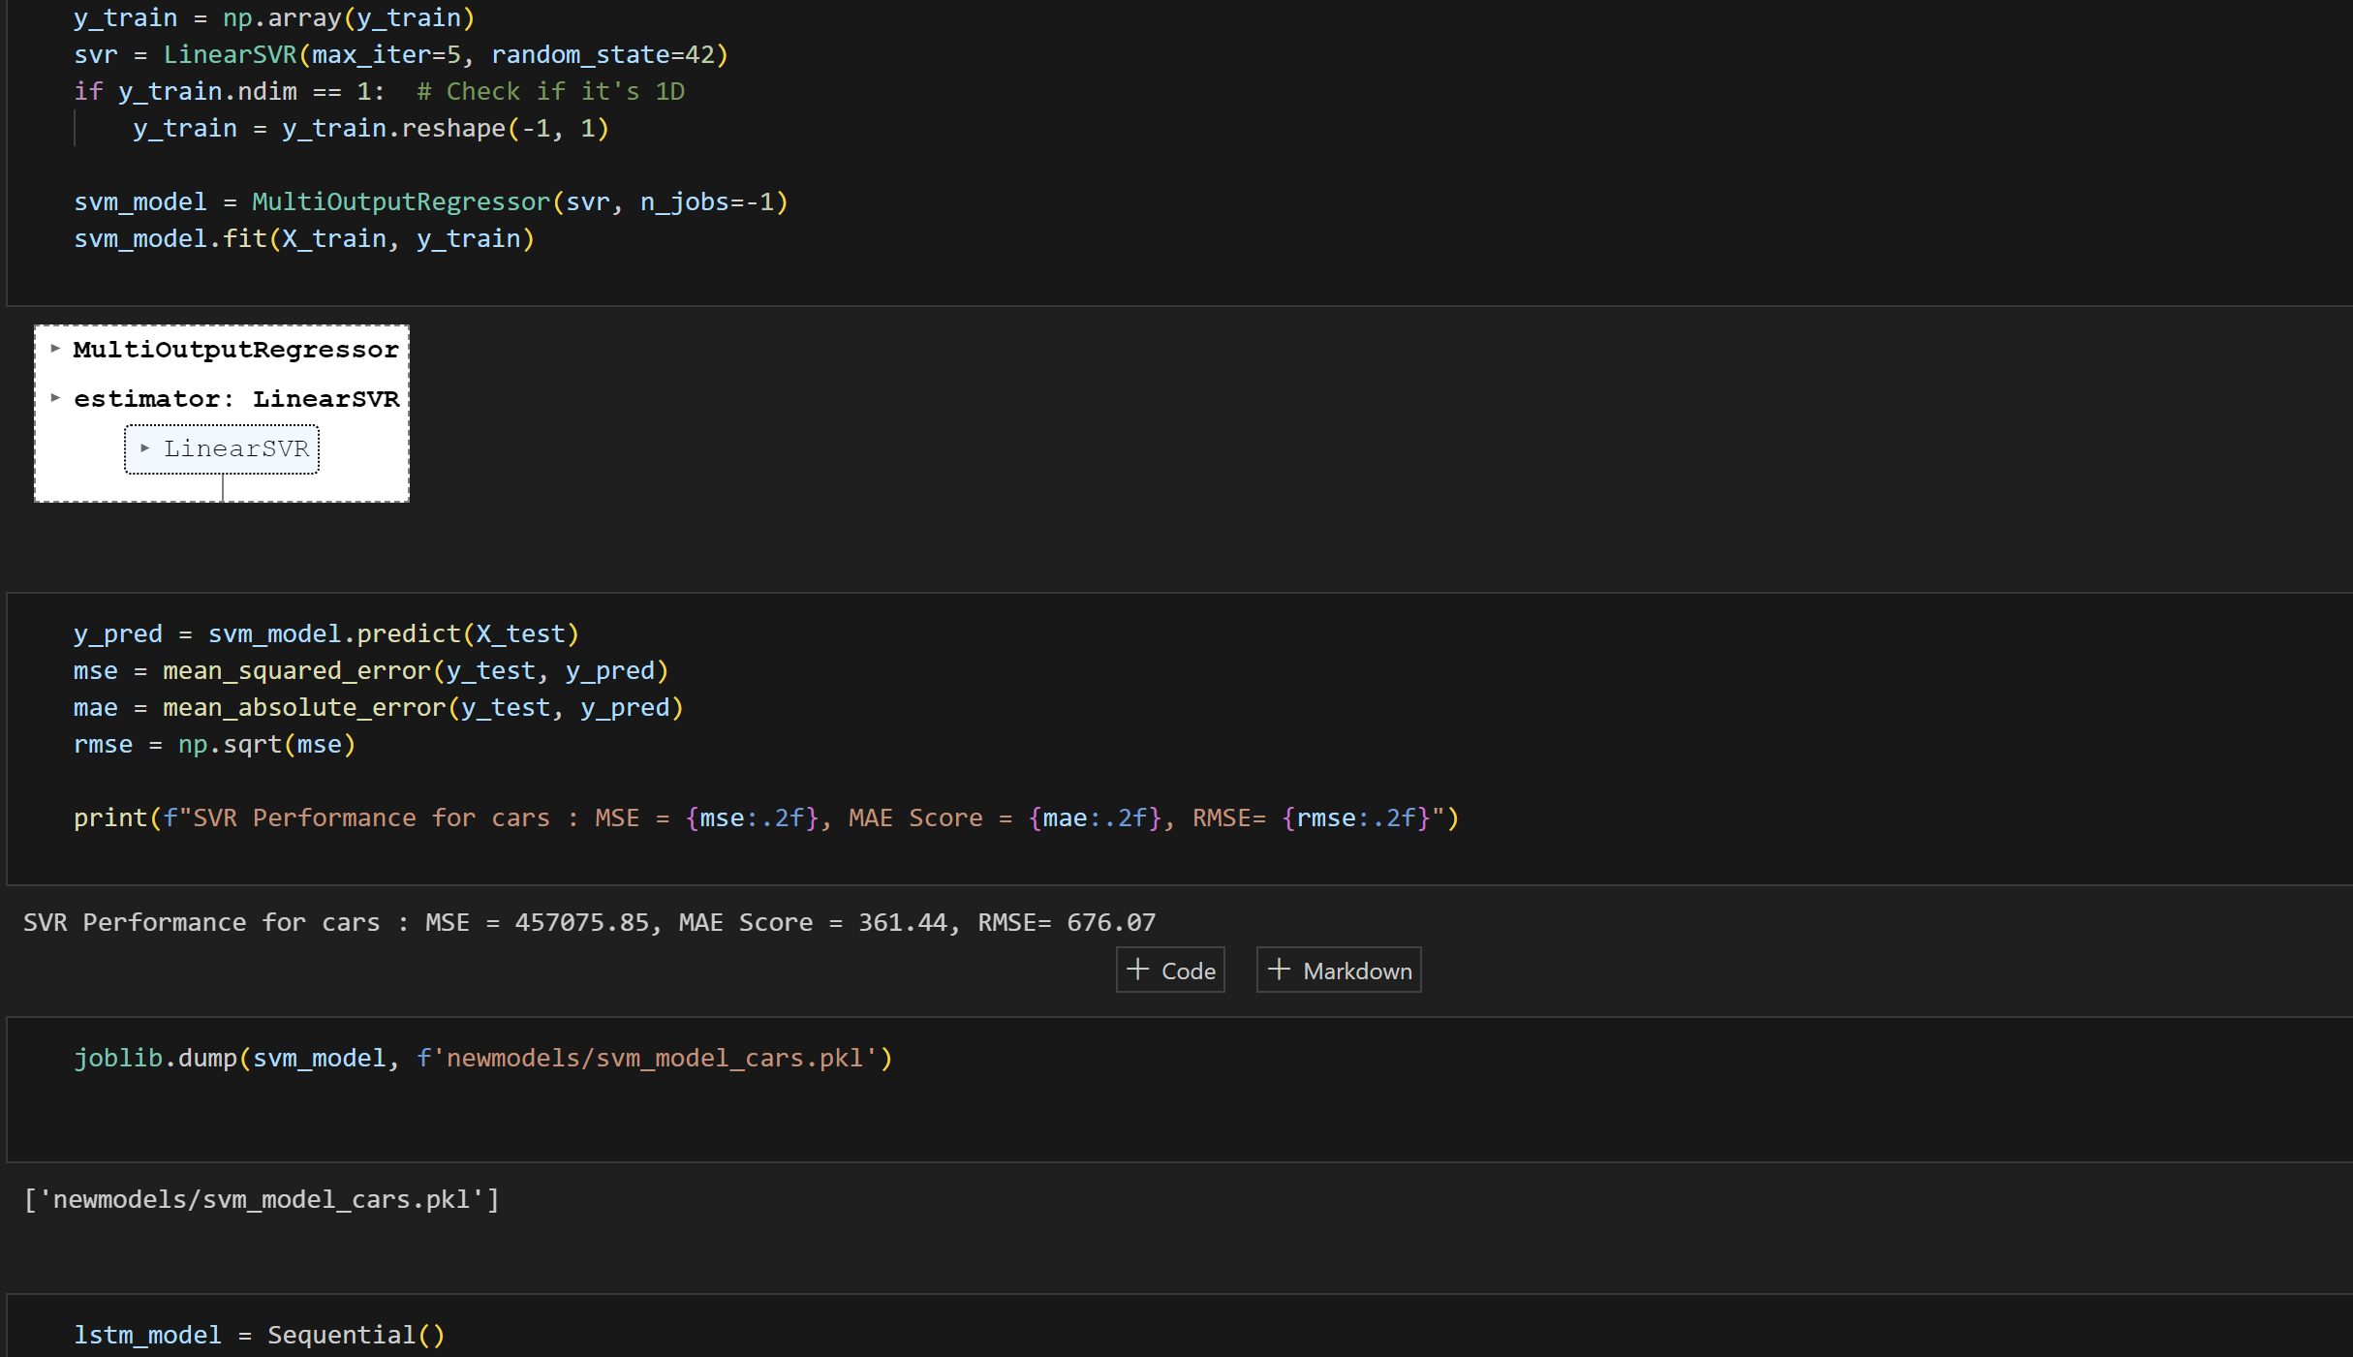

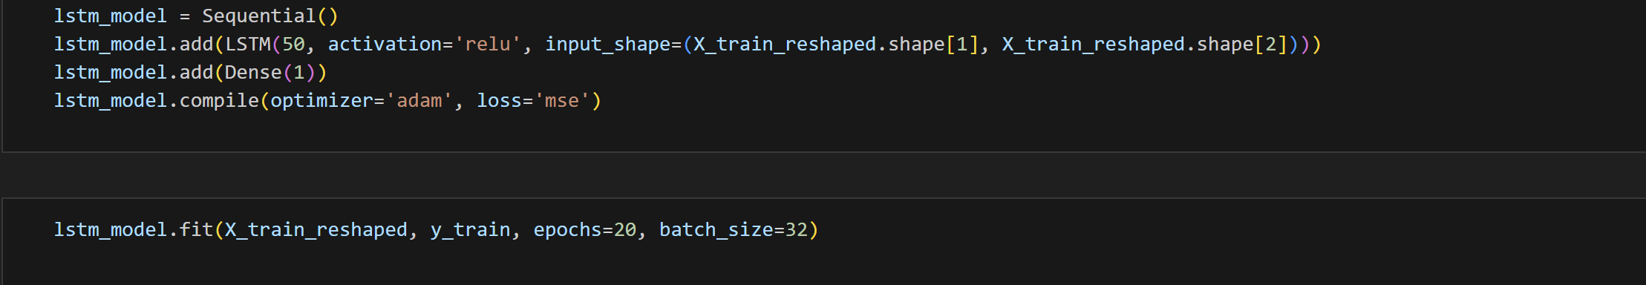

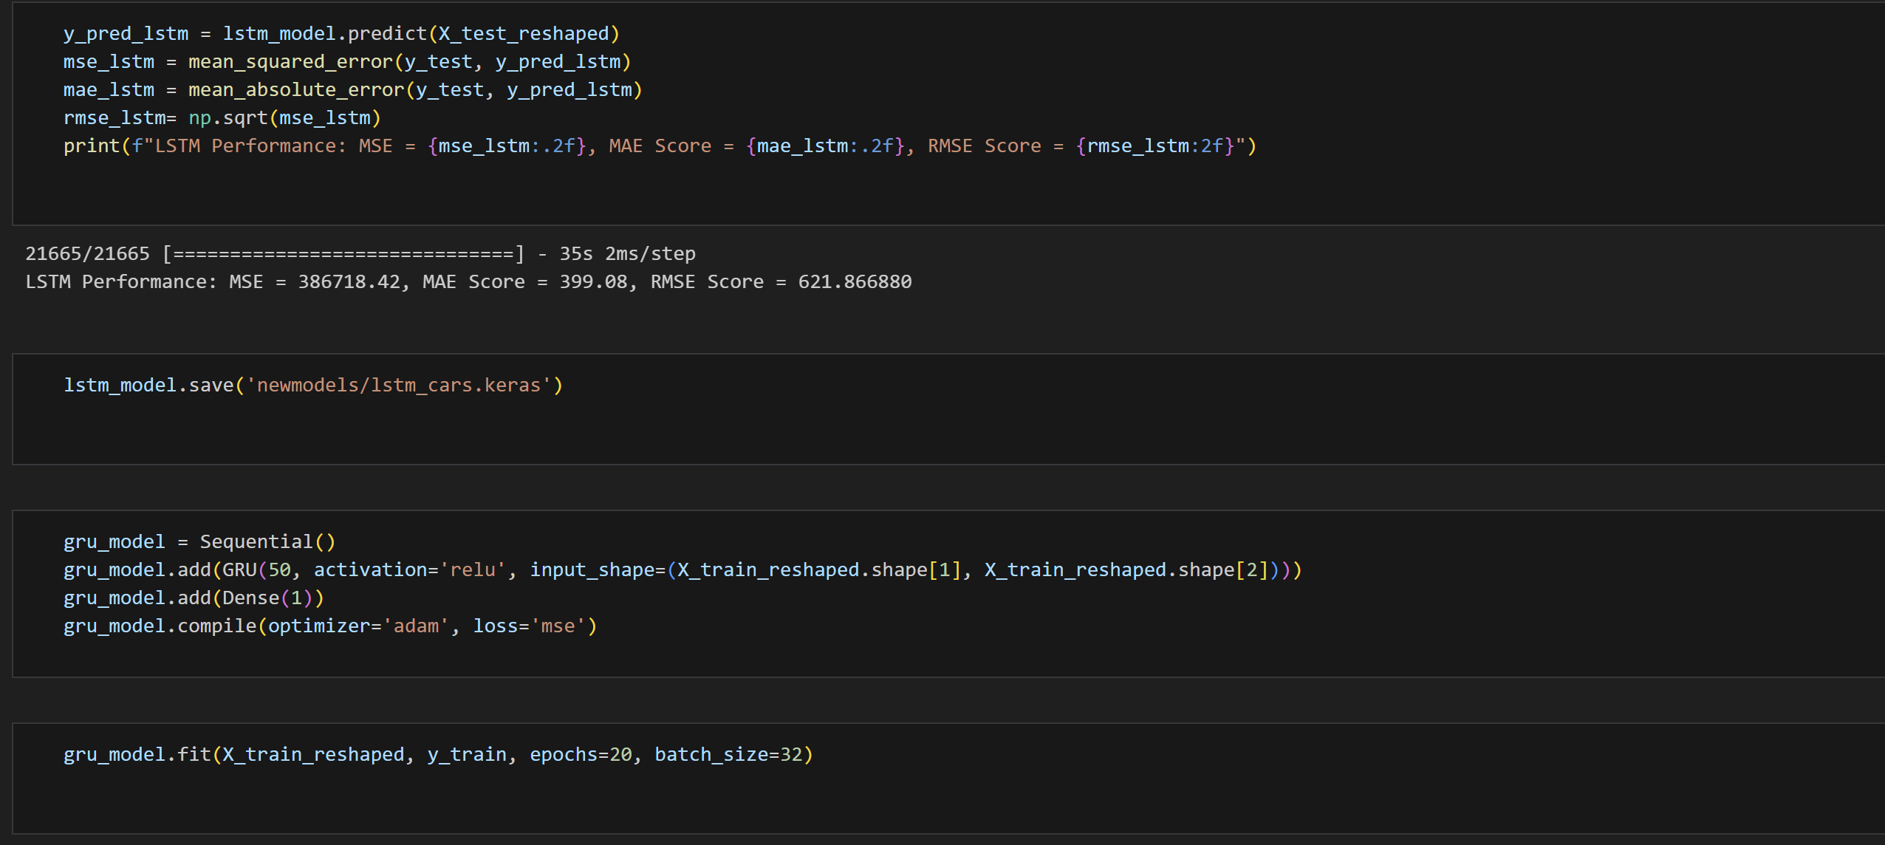

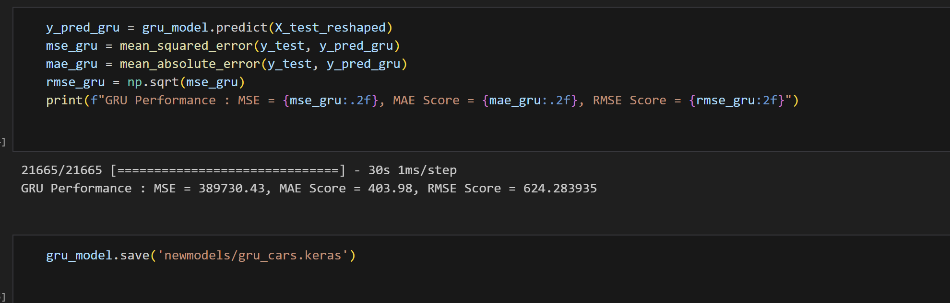

c)Two wheeled motorcycles  
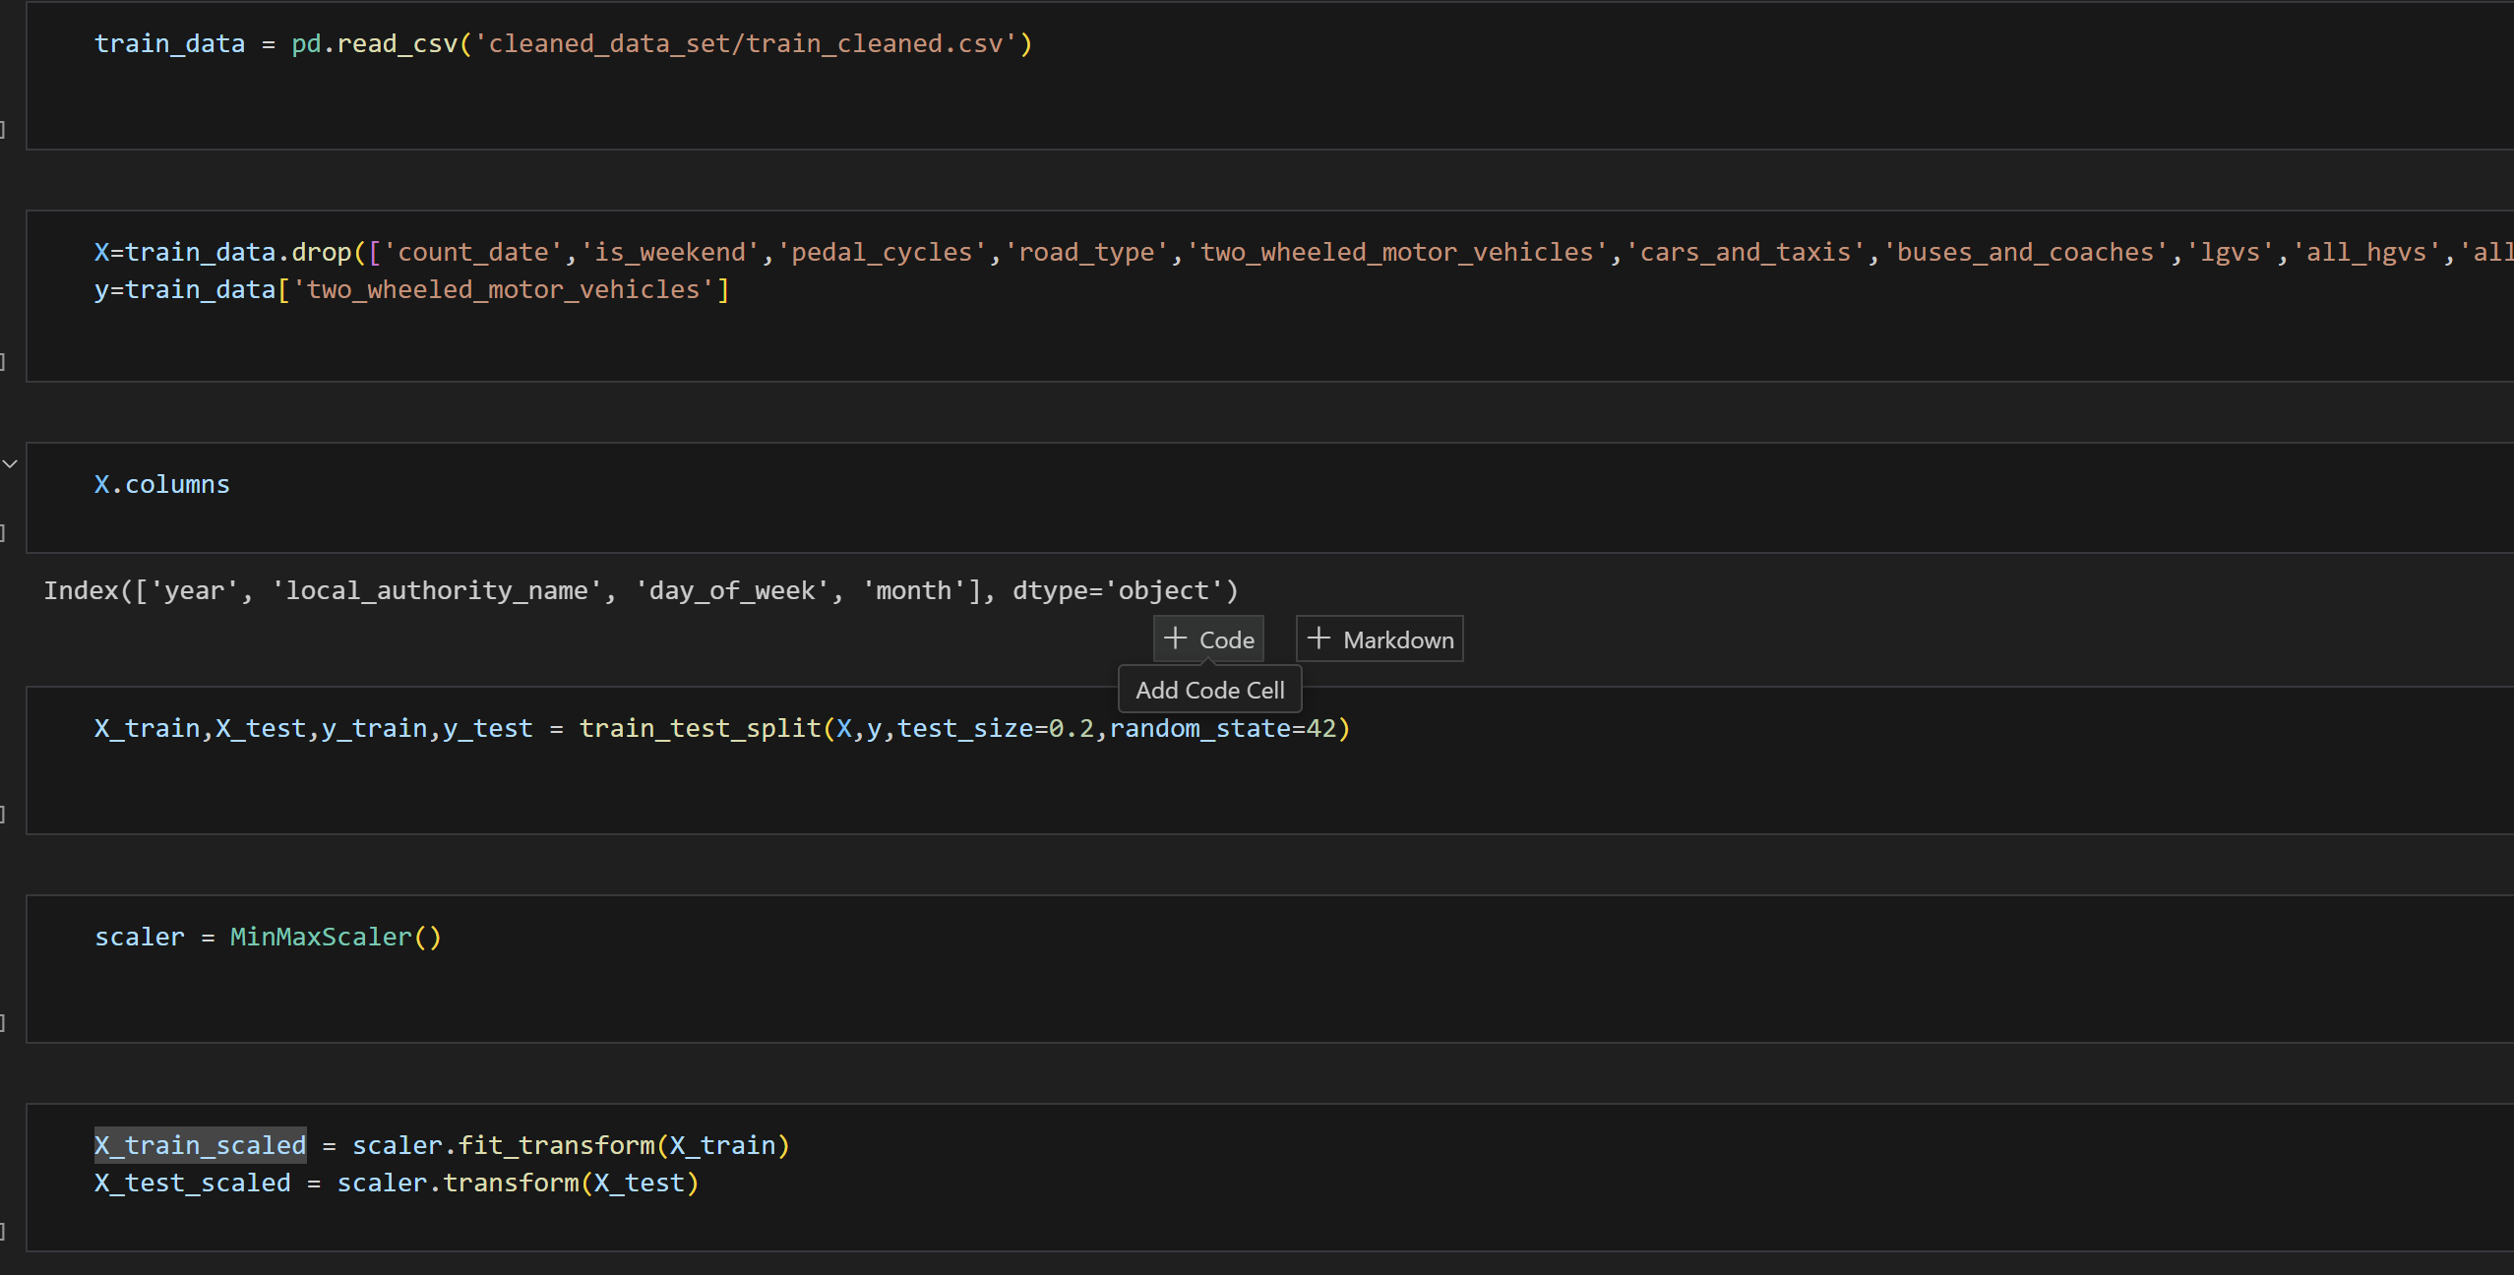

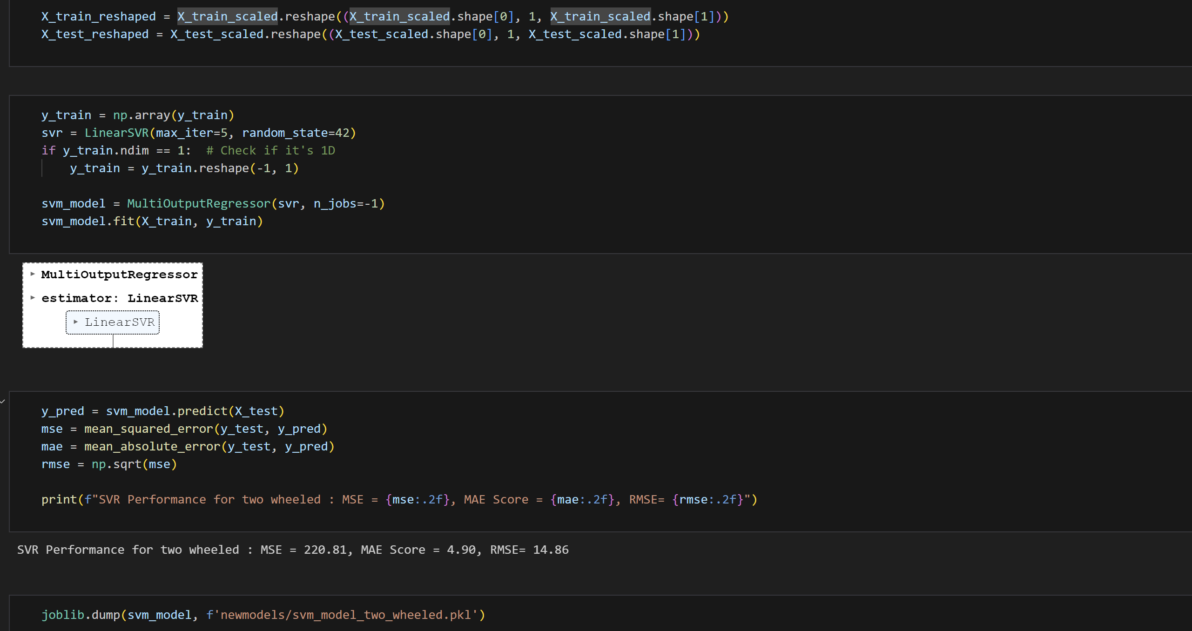

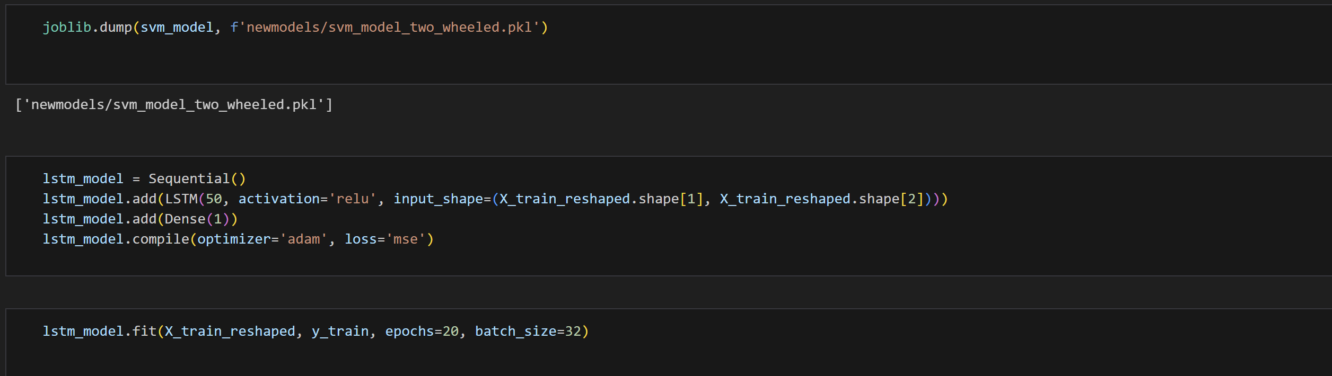

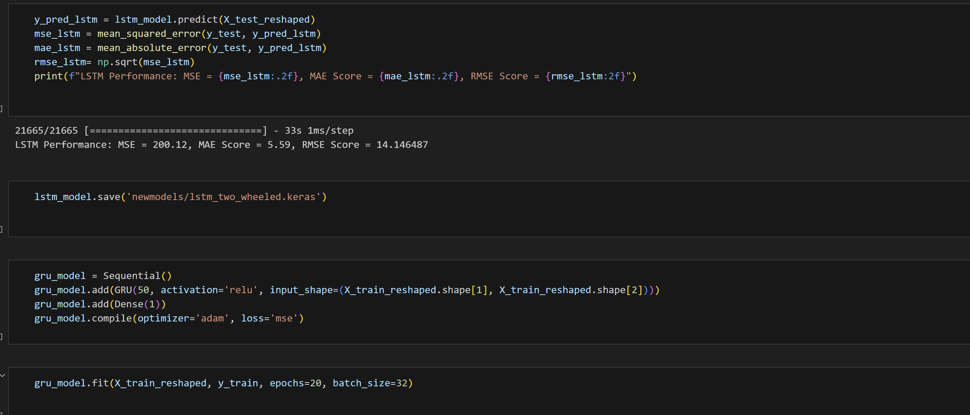

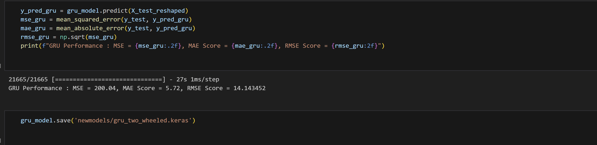

d) Buses and coaches

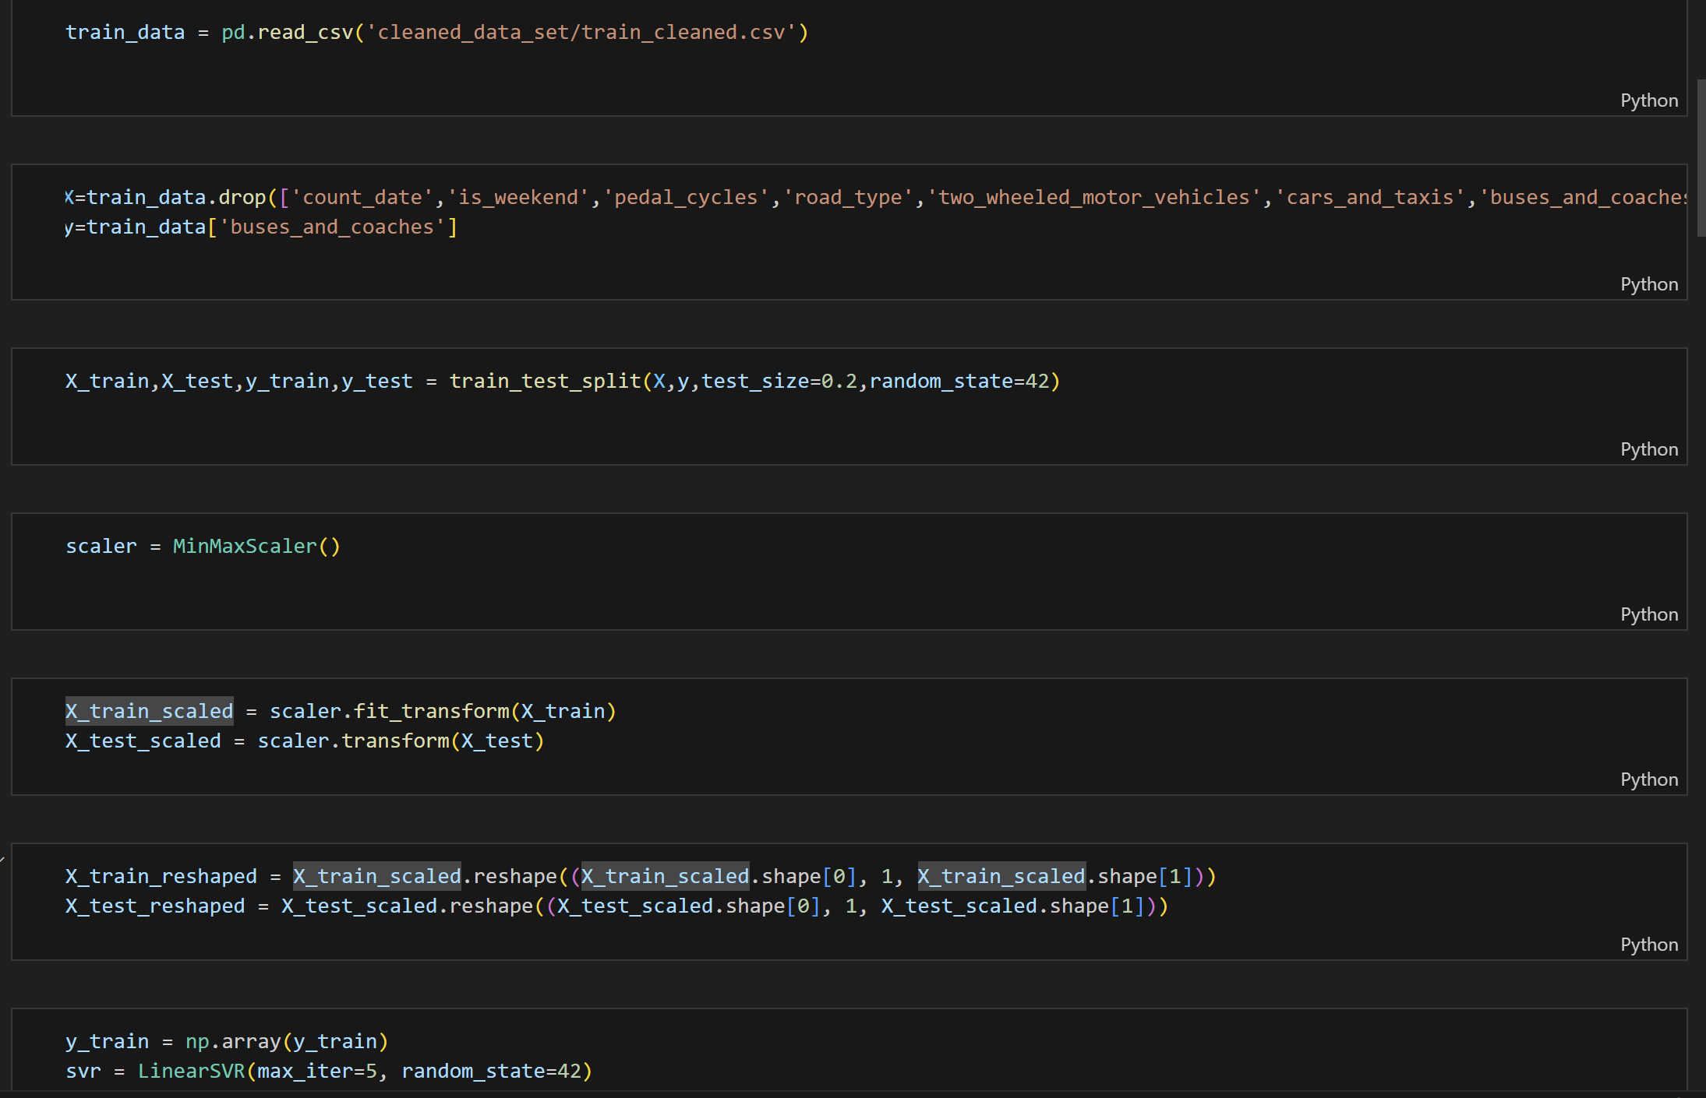

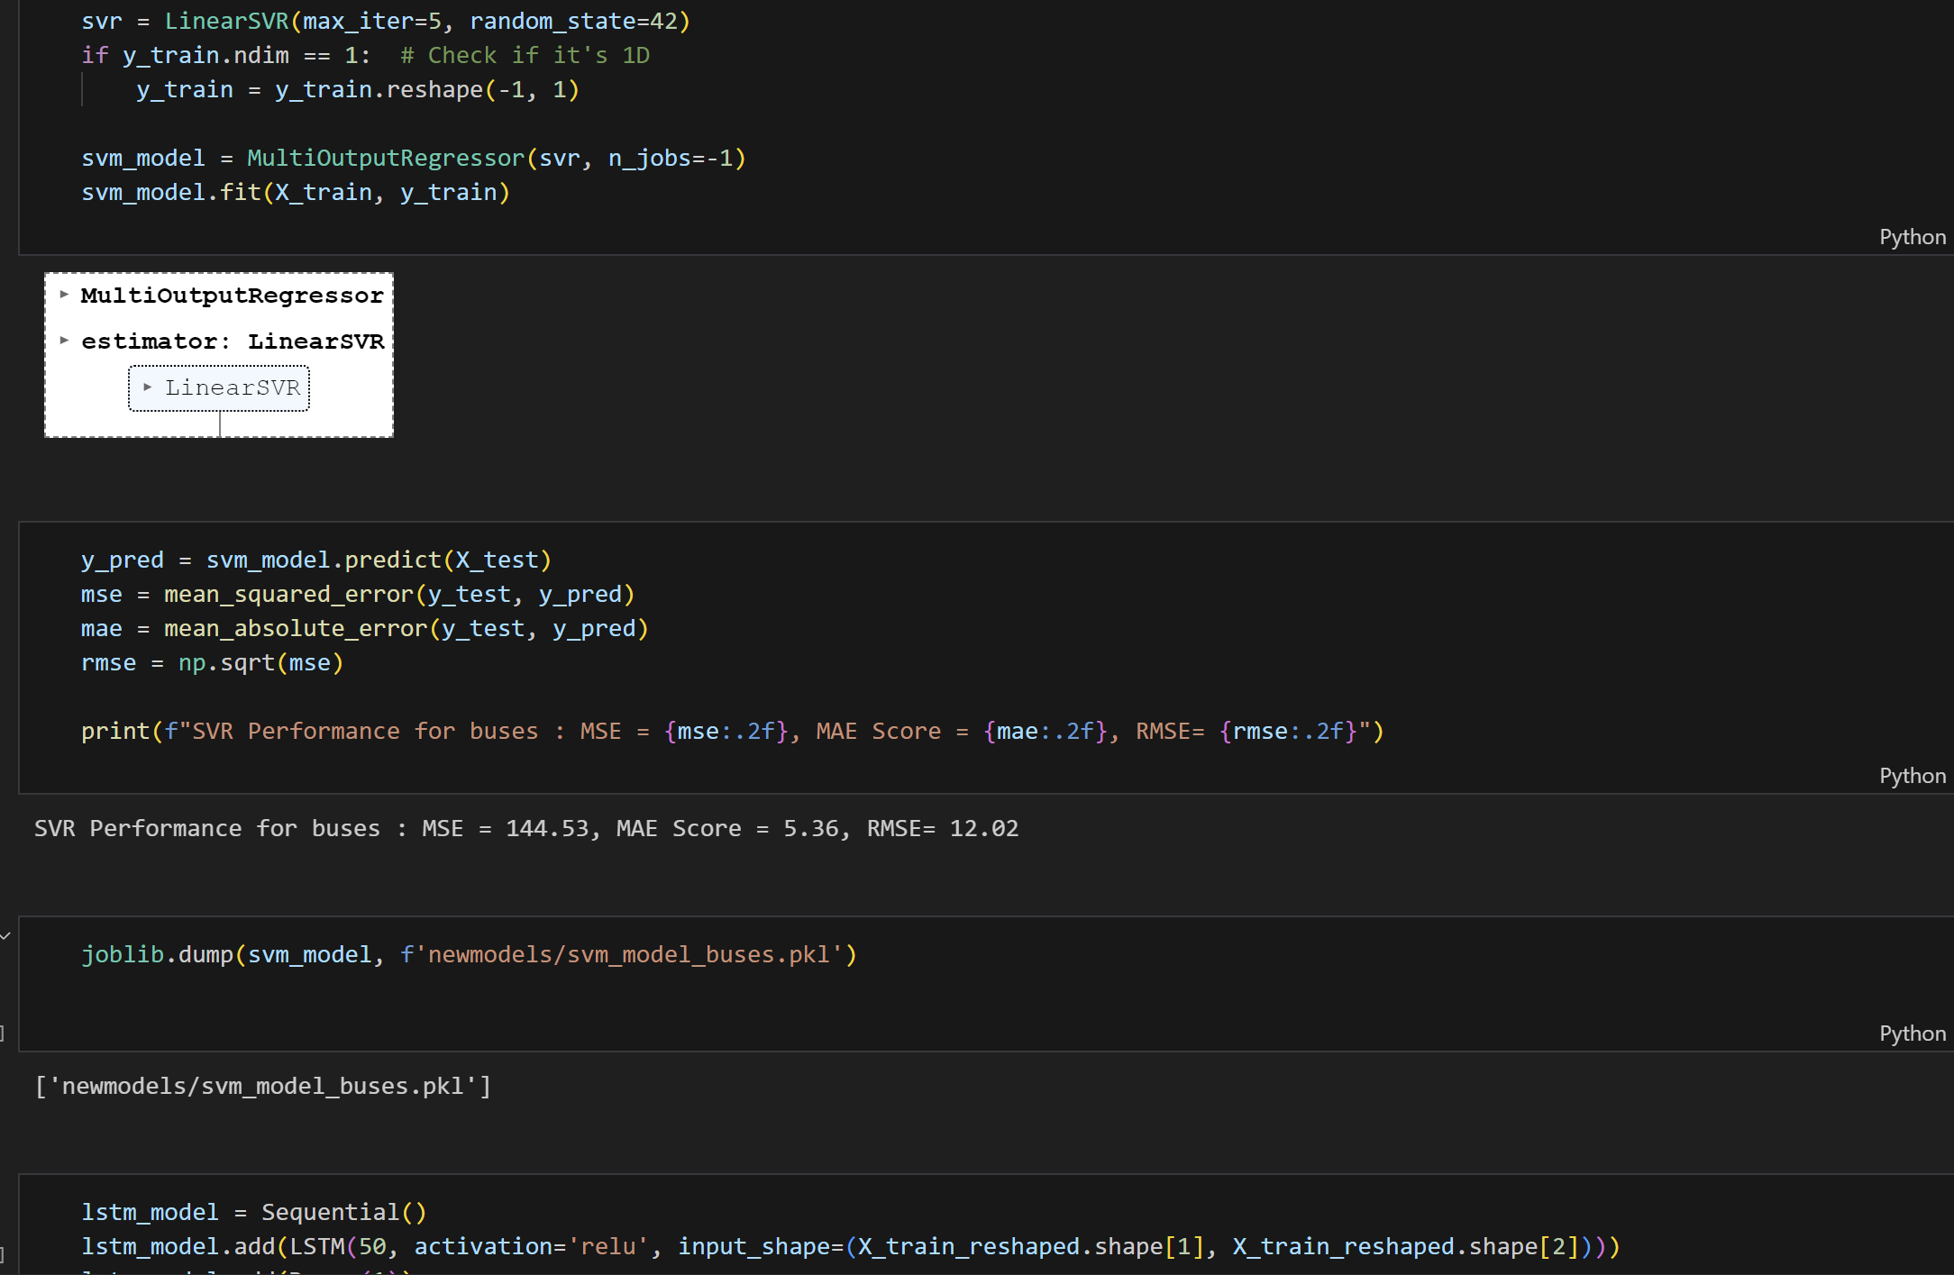

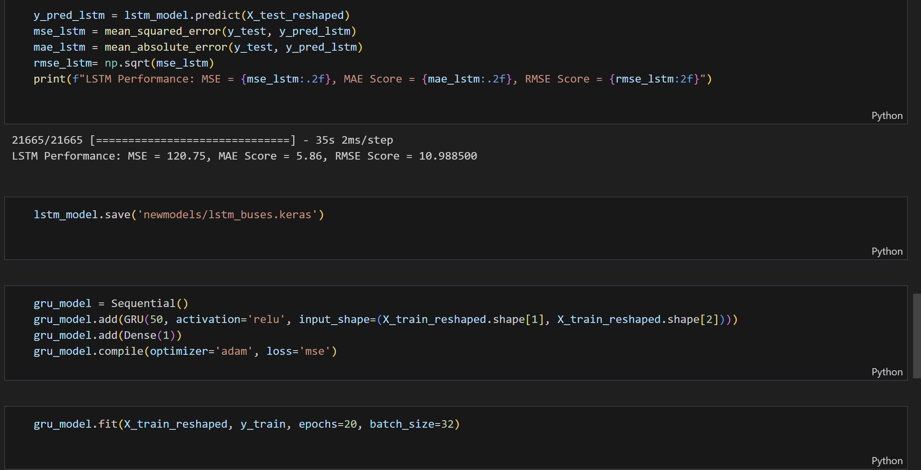

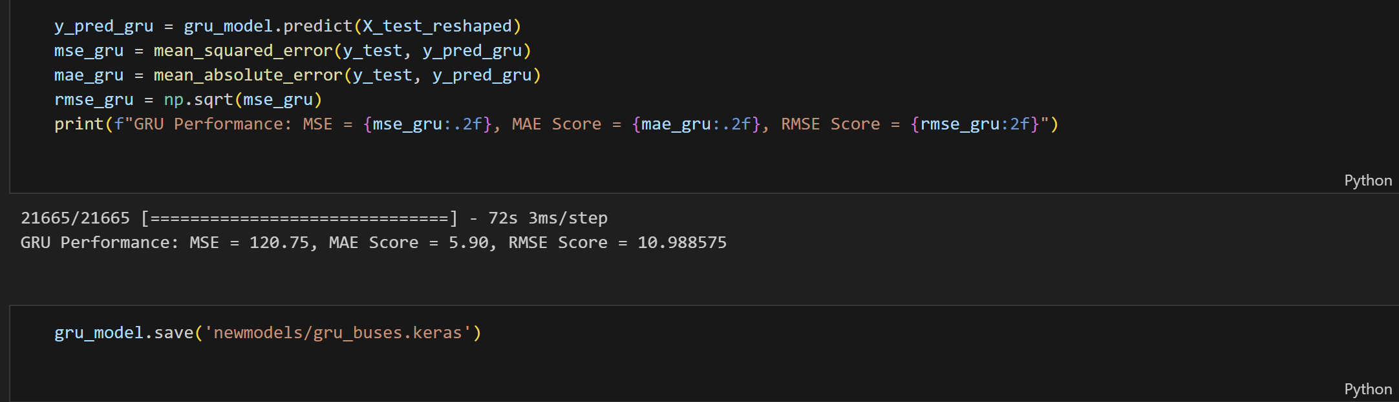

e) lgvs

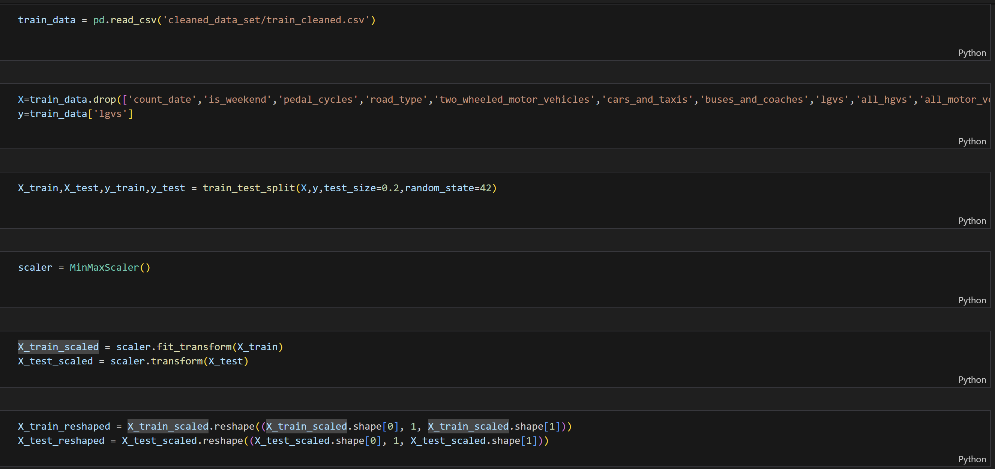

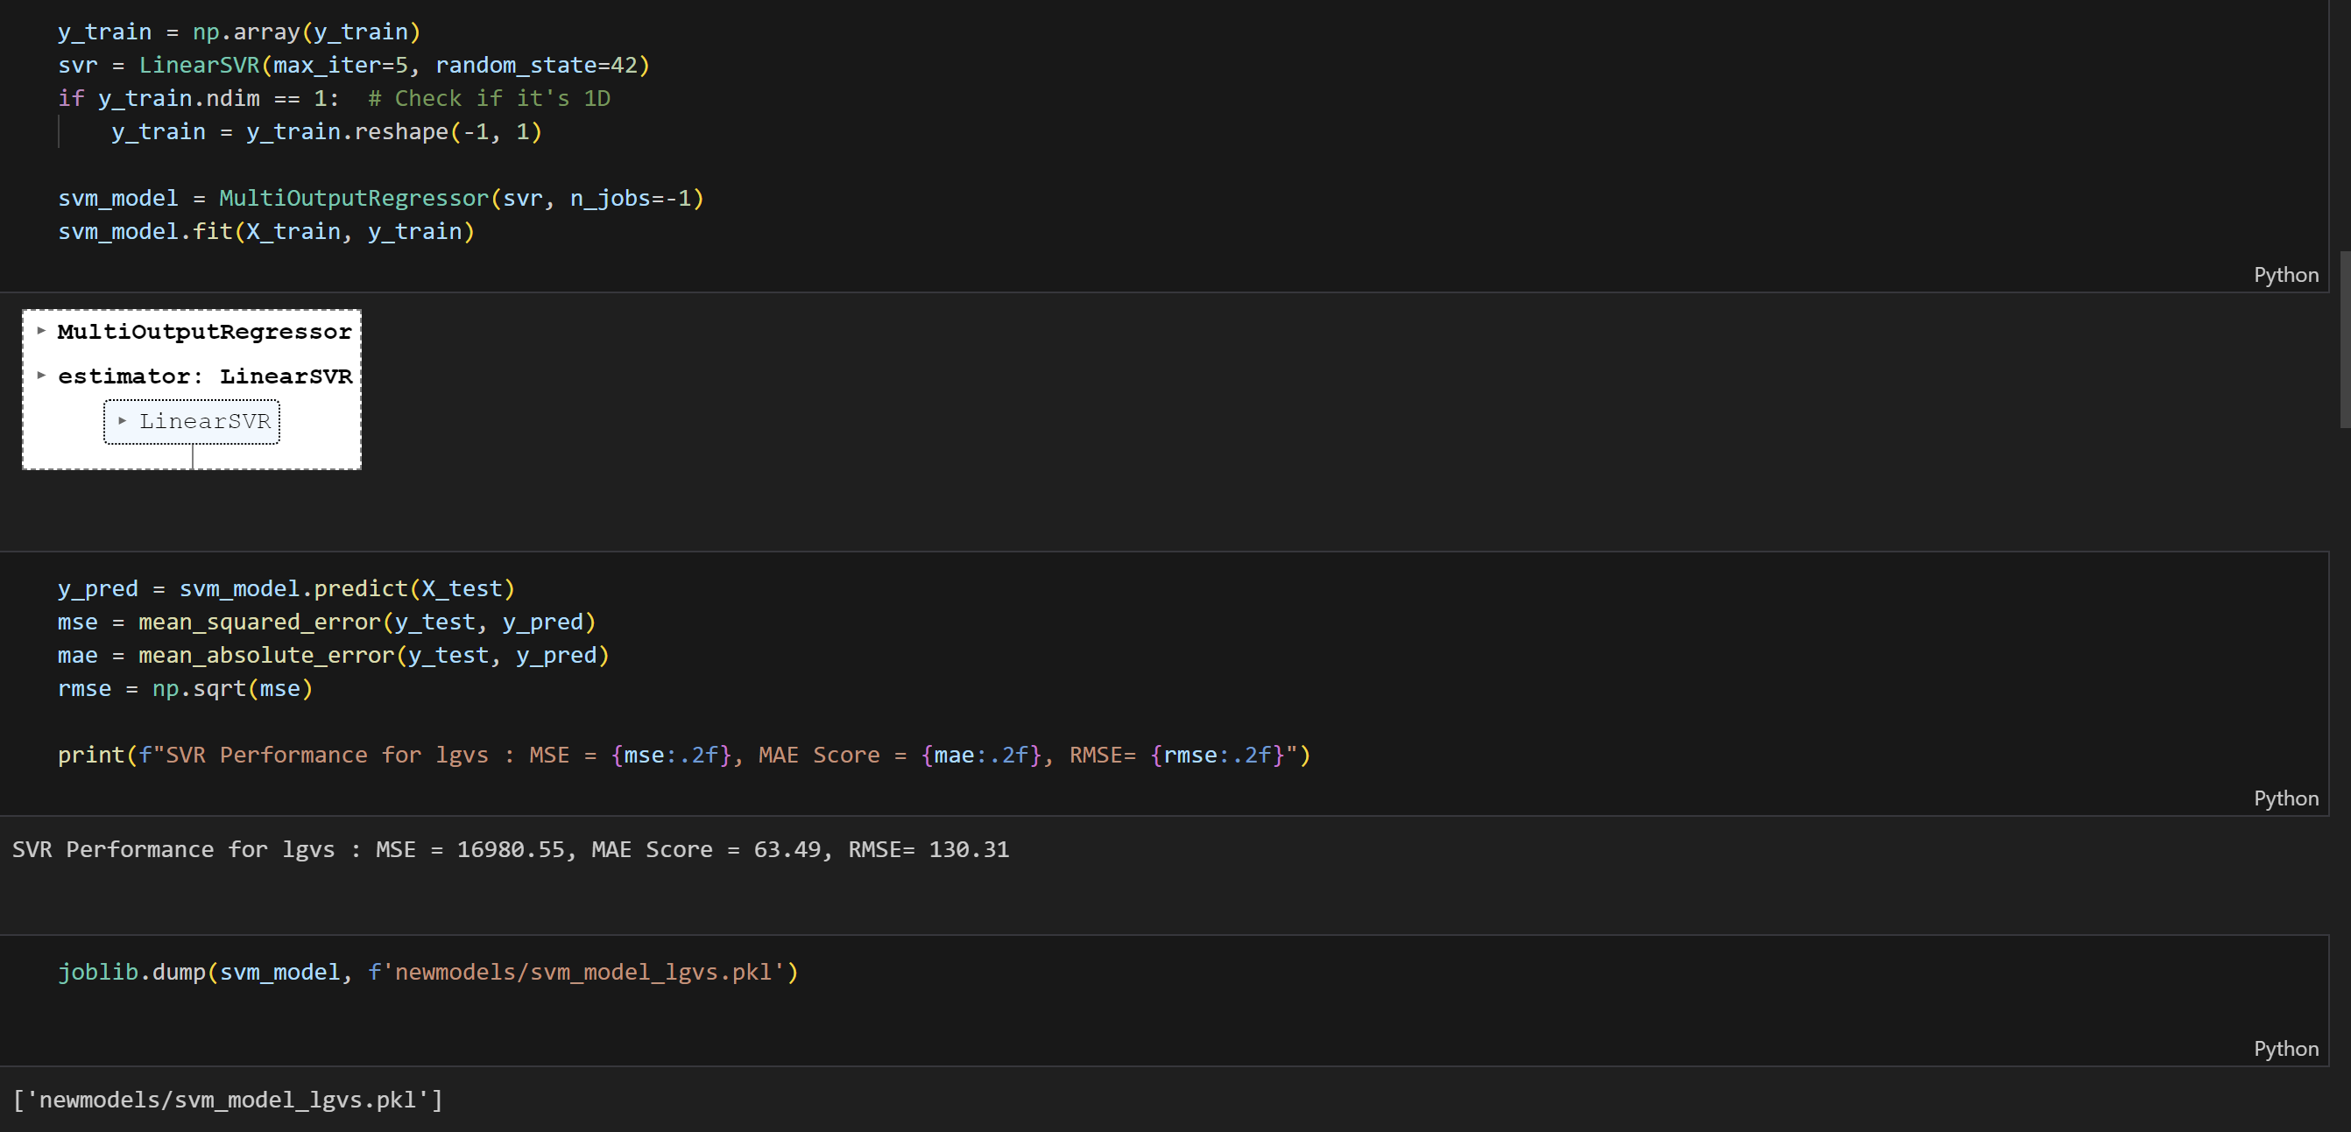

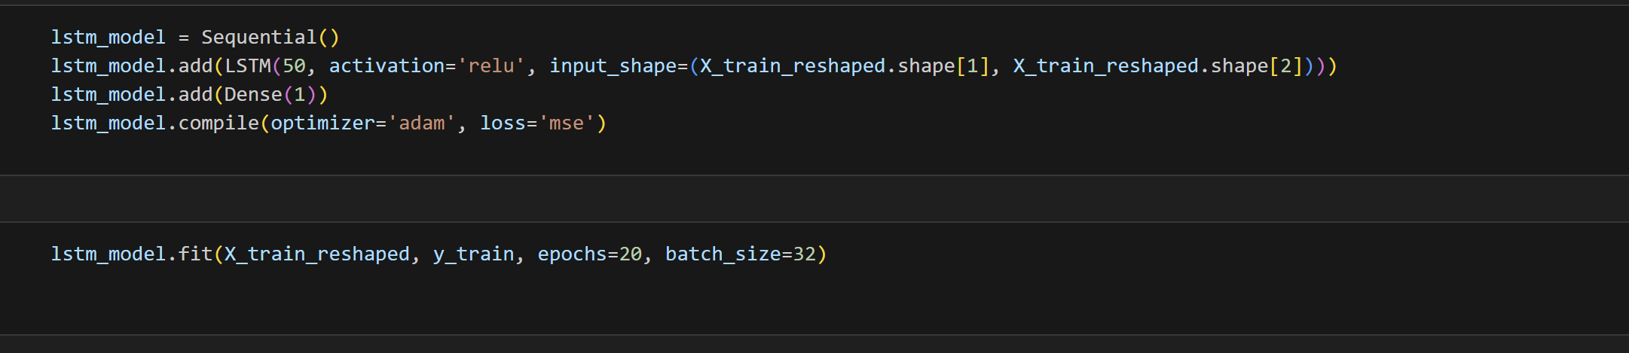

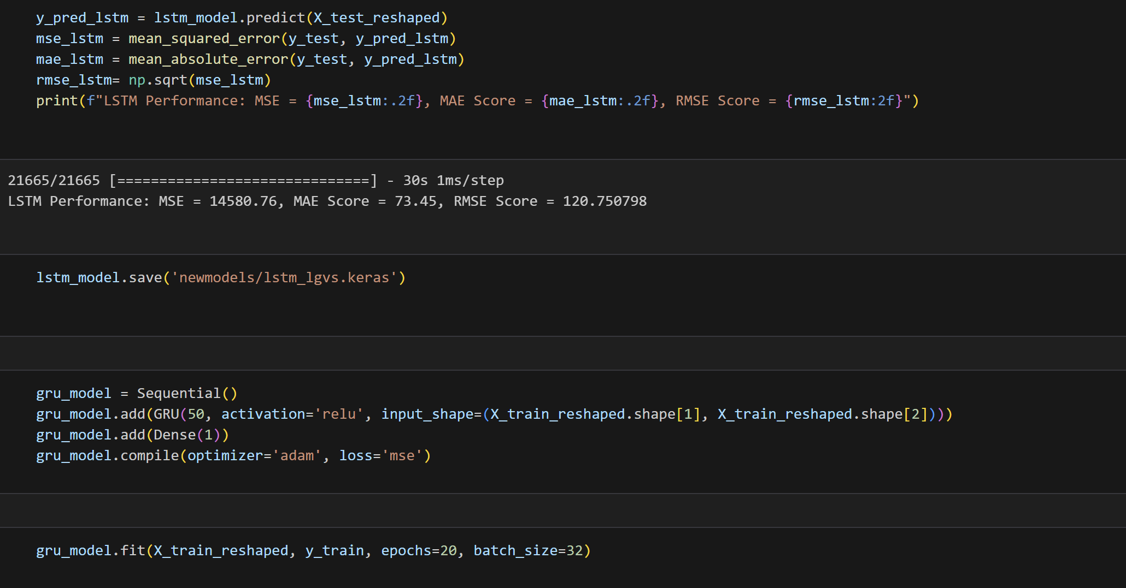

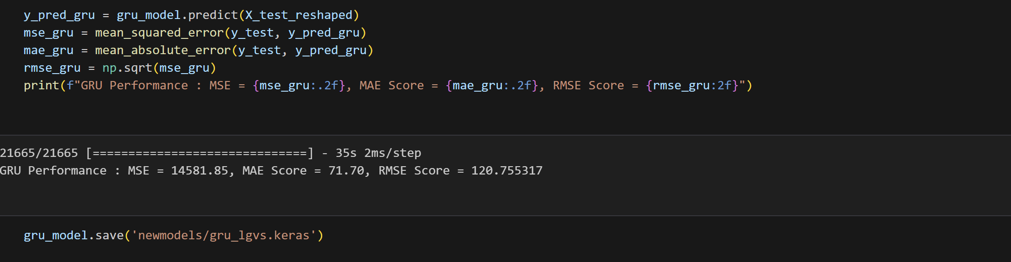

f) hgvs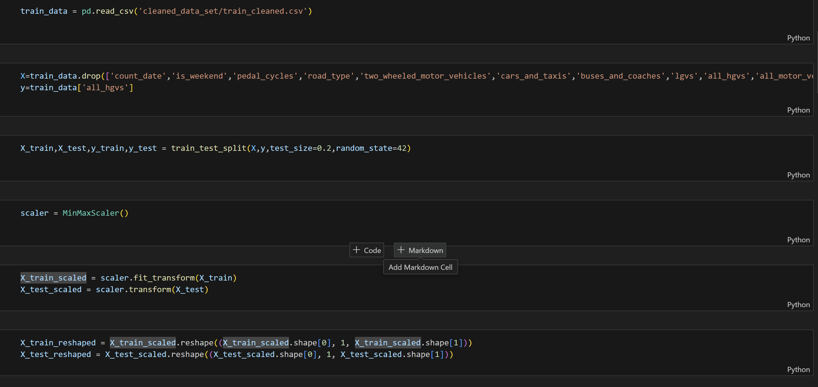

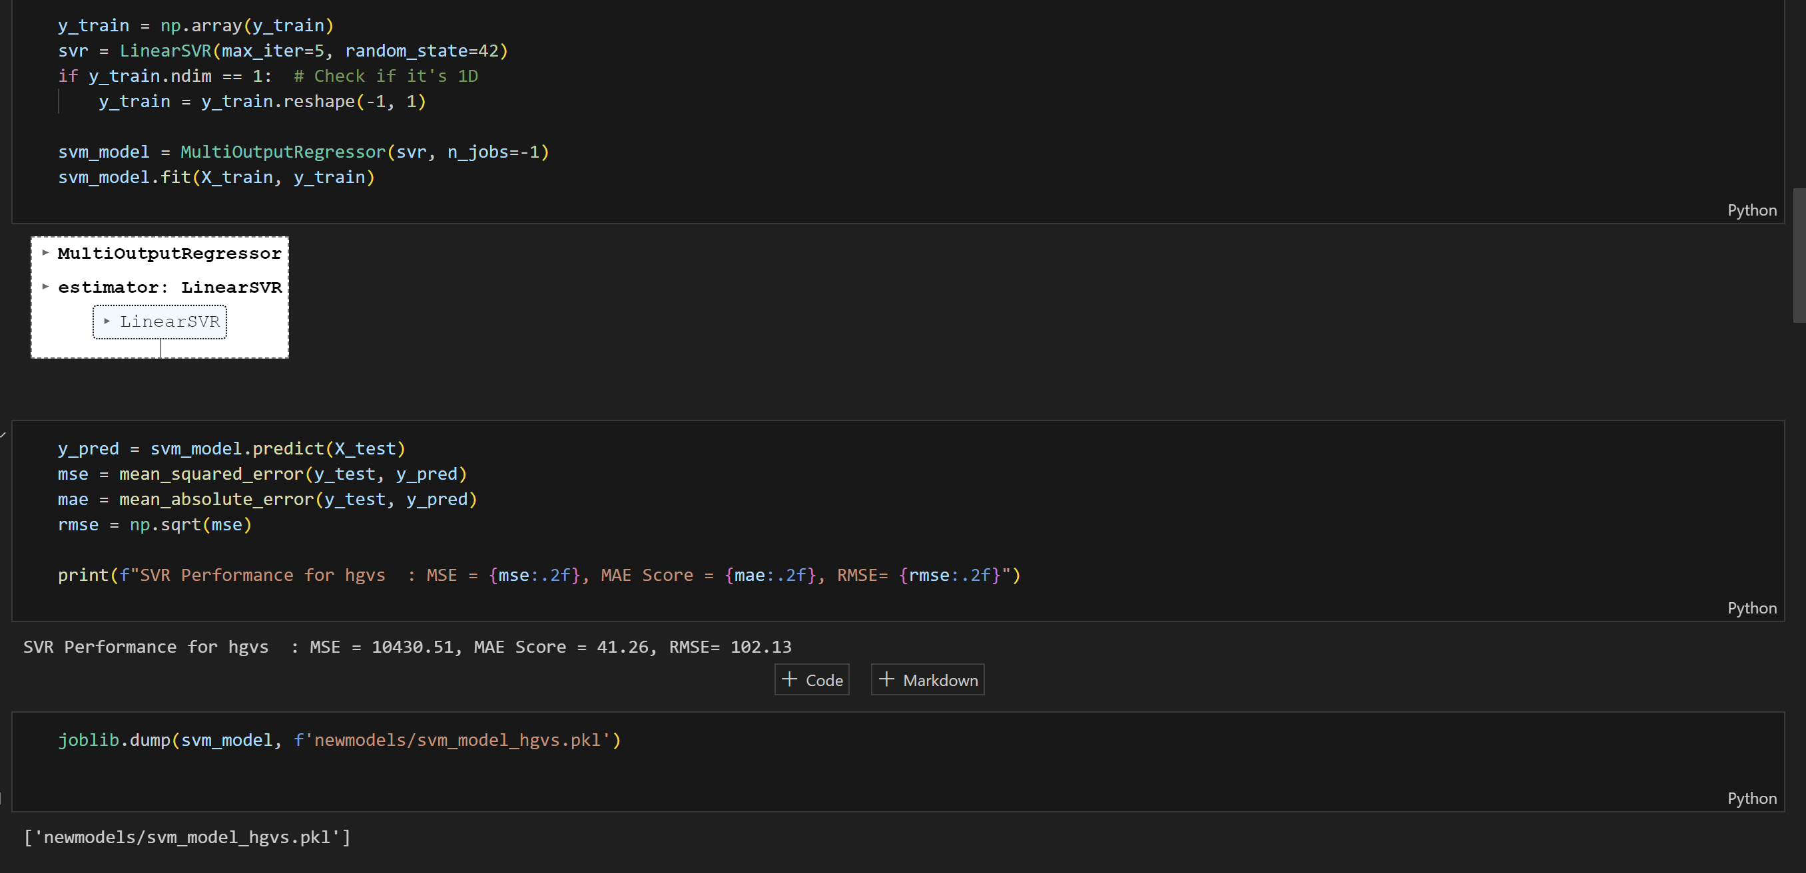

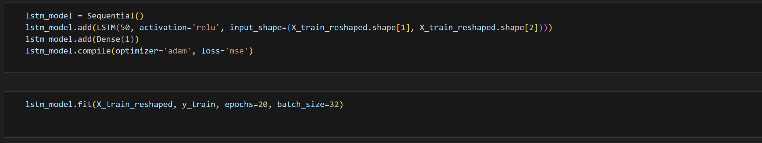

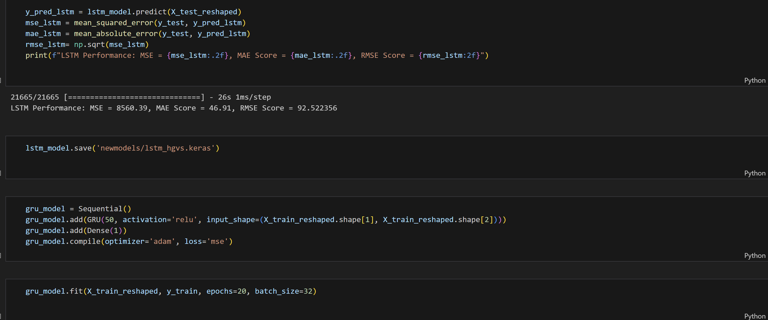

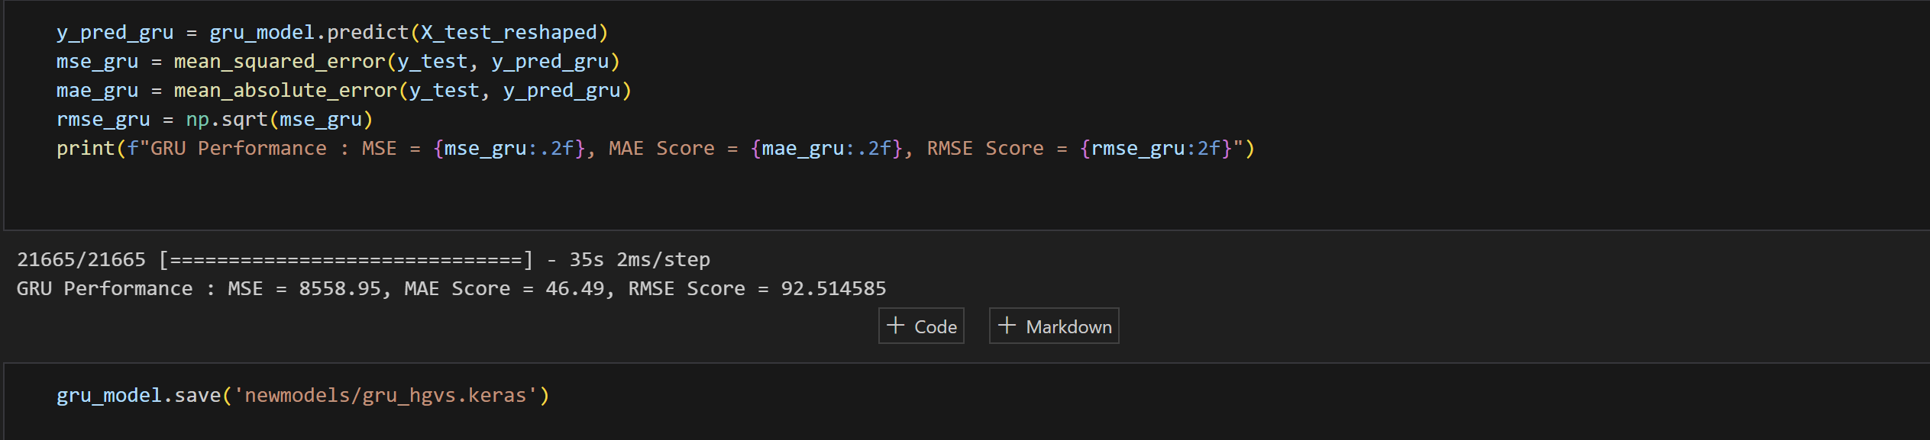

The code for Application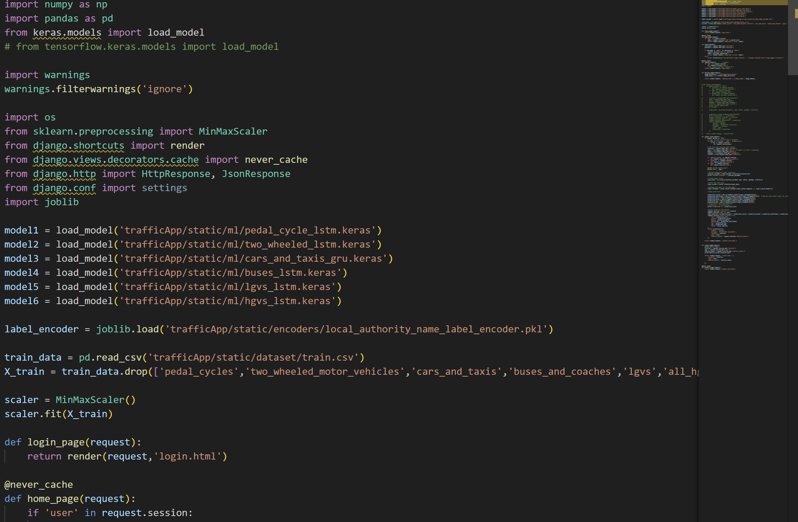

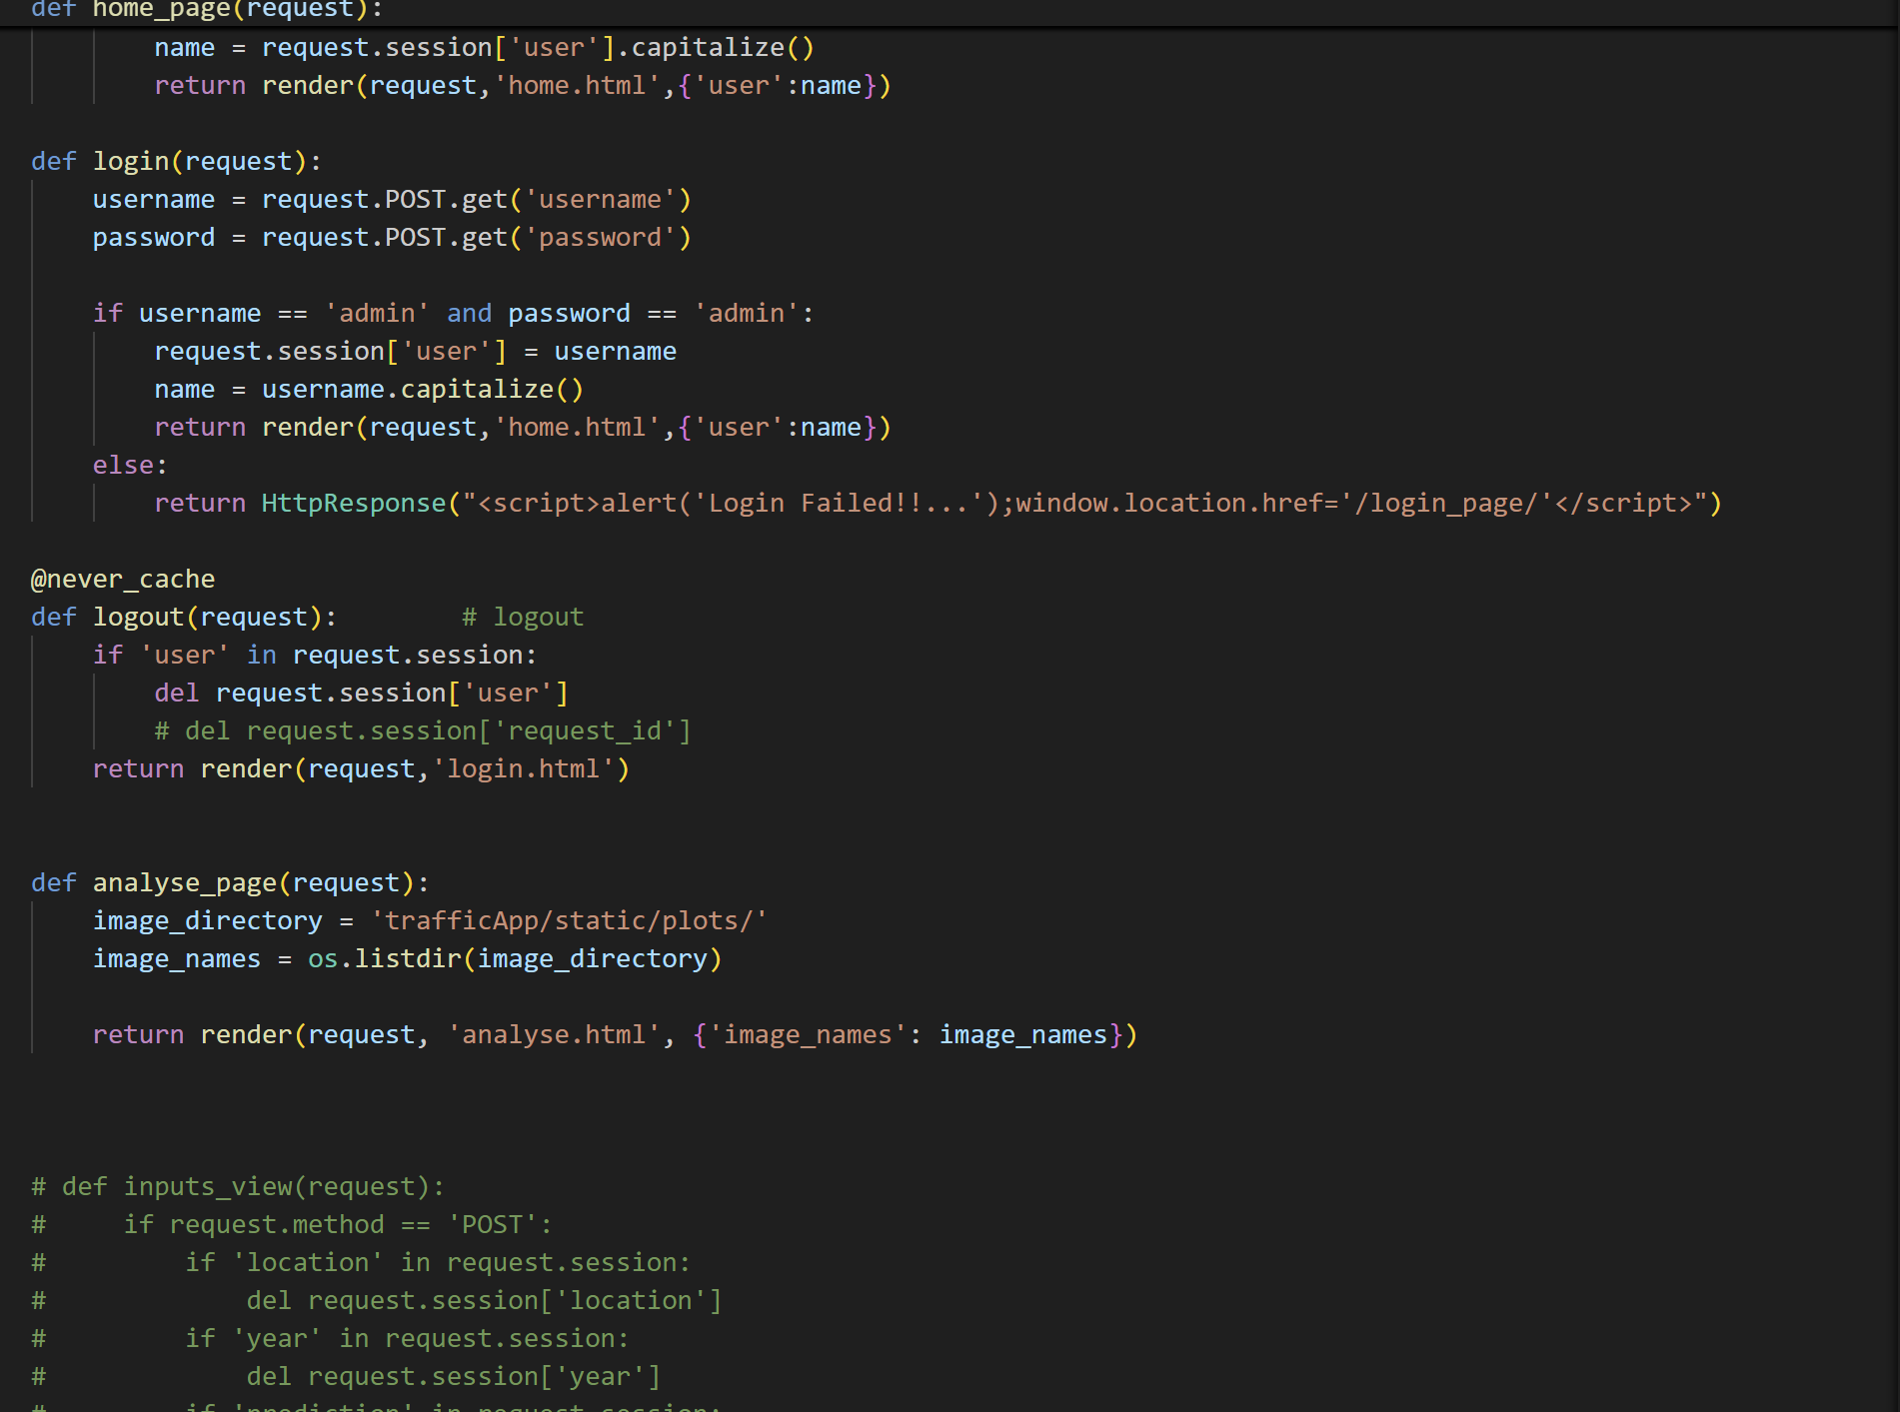

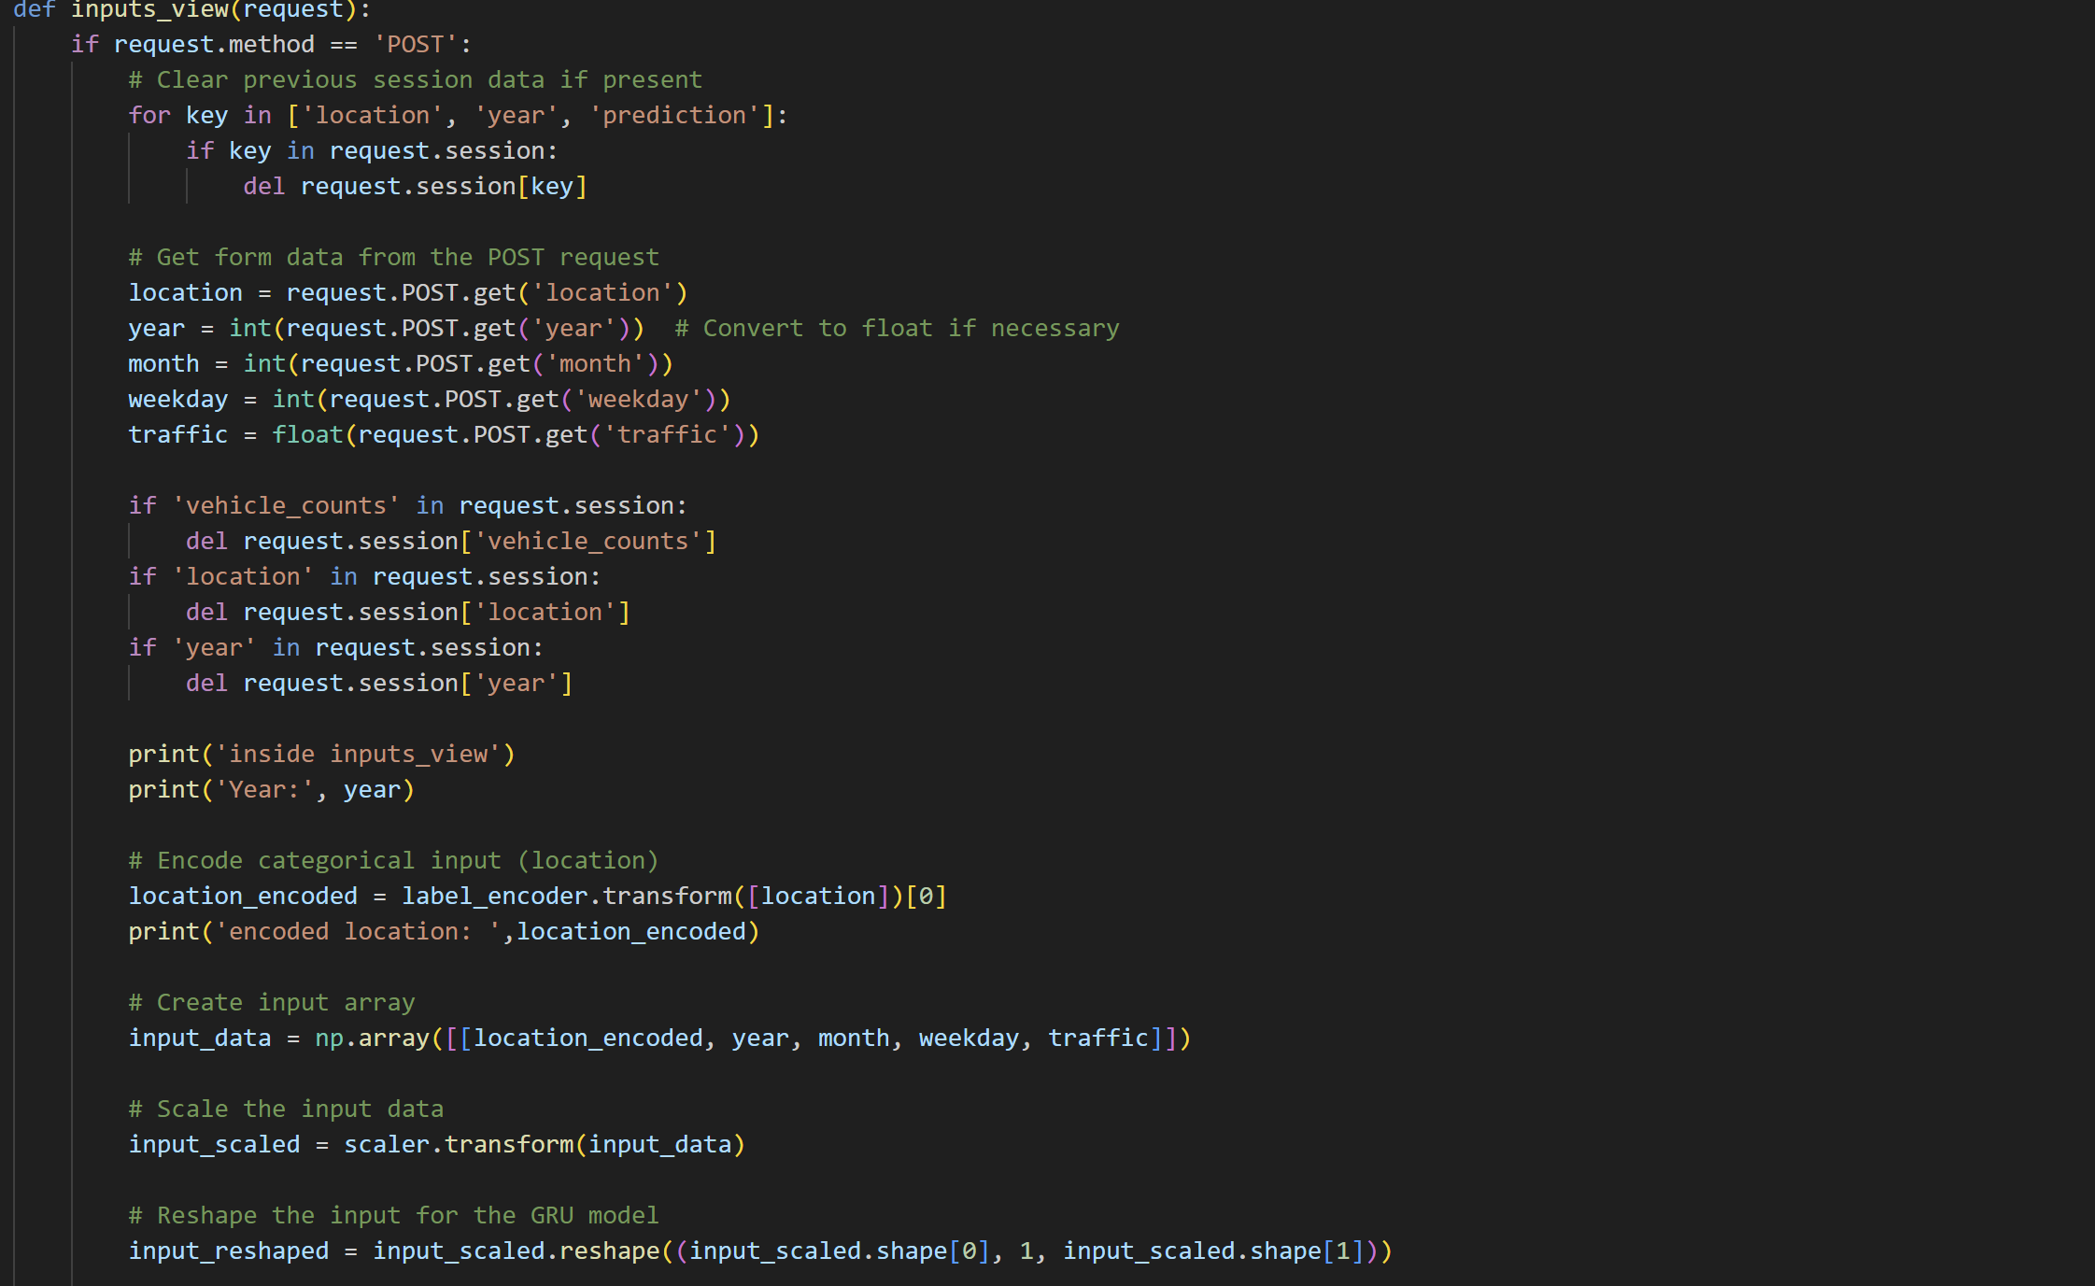

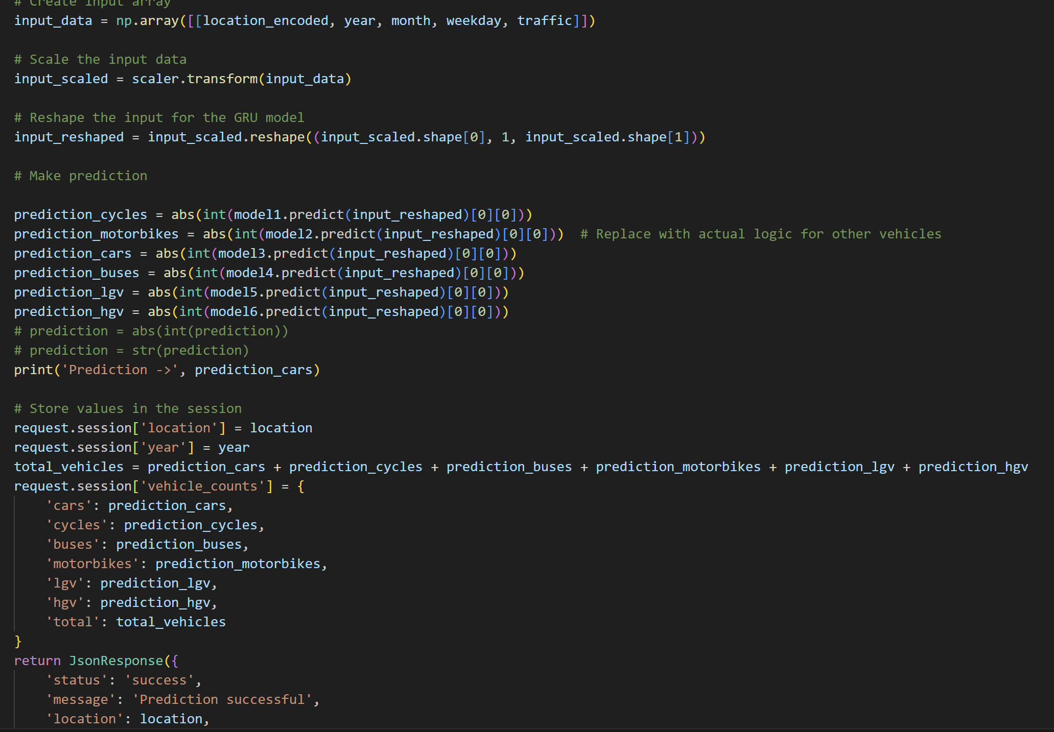

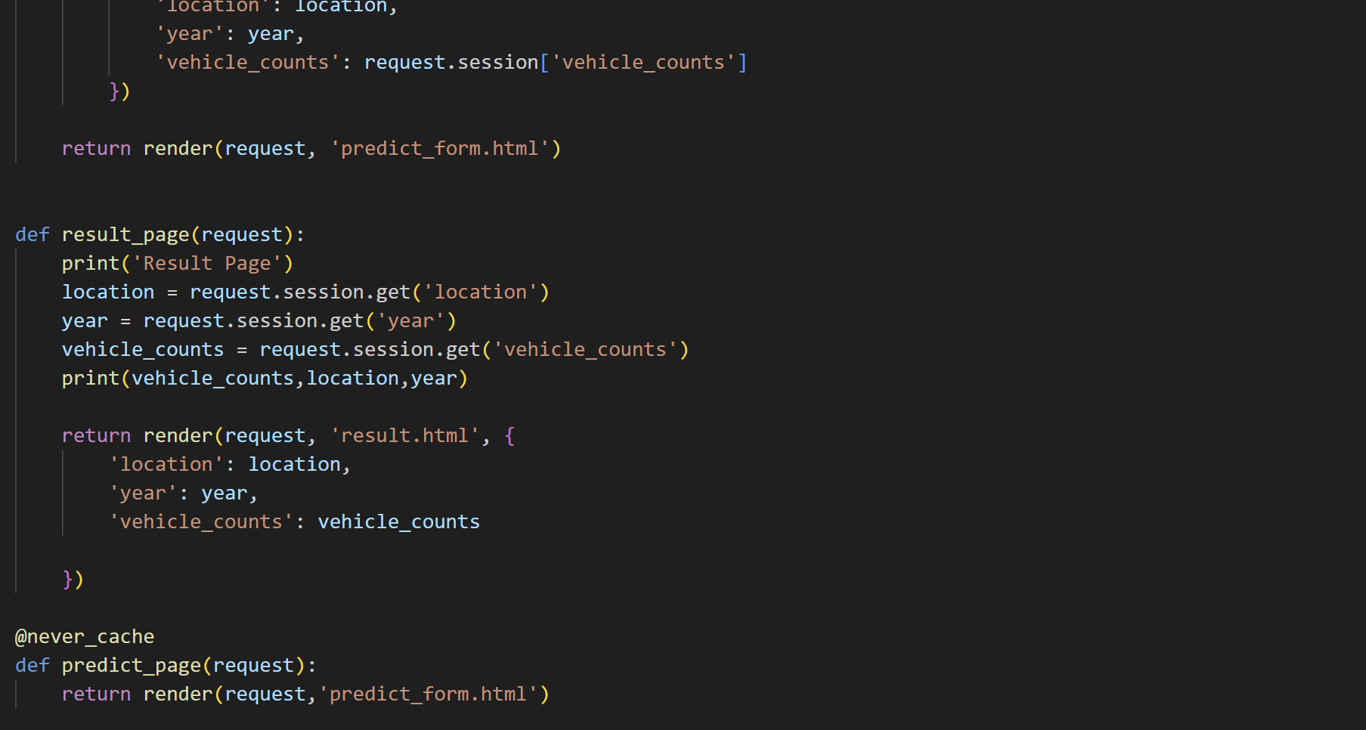

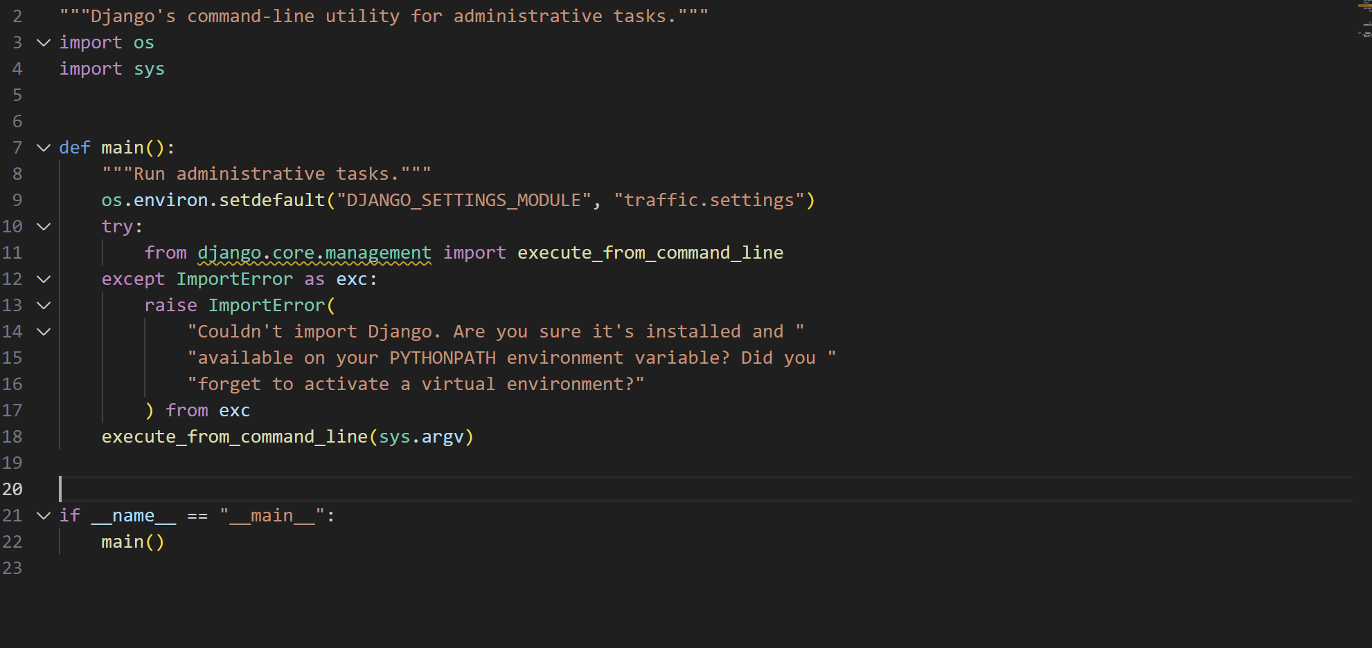

## Appendix D – Heat map

The heatmap that shows the traffic distribution in Great Britain.

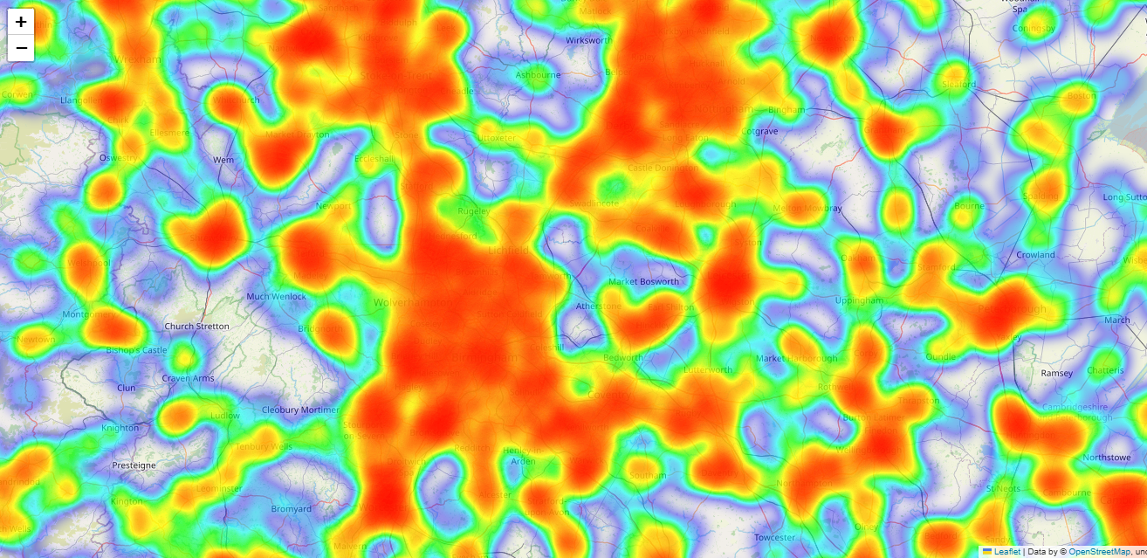

1. College of Social Sciences and Arts - Dr. Antonia Ypsilanti (a.ypsilanti@shu.ac.uk )

   College of Business, Technology and Engineering - Dr. Tony Lynn (t.lynn@shu.ac.uk )

   College of Health, Wellbeing and Life Sciences - Dr. Nikki Jordan-Mahy (n.jordan-mahy@shu.ac.uk )
2. Safety guidance for online research includes information on how to set up online surveys and/or conduct online interviews/focus groups. These guidelines can be found in BB. Please check with your supervisor/module leader.
3. It is mandatory to attach the Participant Information Sheet (PIS)
4. It is mandatory to attach a Participant Consent Form, unless it is embedded in an online survey, in which case your supervisor must approve it before you start data collection